**Vulnerability Assessment and Penetration Test**

**Report for OWASP Juice Shop**

TEAM Members :

**Habiba hosam eldin salah**

**Sohaila Mohammed Ahmed Mohammed**

**Mohamed Ayman Ahmed**

**Mohamed abdelbasit**

# Table of Contents

***1. Executive Summary***

***2. Technical Findings***

2.1 –Injection

2.2 – broken access control

2.3 - broken Auth

2.4 - Security Misconfiguration:

2.5 - CSRF

2.6 - Sensitive data exposure ALL vulnerabilities

2.7 - Improper input validation ALL vulnerabilities

2.8 – SSRF

2.9 - Miscellaneous vulnerabilities

***3. Conclusion***

***4 . finding summary***

# Assessment Components

# Web app Penetration Test A web app penetration test emulates the role of an attacker on a web application. An engineer will scan the website to identify potential vulnerabilities and perform common and advanced web attacks, such as: Injections, broken access control and other Cross-site scripting (XSS) attacks, Improper Input Validation, and more. The engineer will seek to gain access to hosts through lateral movement, compromise domain user and admin accounts, and exfiltrate sensitive data.

# SCOPE :

**Web-Server Penetration Testing** : OWASP Juice Shop

# 1 - Executive Summary

Our project was about testing and applying pen testing skills into a real world example like owasp juice shop and in this report we will cover our findings through this journey

# 2. Technical findings

1. **- Injection :**

**Christmas Special**

* **Severity**: High
* **Description**:  
  A SQL Injection vulnerability was identified in search query allows users to inject union query to dump all the data of the products using that I found the id of
* **Steps to Reproduce**:
  1. Discovered the search query param :

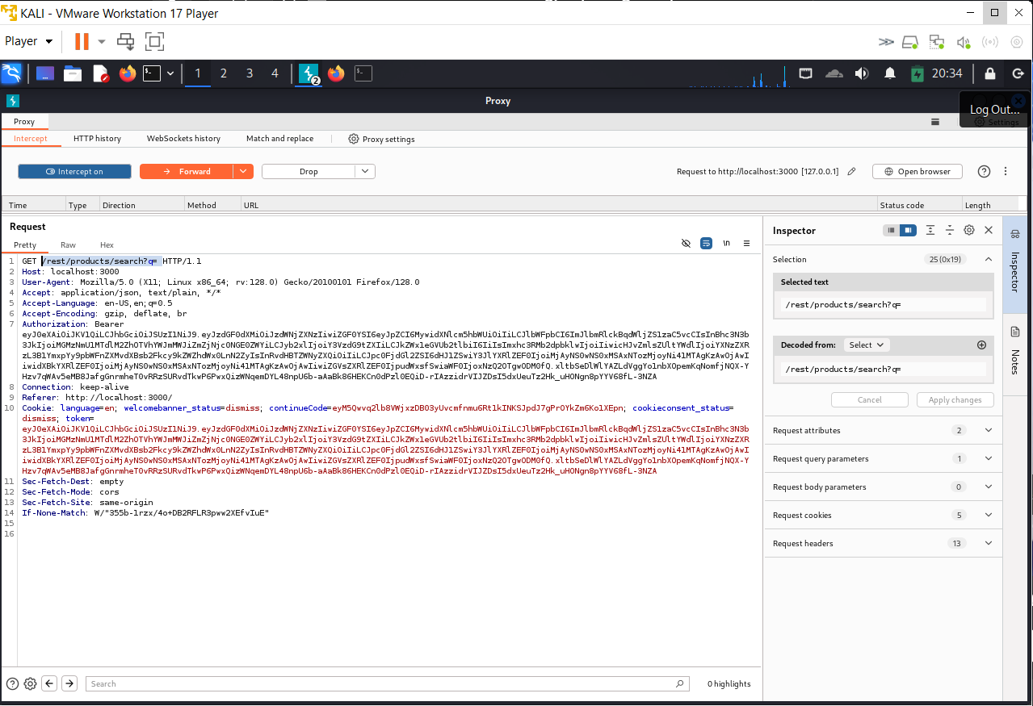

* 1. Inject the payload .

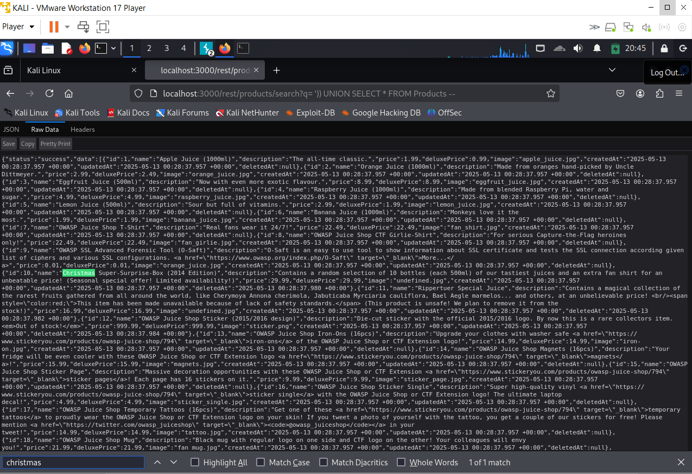

* 1. Use the found data in the order request :

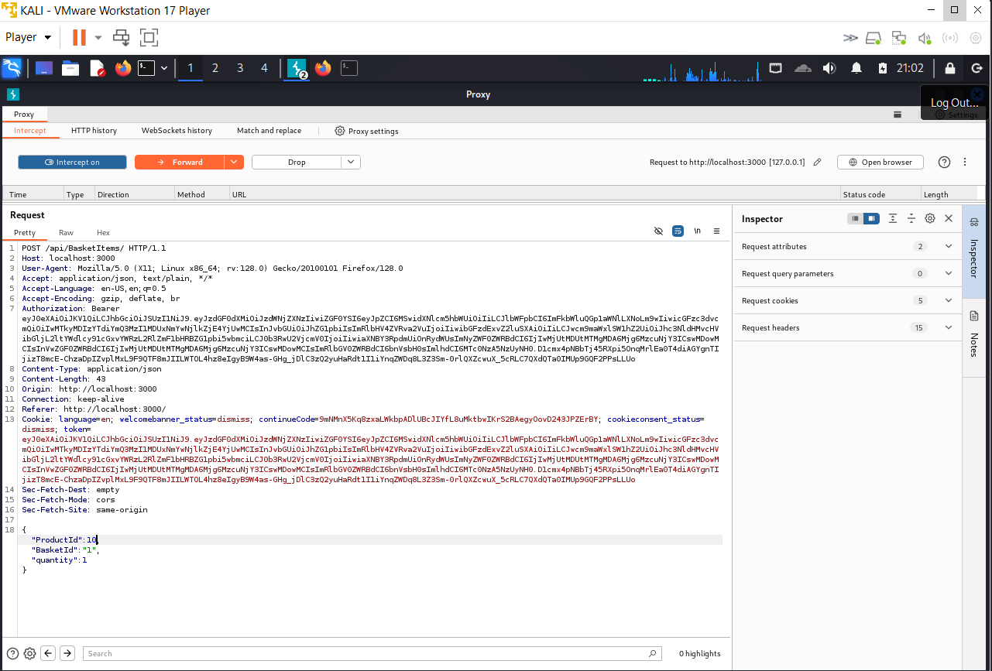

* 1. Successfully the product was added

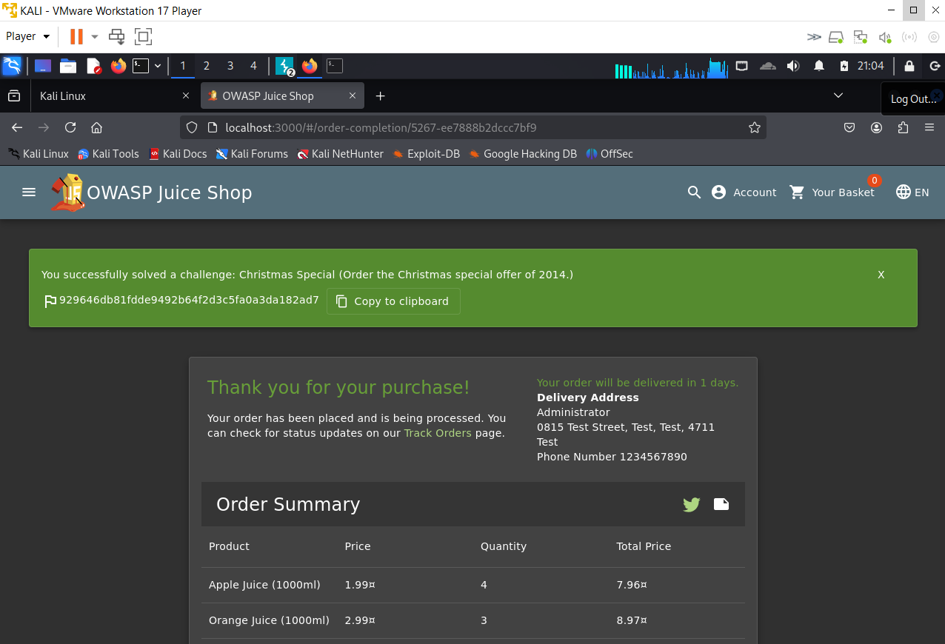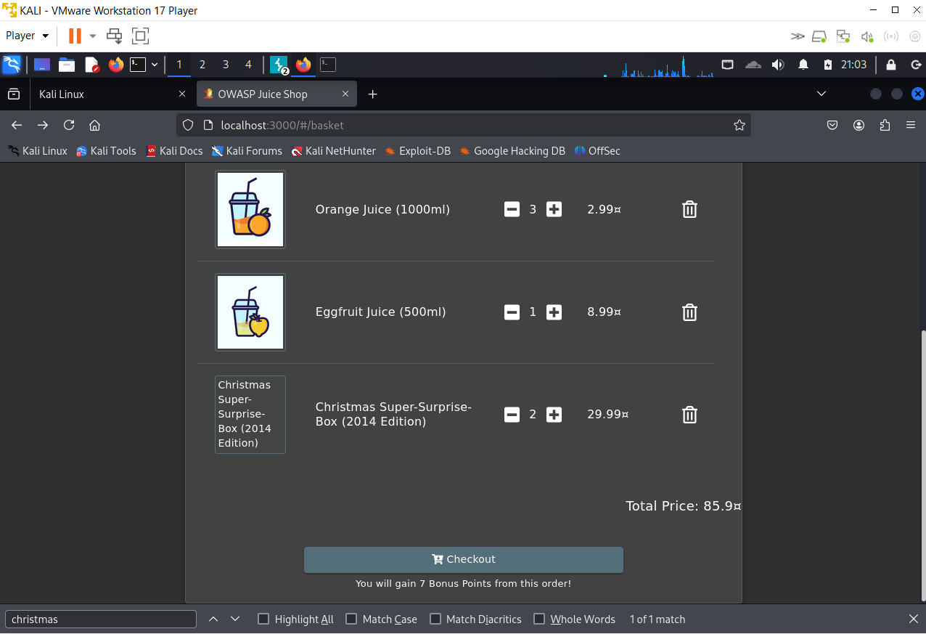

### ****SQL Injection in Login Form****

* **Severity**: High
* **Description**:  
  A SQL Injection vulnerability was identified in the login form of the application. This allows an attacker to bypass authentication mechanisms and potentially gain unauthorized access to user accounts, including administrative ones.
* **Affected Component**:  
  /login form
* **Steps to Reproduce**:
  1. Discovered the admin's email via recon in blog posts and product comments.
  2. Navigated to the login page.
  3. Entered the following payload in the **password** field:

**' OR '1'='1 --**

* 1. Successfully bypassed the login mechanism and was logged in as the admin user.
* **Impact**:  
  An attacker can gain full access to the application as an administrator without valid credentials. This can lead to full compromise of user data, application settings, and potential lateral movement within the internal infrastructure.
* **Poc** :
* 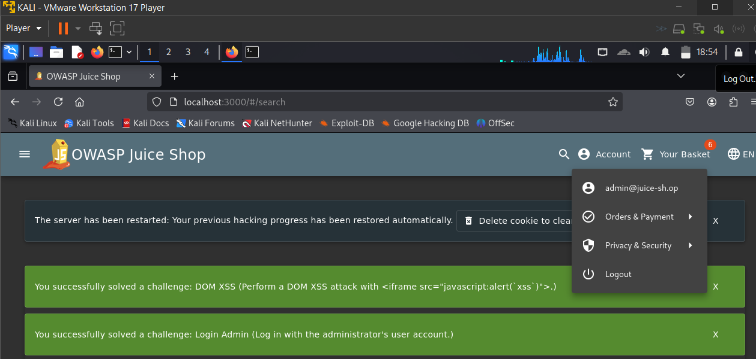

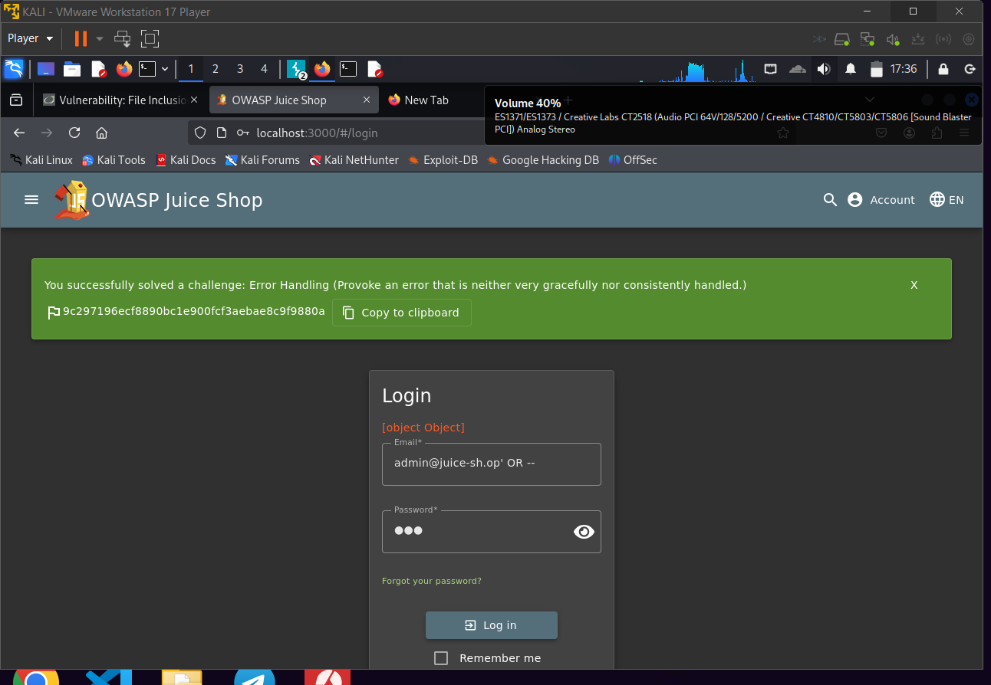

### ****SQL Injection via Login Form – Authentication Bypass and Account Takeover****

* **Severity**: High
* **Description**:  
  A critical SQL Injection vulnerability exists in the login form of the application. Through weak input handling in the authentication logic, an attacker can bypass login controls and access arbitrary user accounts, including administrator-level accounts.
* **Affected Component**:  
  /login endpoint
* **Steps to Reproduce**:
  1. **Reconnaissance Phase**:
     + Explored blog posts and product comments across the website.
     + Collected publicly exposed email addresses, including that of the admin and another user.
  2. **Login Form Weakness Discovery**:
     + The login form does not implement input sanitization or parameterized queries.
  3. **Payload Execution**:
     + Used the following payload in the **password** field:

**' OR '1'='1 --**

* + - Combined with known emails, this allowed login as valid users without knowing their actual passwords.
  1. **Impact**:
     + Successfully logged in to **two separate user accounts**, including an administrator.
     + These actions allowed me to solve **two challenges** simulating real-world exploitation:
       - Challenge 1: Identify and exploit a SQLi-based authentication bypass.
       - Challenge 2: Gain access to protected user data via account takeover.
* **Impact**:  
  The vulnerability demonstrates complete failure of the authentication mechanism. Any attacker with minimal knowledge can:
  1. Log in as any known user
  2. View sensitive data
  3. Modify user information or perform actions on their behalf
* Poc :

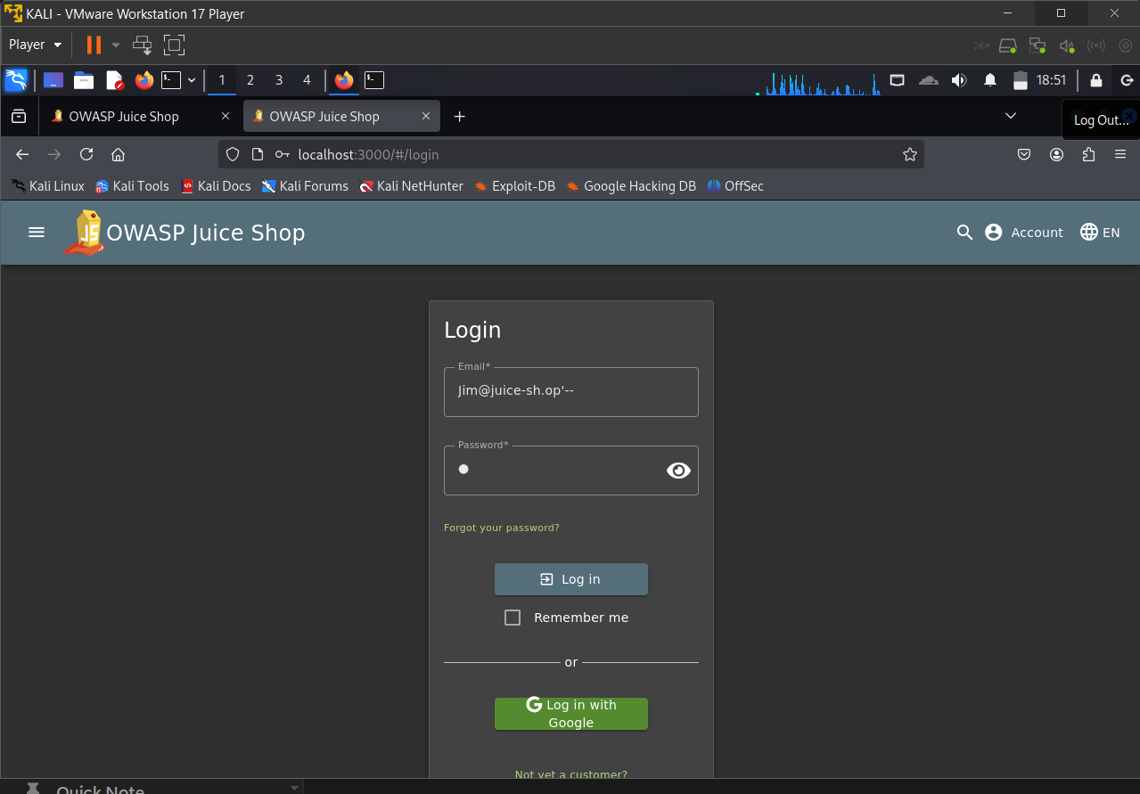

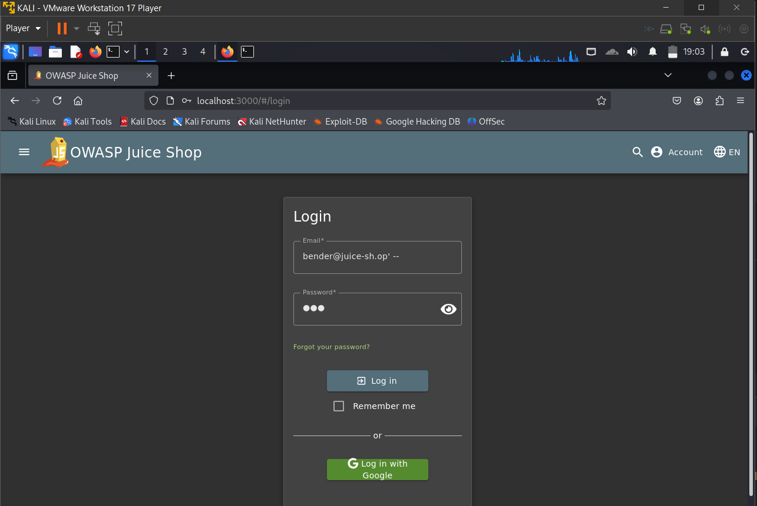

### ****User Credentials****

* **Severity**: High
* **Description**:  
  A critical SQL Injection vulnerability exists in search query param search?q= and that allows the user to inject sql payloads
* **Steps to Reproduce**:
* **1**- go to / rest/products/search?q=
* 2- tried **‘OR 1=1 --** and it bypassed , there is a logic problem
* 3 – tried **‘UNION SELECT * FROM USERS --** it gives
* 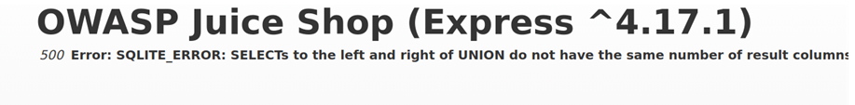
* **4**- inject this payload test')) UNION SELECT username, password, role, deletedAt, isActive, createdAt, id, email, profileImage FROM USERS—
* **5** – boom ! all users data

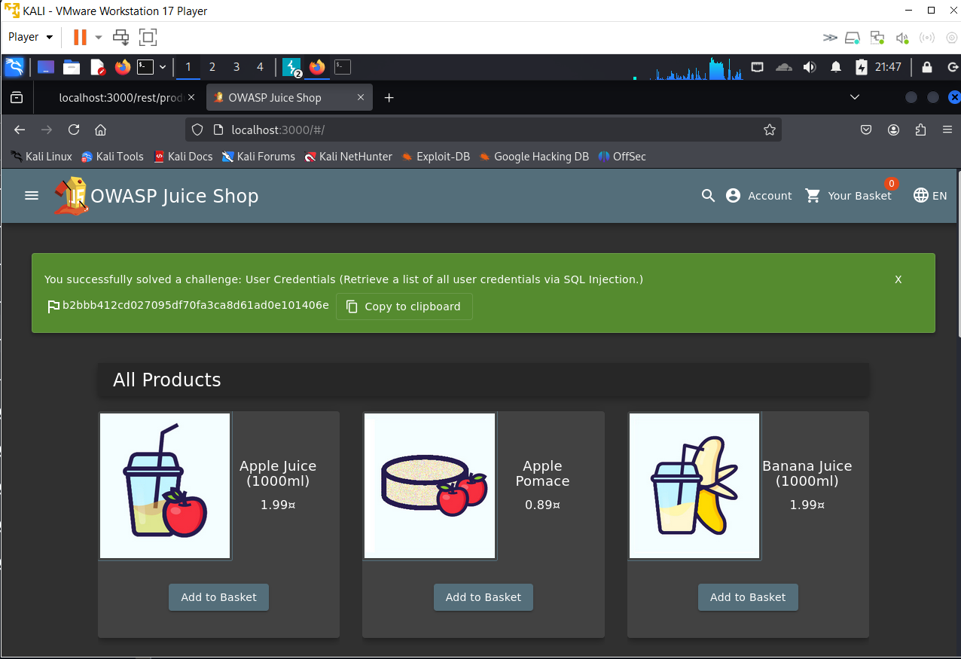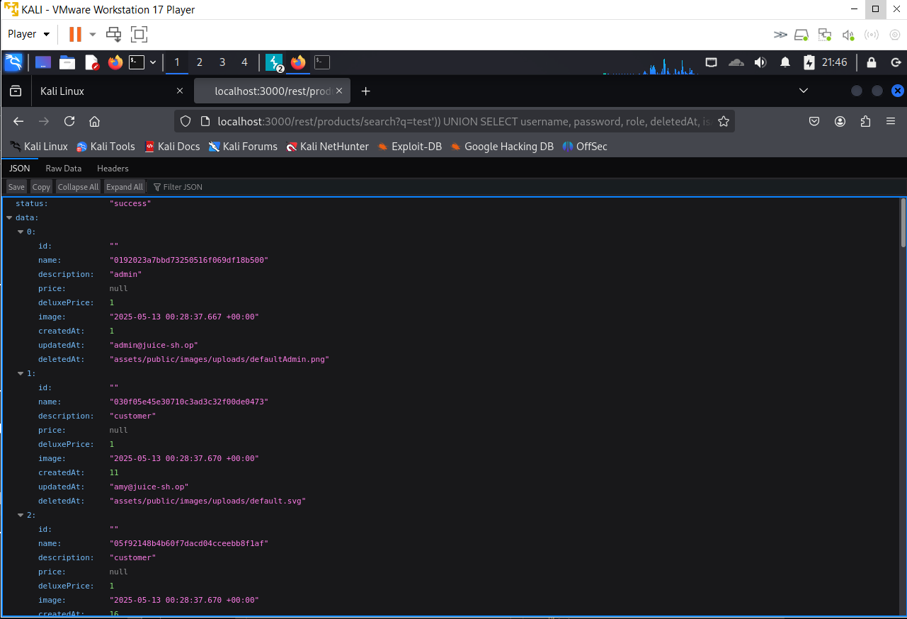

### ****Reflected Cross-Site Scripting (XSS) in Search Functionality****

* **Severity**: Medium
* **Description**:  
  A **reflected XSS** vulnerability was discovered in the search functionality of the web application. The input provided in the q parameter of the search endpoint is directly reflected in the HTML response without proper sanitization or encoding, allowing attackers to execute arbitrary JavaScript in the context of a victim's browser.
* **Affected Component**:  
  /search?q=
* **Steps to Reproduce**:
  1. Navigated to the following URL:

**https://target-site.com/search?q=<img src=z onerror=alert(1)>**

* 1. Observed the browser executing the payload, triggering a JavaScript alert(1) popup.
  2. Confirmed the input is reflected in the page source without encoding.
* **Impact**:  
  An attacker could trick users into clicking a malicious link (e.g., via email, social media, or phishing). If a victim accesses the link, JavaScript code can execute in their browser, allowing for:
  1. Session hijacking
  2. Defacement
  3. Redirection to malicious sites
  4. Phishing of credentials
* **Evidence**:
  1. URL tested:

javascript

CopyEdit

/search?q=<img src=z onerror=alert(1)>

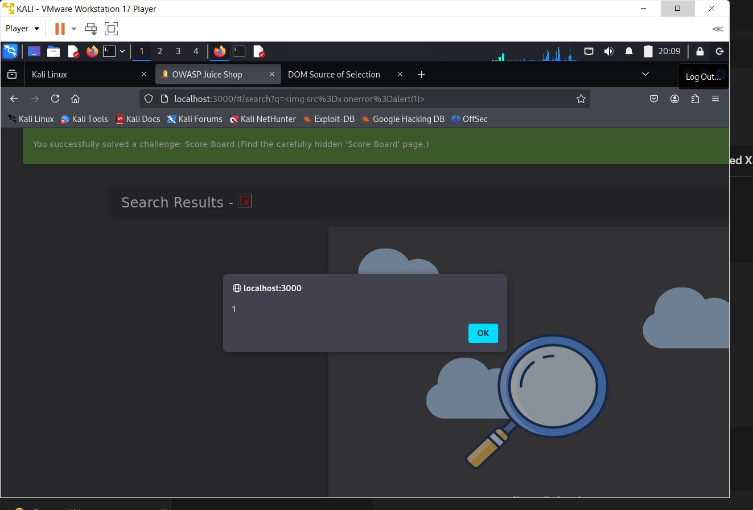

**Database schema**

**Severity: High**

**Description:**

An **SQL Injection vulnerability** exists in the product search functionality. By injecting a malicious payload into the search query parameter, an attacker was able to extract the full **database schema**, including the structure of tables and columns.

**Affected Component:**

GET /rest/products/search?q=<payload>

**Steps to Reproduce:**

1. Intercepted the search request using **Burp Suite**.
2. Modified the q parameter to include the following payload:

sql

CopyEdit

banana')) UNION SELECT sql,2,3,4,5,6,7,8,9 FROM sqlite_master--

1. Forwarded the modified request.

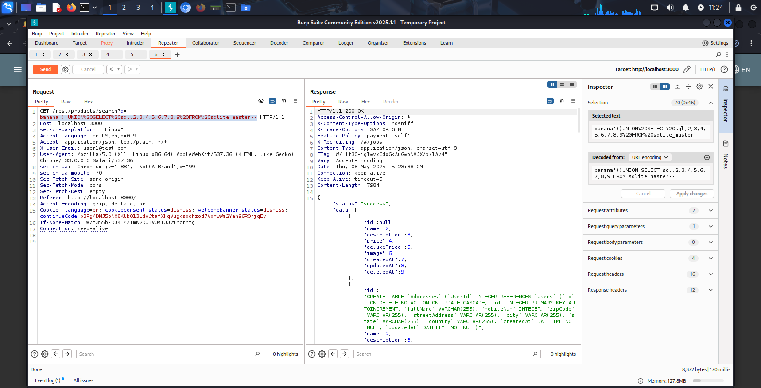

1. The server responded with the following JSON output that included part of the **SQL schema**:

{

"id": "CREATE TABLE \"Addresses\"...",

"name": 2,

"description": 3,

...

}

This output contained full SQL CREATE TABLE statements, including table names like Users, Addresses, and all column definitions.

**Impact:**

* Attacker gains visibility into internal database structure (Users, Addresses, etc.).
* Can identify relationships and sensitive fields (e.g., password, email, mobileNum).
* Facilitates **targeted SQLi** or **data extraction attacks**.
* Compromises database confidentiality and increases risk of full exploitation.

**Remediation:**

* Sanitize and parameterize all user input using **prepared statements**.
* Disable verbose SQL error responses and avoid exposing internal structures.
* Implement **Web Application Firewall (WAF)** to detect and block injection patterns.
* Regularly test and audit input endpoints for injection vulnerabilities.

**Poc**

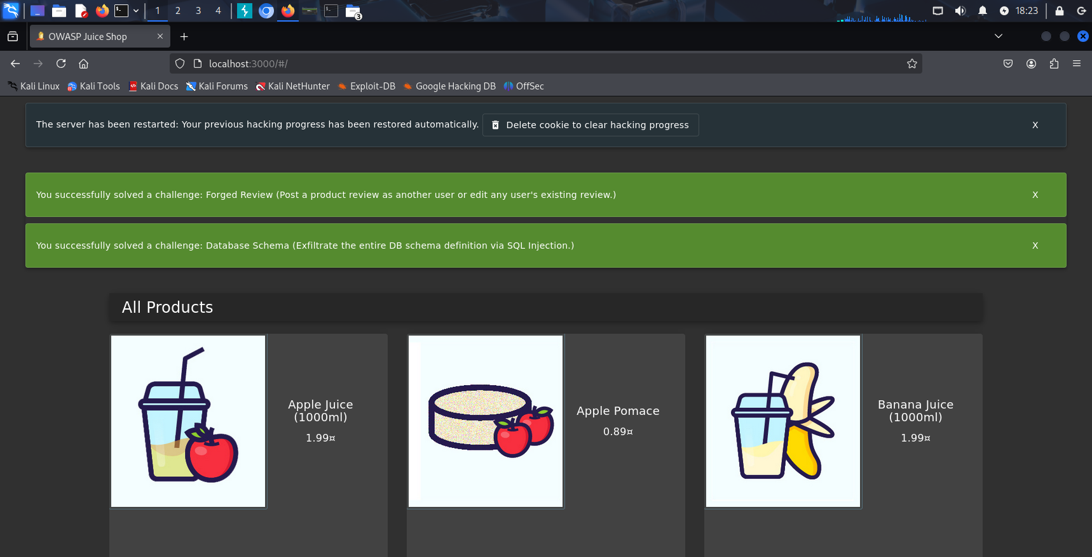

**2- Brocken access control:**

**(Easter Egg)**

**First we started by reaching the endpoint /ftp but using our method of null injection.**

-Severity:  
High (unauthorized access to hidden content and potential sensitive data)

- Description:  
Broken Access Control occurs when an application fails to properly restrict access to resources, allowing unauthorized users to bypass intended security measures. In OWASP Juice Shop, the /ftp endpoint is vulnerable to null byte injection, enabling the download of restricted files. This exposes a Base64-encoded string that, after decoding and ROT13 decryption, reveals a hidden endpoint. Accessing this endpoint redirects to a restricted page, demonstrating a significant access control flaw that violates the application's security model.

- Affected Component:  
File transfer endpoint  
/ftp  
The endpoint lacks proper validation, allowing null byte injection to bypass file type restrictions and access hidden content, including an encoded path to a restricted page.

Steps to Reproduce (in OWASP Juice Shop):

1. Navigate to the /ftp endpoint:  
   http://localhost:3000/ftp
2. Use a null byte injection technique by appending %00 to a file request, e.g., easteregg.gg%00.md.
3. Download the file, which contains a Base64-encoded string:  
   L2d1cm9mZm5lcmZic2hhYWxndXJ2bmFtcmZncmV0dGpndnVhZ3VybWZvcmV0dA==.
4. Decode the Base64 string using a decoder tool, yielding:  
   /gur/offner/fbshaal/gur/vna/mrfgret/tjgqva/gur/mforett.
5. Recognize this as a ROT13-encrypted string and decode it to:  
   /the/devs/are/so/funny/they/hid/an/easter/egg/with/the/easter/egg.
6. Insert the decoded path into the URL:  
   http://localhost:3000/the/devs/are/so/funny/they/hid/an/easter/egg/with/the/easter/egg.
7. The page redirects to a restricted area, confirming the challenge: "You successfully solved a challenge: Nested Easter Egg (Apply some advanced cryptanalysis to find the real easter egg!)."

Impact:  
• Unauthorized access to hidden content, potentially exposing sensitive information or system details.  
• Bypassing of file type restrictions, enabling exploitation of restricted resources.  
• Increased risk of further attacks if additional hidden endpoints are uncovered.  
• Undermines the application's access control integrity, affecting overall security.

Remediation:  
• Implement strict server-side validation to reject null byte injections and enforce file type restrictions.  
• Use access control lists (ACLs) to restrict access to sensitive endpoints and resources.  
• Avoid embedding encoded or encrypted paths in downloadable files to prevent discovery of hidden routes.  
• Monitor and log access attempts to the /ftp endpoint to detect and block unauthorized requests.  
• Regularly audit the application for hidden endpoints and ensure proper authorization checks.

PoC (Proof of Concept):

Downloading the file reveals a Base64-encoded string, which, after decoding to /gur/offner/fbshaal/gur/vna/mrfgret/tjgqva/gur/mforett and applying ROT13 to get /the/devs/are/so/funny/they/hid/an/easter/egg/with/the/easter/egg, allows access to the restricted page when requested.

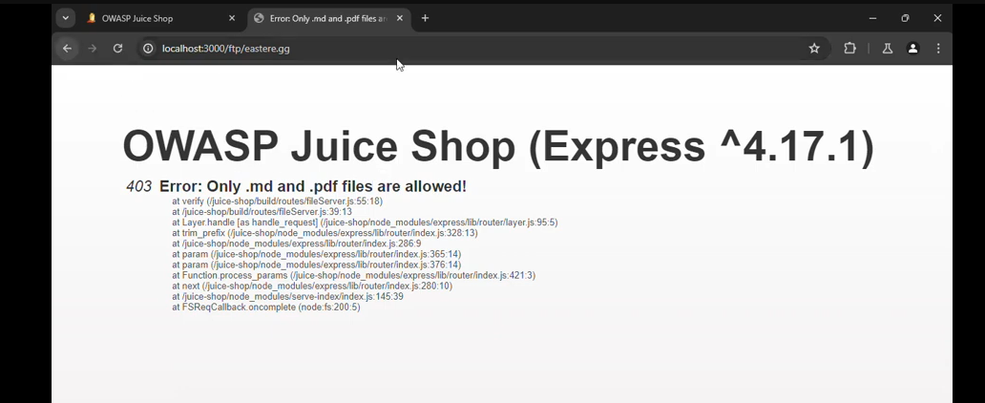

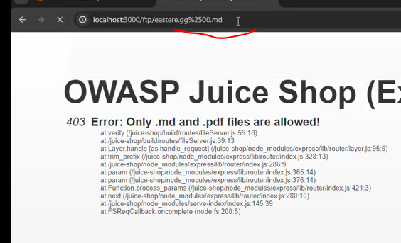

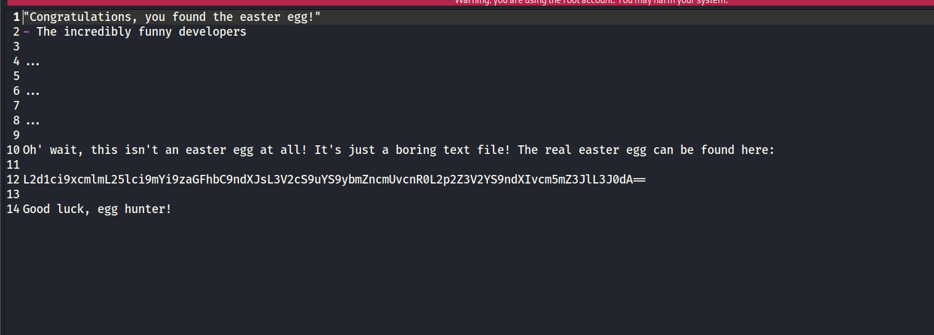

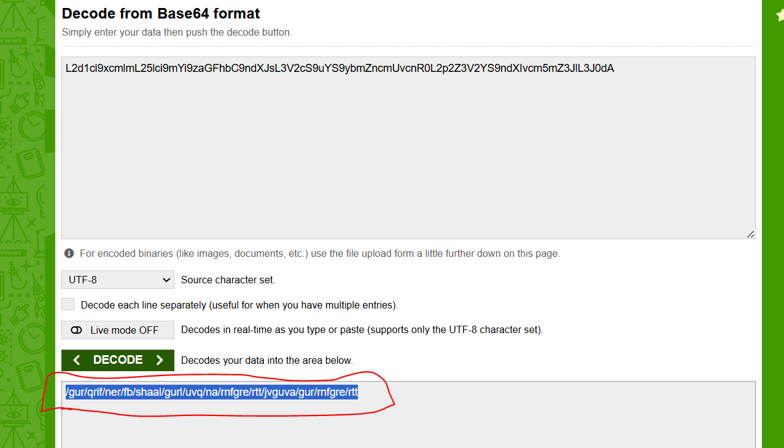

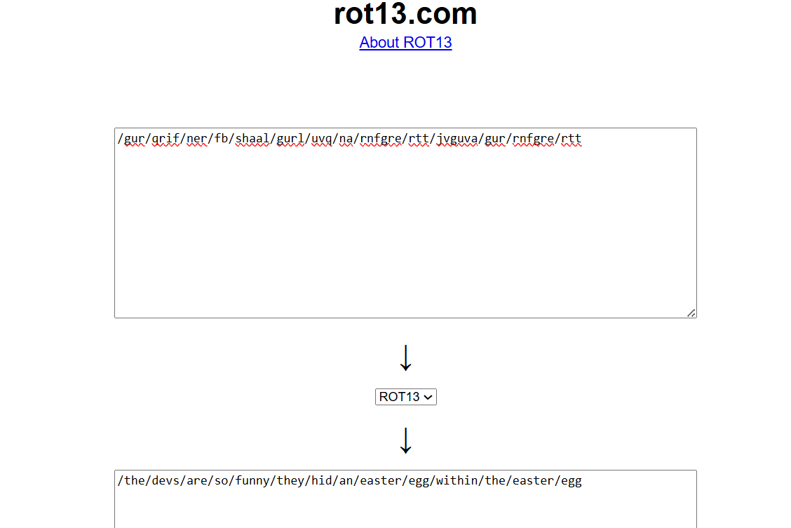

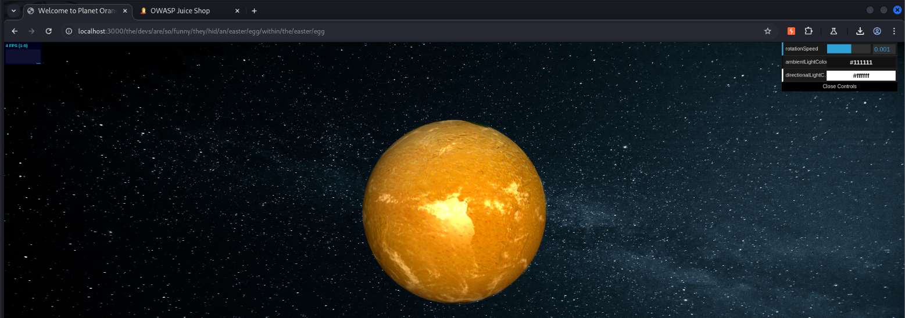

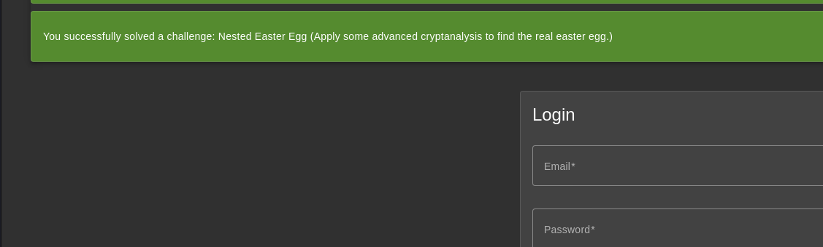

**Find the hidden scoreboard**

**Severity: low**

**Description**

A **Broken Access Control** vulnerability exists in the OWASP Juice Shop. The application allows users to inspect the page of the front so anyone can find the hidden path of the scoreboard .

**PoC :**

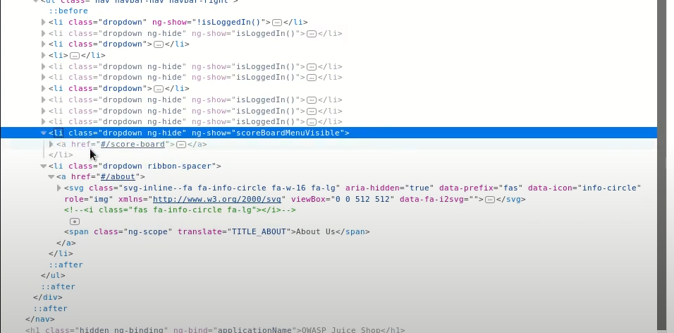

# View Basket

**Severity: High**

**Description**

A **Broken Access Control** vulnerability exists in the "View Basket" feature of OWASP Juice Shop. The application fails to properly verify ownership of the shopping basket when accessing it via its ID. This allows any authenticated user to view another user's basket by simply altering the Basket ID in the request, without any server-side authorization enforcement.

**Affected Component**

GET /api/Basket/:id

**Steps to Reproduce**

1. Logged into the Juice Shop with a valid user account.
2. Navigated to the /basket page and intercepted the HTTP request using **Burp Suite**.
3. Observed the following request:

http

GET /api/Basket/3 HTTP/1.1

Host: localhost:3000

1. Modified the Basket ID to 8:

http

GET /api/Basket/8 HTTP/1.1

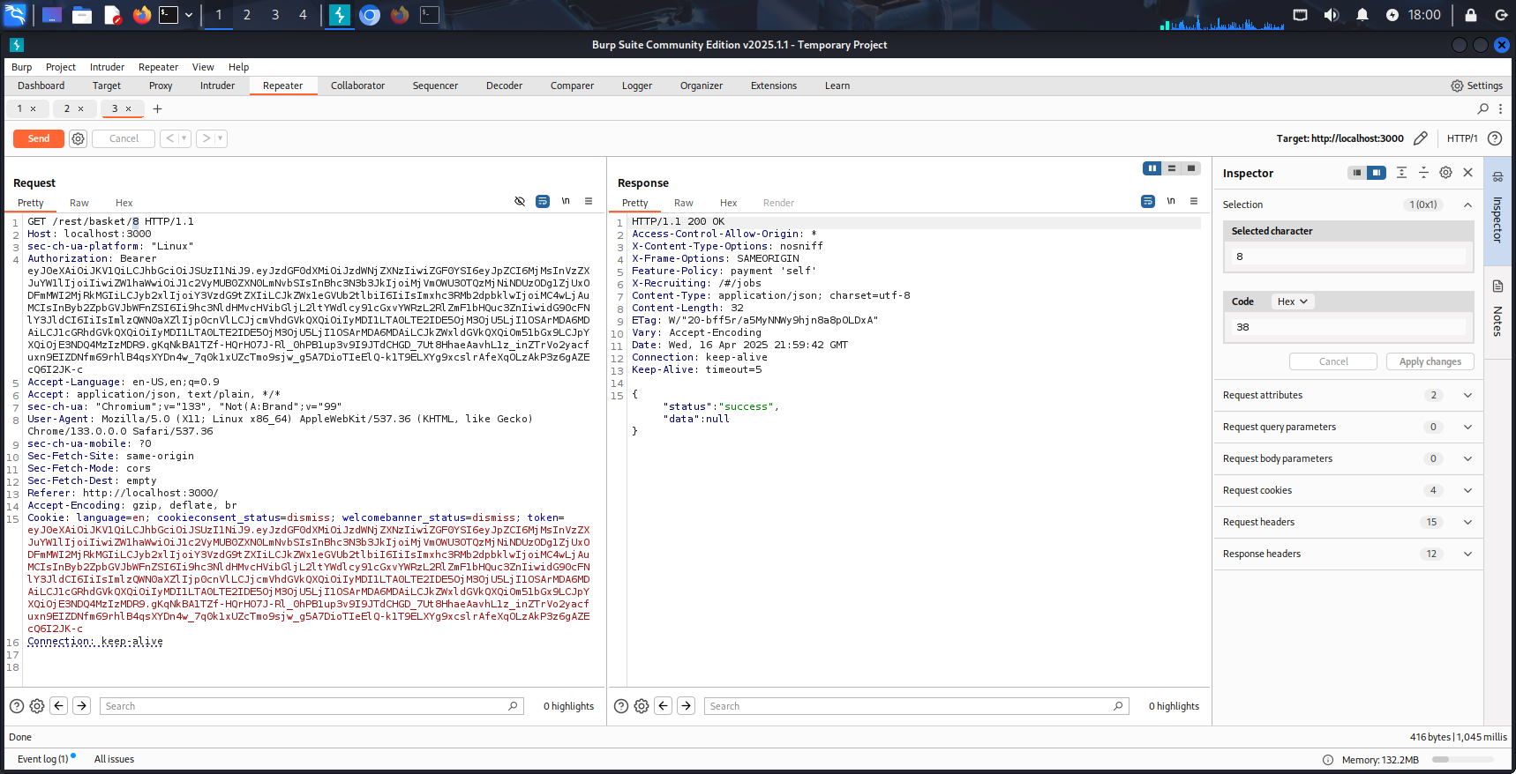

1. The server responded with the contents of **another user’s basket** without verifying that I had permission to access it.

**Impact**

An attacker can view the contents of **any user's basket** by modifying the ID parameter, exposing private information such as selected products and user behavior. This violates data confidentiality and, if combined with other vulnerabilities, may lead to **privilege escalation or full account compromise**.

**Remediation**

* Enforce server-side access control by verifying that the requesting user is the **owner of the basket** before returning its data.
* Never rely solely on client-supplied identifiers (like Basket ID) for authorization.
* Use the authenticated user’s session or token data to determine ownership on the backend.

**Poc**

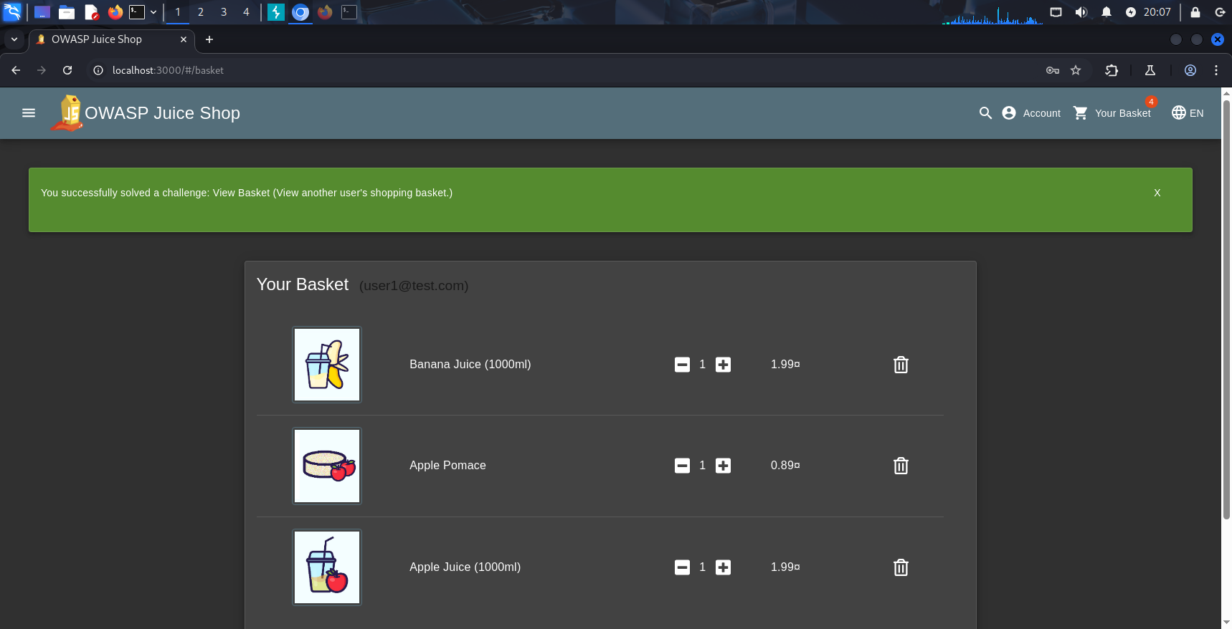

# Admin Section

**Severity: Critical**

**Description**

A **Broken Access Control** vulnerability exists in the "Admin Section" of OWASP Juice Shop. The application fails to enforce proper role-based access control, allowing any authenticated user to directly access the administrator dashboard by navigating to its known URL path, without validating whether the user has admin privileges.

**Affected Component**

GET /administration

**Steps to Reproduce**

1. Logged into the Juice Shop using a **standard (non-admin) user** account.
2. Manually accessed the admin panel by entering the URL directly in the browser:

https:// http://localhost:3000/#/administration

1. The server responded with HTTP 200 OK, and the full admin dashboard was rendered, despite the user having no admin privileges.
2. Admin-only functionalities like **user management**, **review control**, and **application settings** were accessible.

**Impact**

This vulnerability allows an attacker with any valid user account to escalate privileges and gain unauthorized **administrator-level access**. Potential consequences include:

* Viewing or modifying sensitive user data
* Managing product reviews
* Making configuration-level changes to the application
* Chaining with other vulnerabilities for deeper system compromise

This is a clear case of **Vertical Privilege Escalation**, and due to the extent of control gained, the severity is **Critical**.

**Remediation**

* Implement strict **role-based access control (RBAC)** on the backend to validate each request to /administration.
* Do not rely on frontend routing or visibility toggles to enforce access rights.
* Server-side logic should check the user's role from the session or token and **deny access** unless the role is explicitly admin.
* Return **HTTP 403 Forbidden** for unauthorized access attempts.

**Poc**

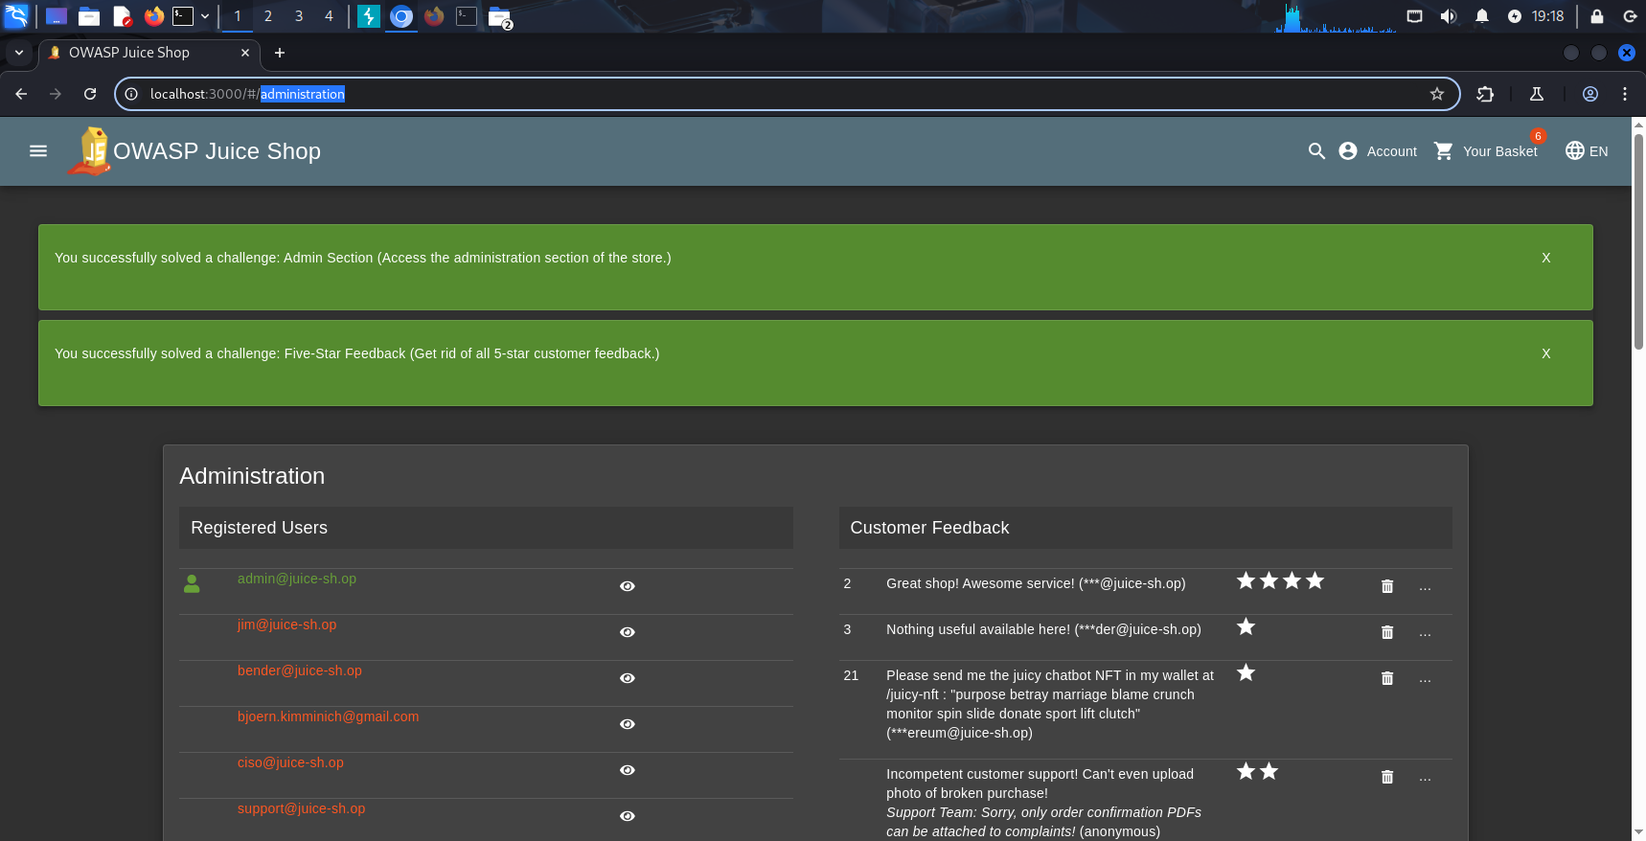

**Five-Star Feedback**

**Severity: Low**

**Description**

This vulnerability allows a user to **delete a 5-star customer feedback** by exploiting unauthorized access to the admin panel. Although this requires a prior Broken Access Control exploit (Admin Section challenge), the specific impact here is the ability to **remove positive ratings**, impacting product reputation and trust.

**Affected Component**

DELETE /api/Feedback/:id  
(via /administration dashboard)

**Steps to Reproduce**

1. First, exploited the **Admin Section** vulnerability by accessing:

https://juice-shop.example.com/administration

1. The admin dashboard loaded successfully without checking the user's role.
2. Navigated to the **Customer Feedbacks** section.
3. Identified a review with a **5-star rating**.
4. Clicked the trash icon next to it, which sent this request:

**Request:**

DELETE /api/Feedback/id HTTP/1.1

Host: localhost:3000

1. The server responded with HTTP 200 OK, and the review was deleted.

**Impact**

This allows any authenticated user (not just admins) to:

* Delete **positive product reviews**
* Manipulate the rating system
* Reduce trust and fairness in feedback visibility

Although this action depends on a prior privilege escalation, the vulnerability lies in the **lack of authorization checks** when deleting feedback.

**Remediation**

* Add **authorization middleware** to all feedback-related endpoints
* Validate user roles server-side before allowing deletion
* Log review deletions for audit and rollback purposes

# Poc

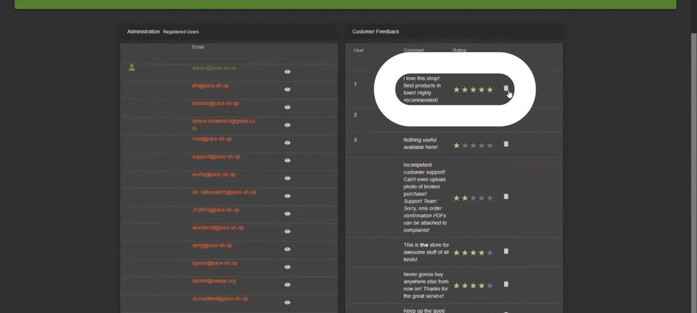

**Manipulate Basket**

**Severity: High**

**Description**

The application allows an authenticated user to manipulate another user's shopping basket by modifying the BasketId in a request. This happens due to missing server-side authorization checks, which should verify that the user has permission to modify the specified basket.

**Affected Component**

PUT /api/BasketItems/:id

**Steps to Reproduce**

1. Logged in as a normal user (e.g., user@example.com).
2. Opened **Burp Suite** and intercepted a request after adding a product to the basket. The following request was observed:
3. In Burp Suite, modified the BasketId in the request to a different value, assuming it belongs to another user.
4. Forwarded the following malicious request:

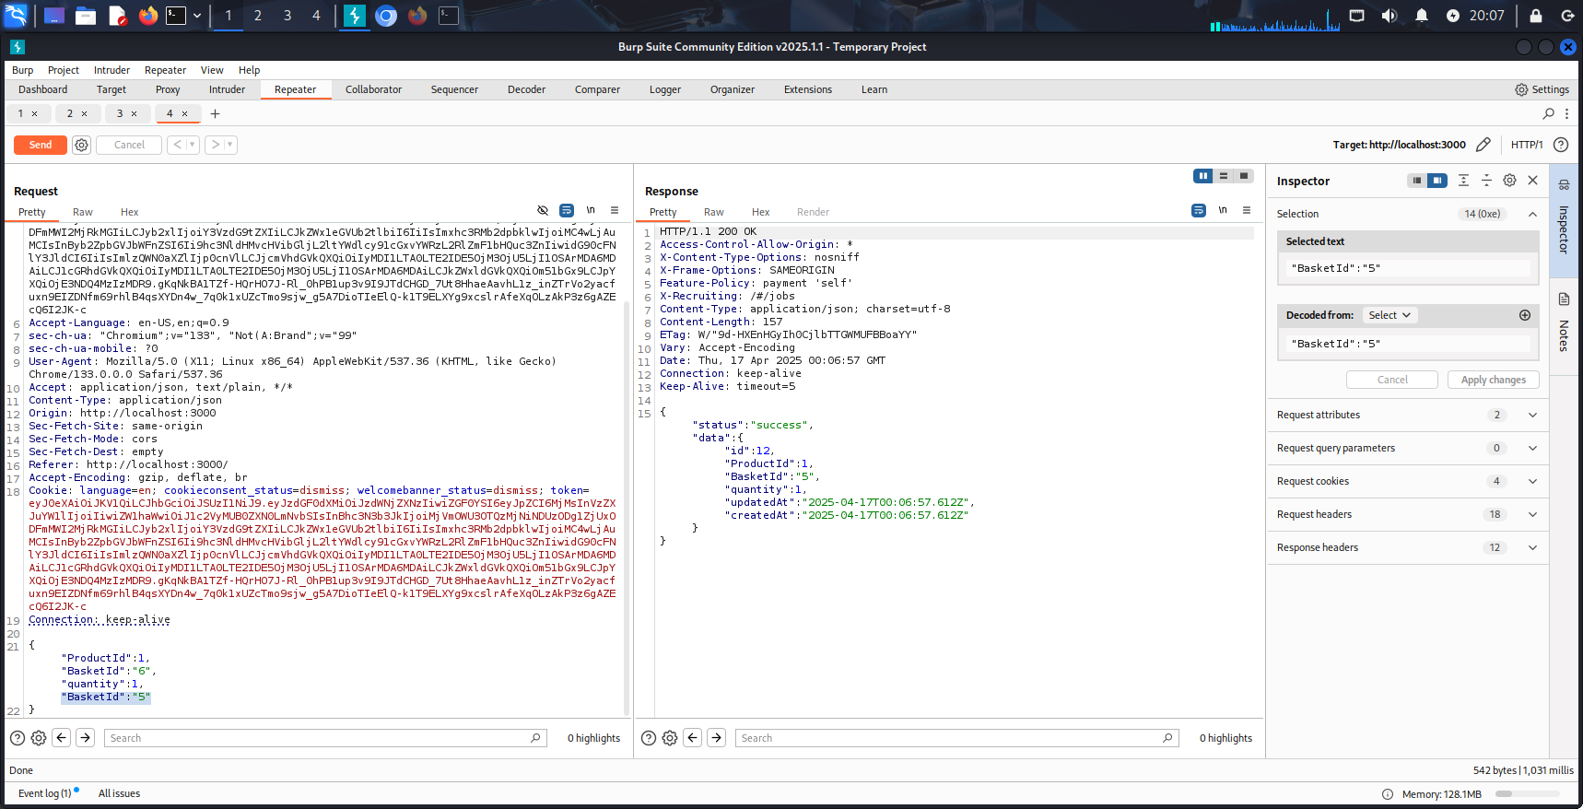

1. The server accepted the request and added the product to **another user’s basket**, without any ownership validation.

**Impact**

* An attacker can modify the contents of another user's shopping basket.
* This could lead to:
  + Confusion or disruption of purchases.
  + Abuse of discounts or promotions.
  + Potential fraudulent behavior or customer manipulation.
* It represents a clear violation of **data integrity** and **access control** principles.

**Remediation**

* The server should enforce **strict ownership checks** for any operation on baskets.
* The BasketId should not be trusted from the client side.
* The server should derive the basket based on the authenticated user's session or token, not from user input.
* Implement proper **authorization middleware** and log suspicious activity.

# Poc

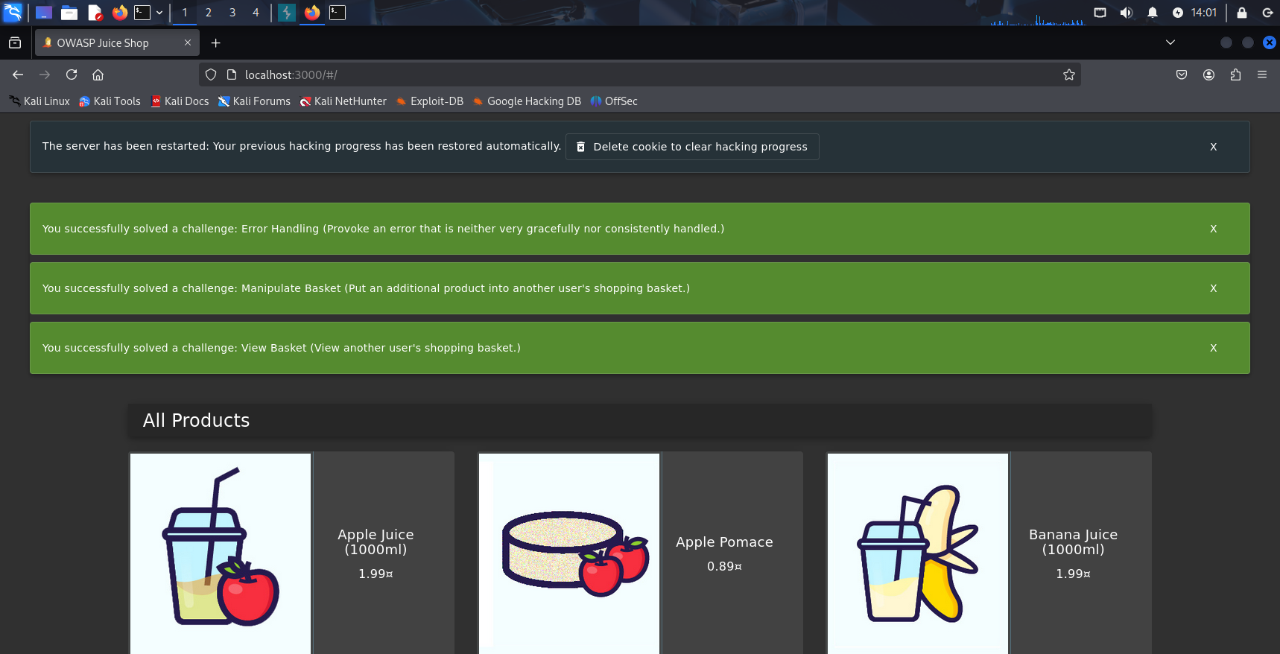

**Forged Feedback**

**Severity: Medium**

**Description**

The application allows users to submit feedback that appears to be from another user by tampering with a hidden userId field in the client-side HTML form. Since the server **does not validate that the userId matches the authenticated user**, this allows attackers to forge feedback in the name of any other user, including admin accounts.

**Affected Component**

POST /api/Feedbacks

**Steps to Reproduce**

1. Logged in as a normal user (e.g., user@example.com).
2. Navigated to the "Customer Feedback" page and opened **Developer Tools (F12)** to inspect the form.
3. Observed a hidden input field in the form:

html

<input "hidden" id="userId" >

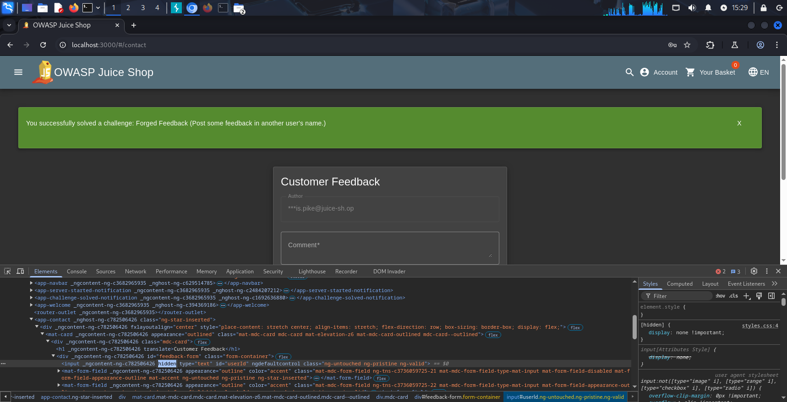

1. Changed the value of userId to 1, which corresponds to the admin user (or another known user ID), directly in the browser using the **Elements** tab or by intercepting the request in **Burp Suite**.
2. Submitted the form with a feedback message. The resulting request looked like:

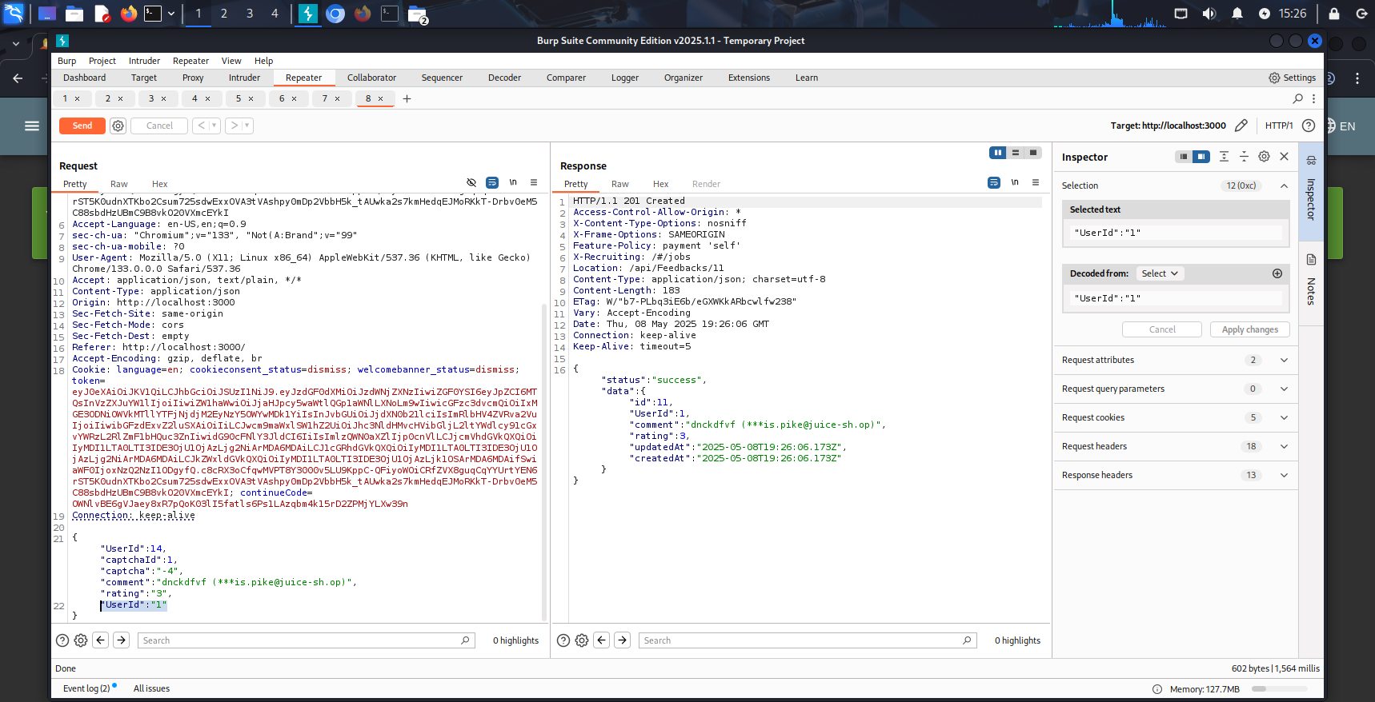

1. The server accepted the request and the feedback appeared to be submitted by user ID 1.

**Impact**

* An attacker can impersonate other users by submitting feedback on their behalf.
* This breaks **authentication integrity** and can:
  + Falsely attribute statements to trusted users (e.g., admins).
  + Damage reputation or create misleading trust signals.
  + Be used for social engineering or internal manipulation.

**Remediation**

* Remove the userId field from the client side entirely.
* Derive the userId on the server side from the authenticated session or JWT token.
* Implement strict server-side validation to reject any userId mismatch between the token and request body.

**Poc**



**Forged Review**

**Severity: Medium**

**Description:**

The application allows users to submit product reviews. However, it does not properly validate or restrict the message and author fields in the request body. This enables an attacker to **forge reviews using any author name**, including impersonating other users or administrators, thus violating trust and allowing manipulation of public-facing content.

**Affected Component:**

POST /api/ProductReviews

**Steps to Reproduce:**

1. Logged in as a normal user (e.g., user@juice-sh.op).
2. Opened a product page and used **Burp Suite** or browser developer tools to intercept the **review submission request**.
3. Modified the JSON request body before it was sent:

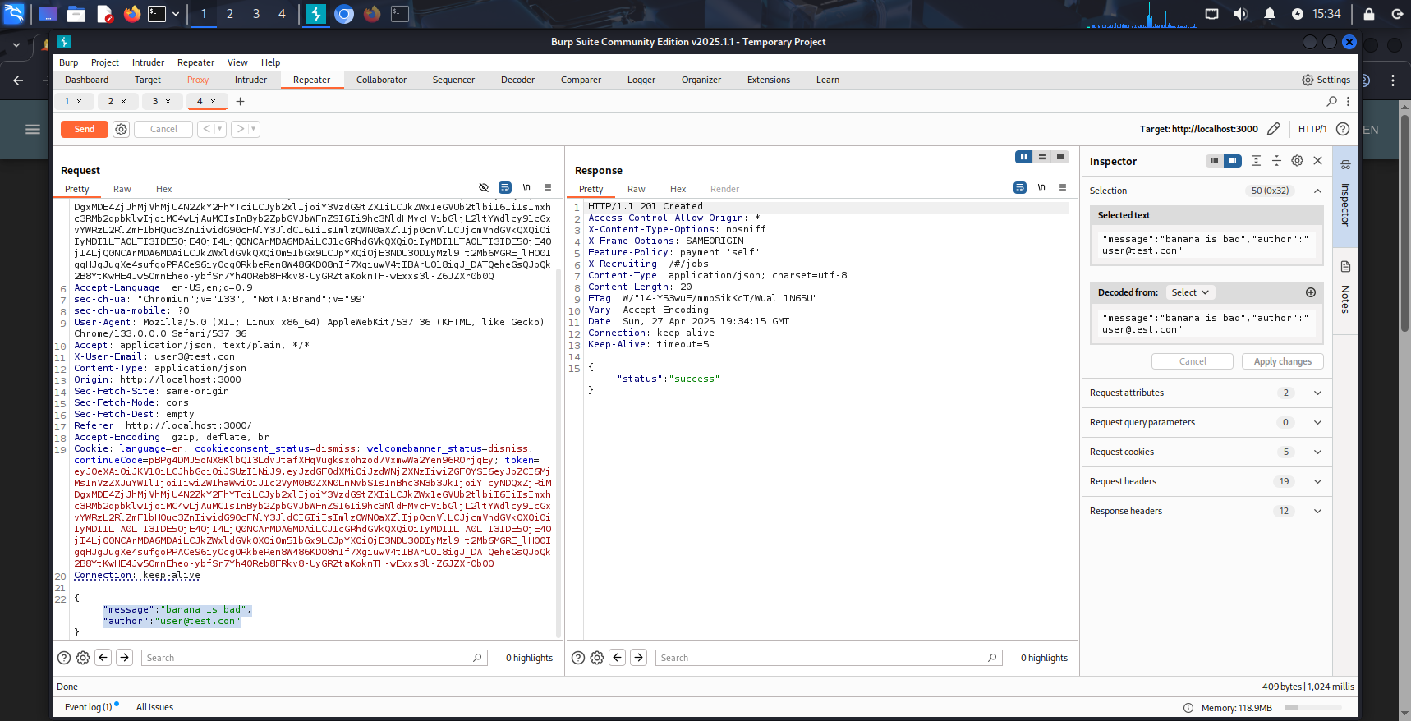

1. Sent the modified request to the server.
2. The review was successfully posted, **displaying the author name as "admin"**, even though the logged-in user was not admin.

**Impact:**

* **Impersonation**: Users can post content under any name, potentially impersonating admins or other users.
* **Reputation manipulation**: Attackers can forge positive or negative reviews to manipulate product trust.
* **No server-side validation**: Indicates lack of integrity controls for critical user-generated content.

**Remediation:**

* Remove author as a user-controllable field; derive it from the authenticated session.
* Sanitize and validate all user input on the server side.
* Log and monitor unusual review activity (e.g., many reviews from the same IP).

# Poc



# 3- Broken authentication:

**( Bjoern's Favorite Pet )**

Severity:  
Medium (unauthorized password reset due to weak authentication controls)

Description:  
Broken Authentication occurs when an application fails to adequately protect user credentials, allowing unauthorized password resets. In OWASP Juice Shop, the Forgot Password mechanism for Bjoern's account ([bjoern@owasp.org](mailto:bjoern@owasp.org)) is vulnerable due to insufficient validation of security question answers. By researching publicly available information, specifically identifying Bjoern's favorite pet as "zaya" from a related video, an attacker can reset his password without proper authentication, completing the "Bjoern's Favorite Pet" challenge.

Affected Component:  
Forgot Password endpoint  
/forgot-password  
The endpoint does not enforce strong authentication or restrict access to security question answers, enabling password resets with easily obtainable information.

Steps to Reproduce (in OWASP Juice Shop):

1. Navigate to the Forgot Password page:  
   http://localhost:3000/#/forgot-password
2. Enter Bjoern's email address: bjoern@owasp.org.
3. Search for information about Bjoern, discovering from a video that his favorite pet is "zaya," which is the required answer for his security question.
4. Submit the Forgot Password request with the email and answer "zaya" to the security question.
5. Receive a password reset token or confirmation, allowing the attacker to set a new password for Bjoern's account.
6. The challenge is marked as solved: "You successfully solved a challenge: Bjoern's Favorite Pet."

Impact:  
• Unauthorized access to Bjoern's account due to weak authentication controls.  
• Exposure of account takeover risks if security questions are publicly deducible.  
• Potential compromise of other user accounts with similar weak authentication mechanisms.  
• Undermines trust in the password recovery process, affecting overall security.

Remediation:  
• Implement multi-factor authentication (MFA) for password reset requests to enhance security.  
• Use complex, non-publicly derivable security questions or replace them with alternative verification methods.  
• Enforce strict validation of security question answers, requiring additional proof of identity.  
• Monitor and log password reset attempts to detect and block suspicious activity.  
• Regularly audit the Forgot Password mechanism to ensure robust authentication controls.

Submitting the request with Bjoern's email and the security question answer "zaya" allows a password reset, exploiting the weak authentication and completing the "Bjoern's Favorite Pet" challenge.

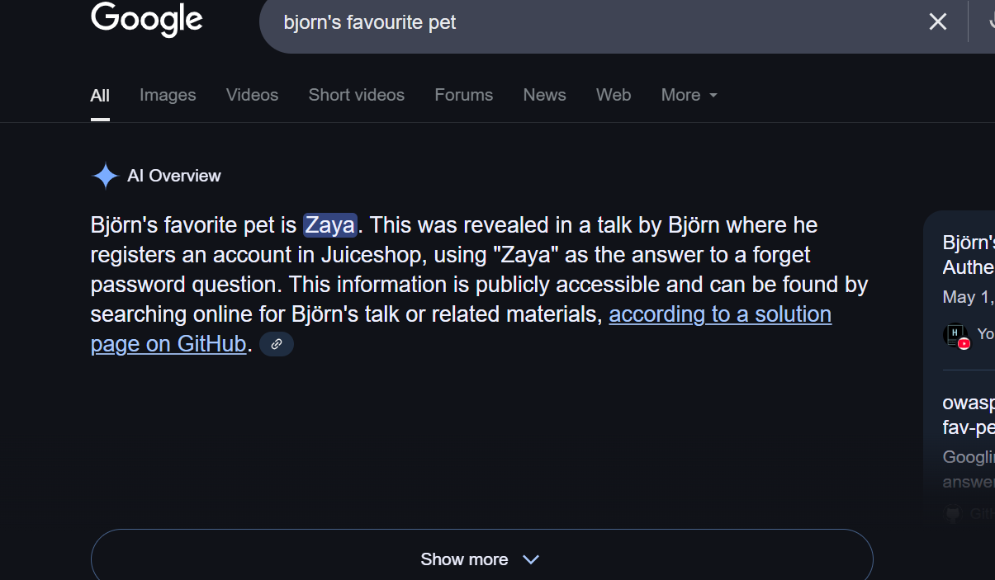

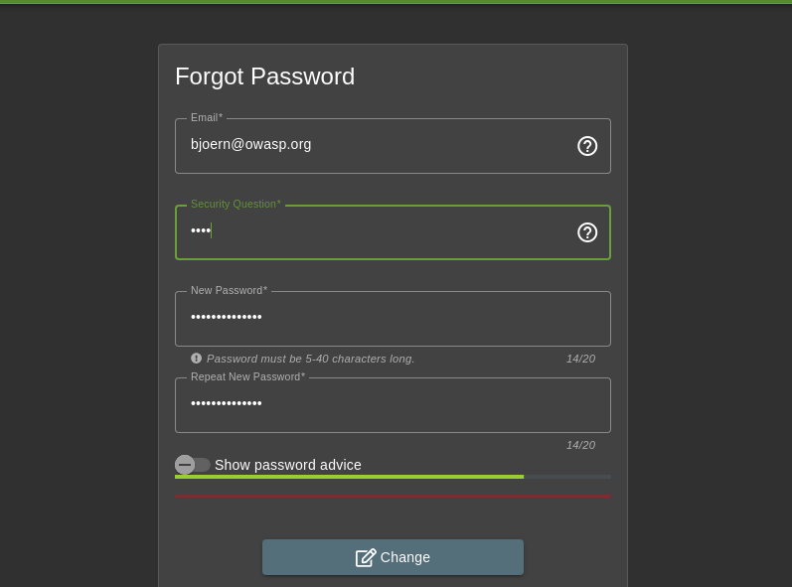

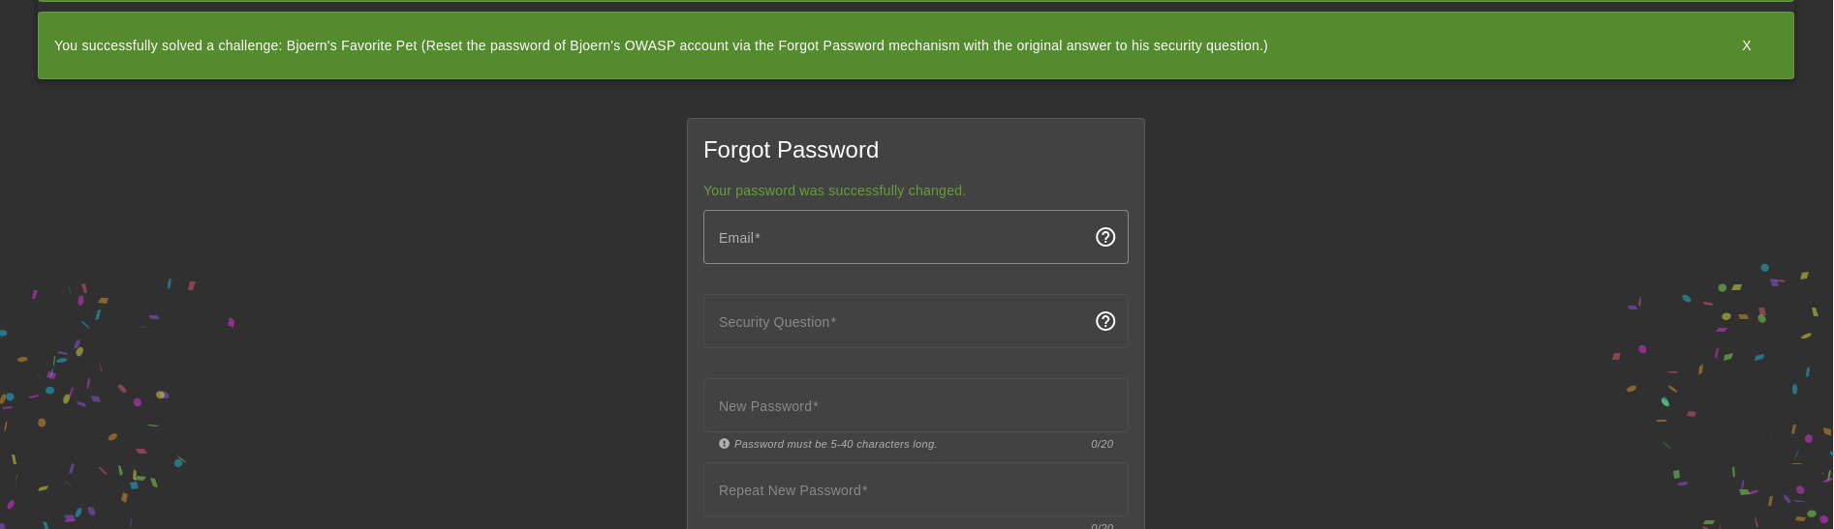

**Change Bender's password into slurmCl4ssic without using SQL Injection or Forgot Password**

**Severity:** High  
**Description:**  
The application allows authenticated users to change the password of their own account without verifying the current password. This weakness can be exploited to change the password of any known user by manipulating the password change request. In this case, the attacker successfully changed the password for the user bender@juice-sh.op without knowing the original password, resulting in full account takeover.

**Affected Component:**  
/api/Users/change-password – Password change endpoint

**Steps to Reproduce:**

1. Logged in with a low-privileged user account.
2. Navigated to the "Change Password" form and intercepted the request using Burp Suite.
3. Observed the following request structure:

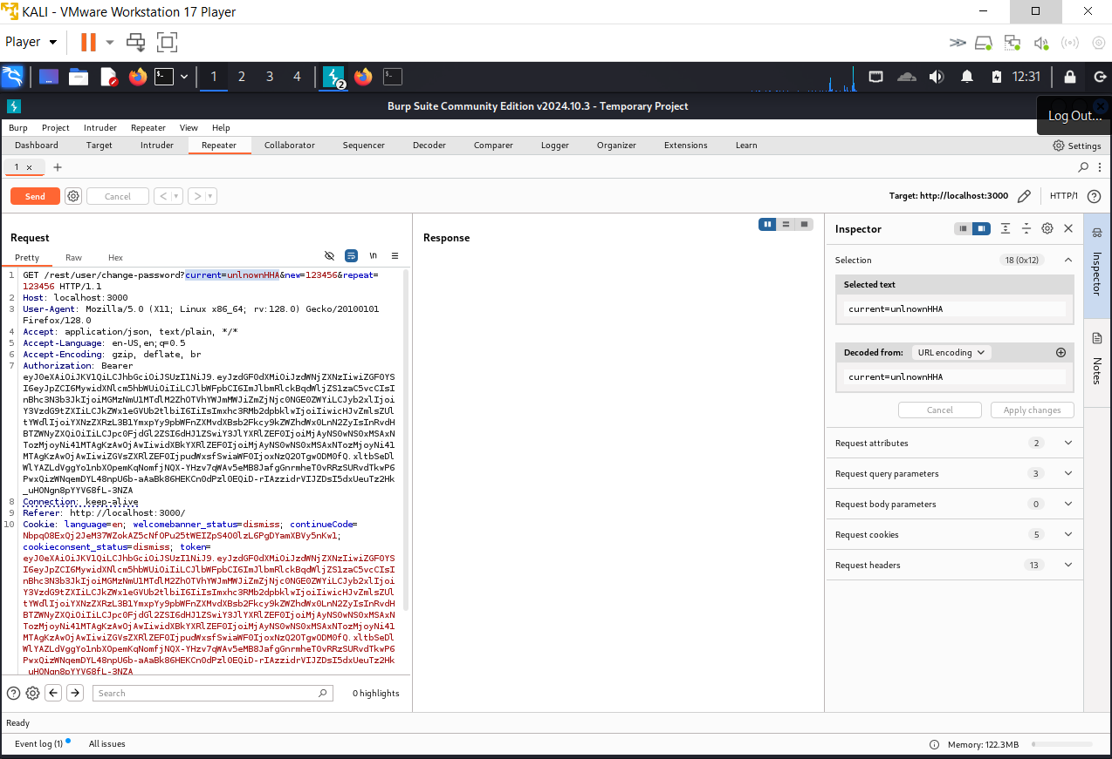

4 - Removed the "current" password field entirely and modified the "new" field to:

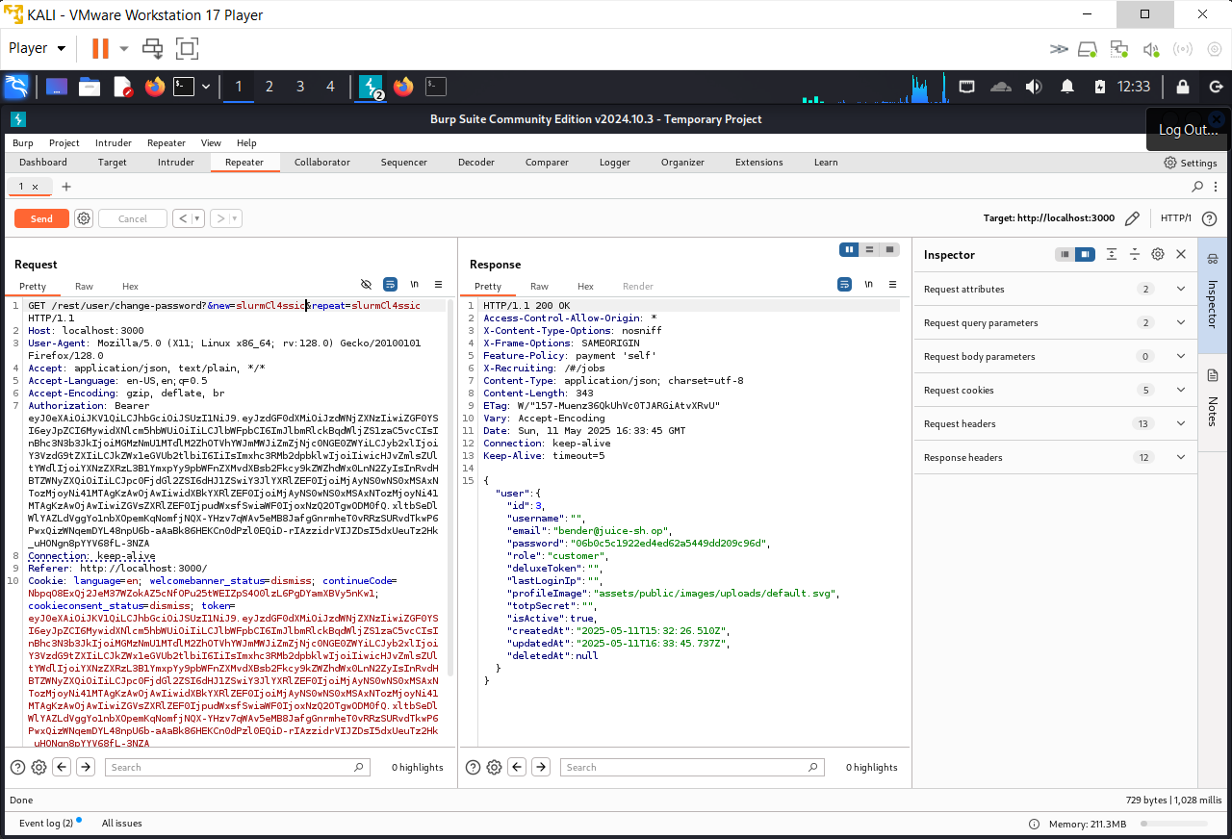

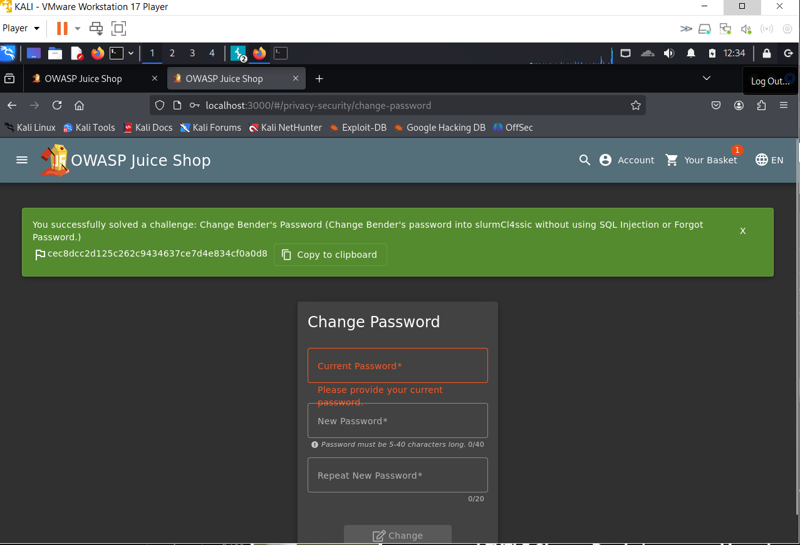

**Reset Jim password**

**Severity:** High  
**Description:**  
The application’s password reset functionality lacks sufficient security controls, allowing an attacker to reset another user's password by answering a weakly protected security question. In this case, the attacker was able to discover the target user's email from public reviews and social interactions, and then find the answer to the security question via basic online reconnaissance. This enables full account takeover without needing access to the original password.

**Affected Component:**  
/reset-password – Password reset mechanism

**Steps to Reproduce:**

1. Discovered the target user’s email (jim@juice-sh.op) through public review comments and interactions.
2. Noticed a comment from the user referencing a specific movie, leading to the assumption that security questions might be guessable based on public content.
3. Initiated a password reset process on the site and was prompted with the security question:  
   *“What is the eldest sibling’s middle name?”*
4. Searched the question’s answer using open-source intelligence (OSINT), specifically Google, and successfully identified the correct answer by combining details from reviews and public records.
5. Submitted the answer, reset the password, and gained unauthorized access to the user’s account.

PoC :

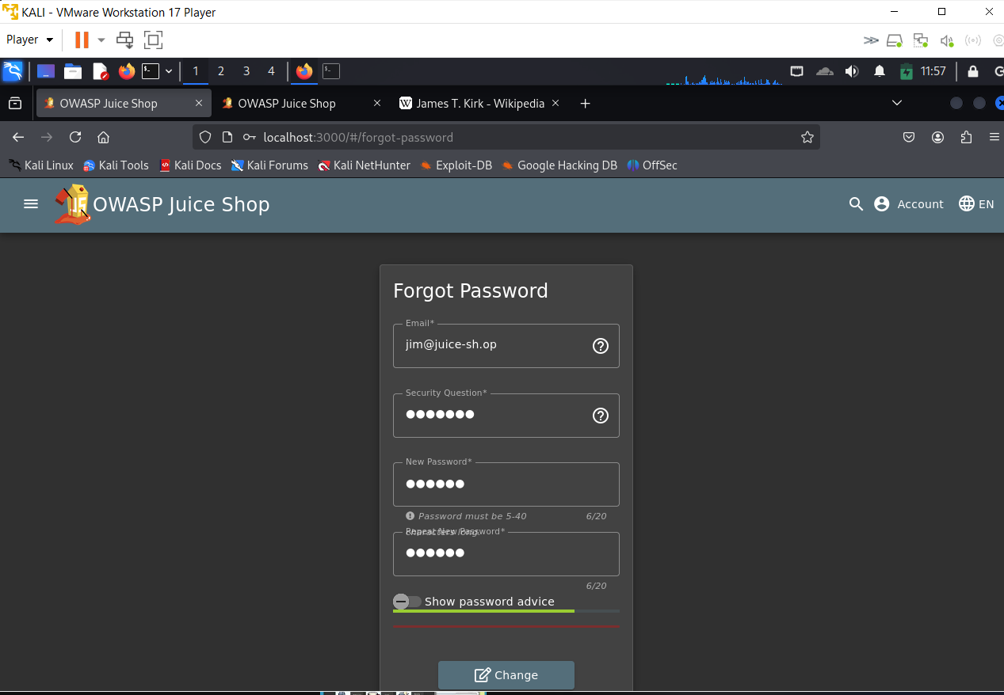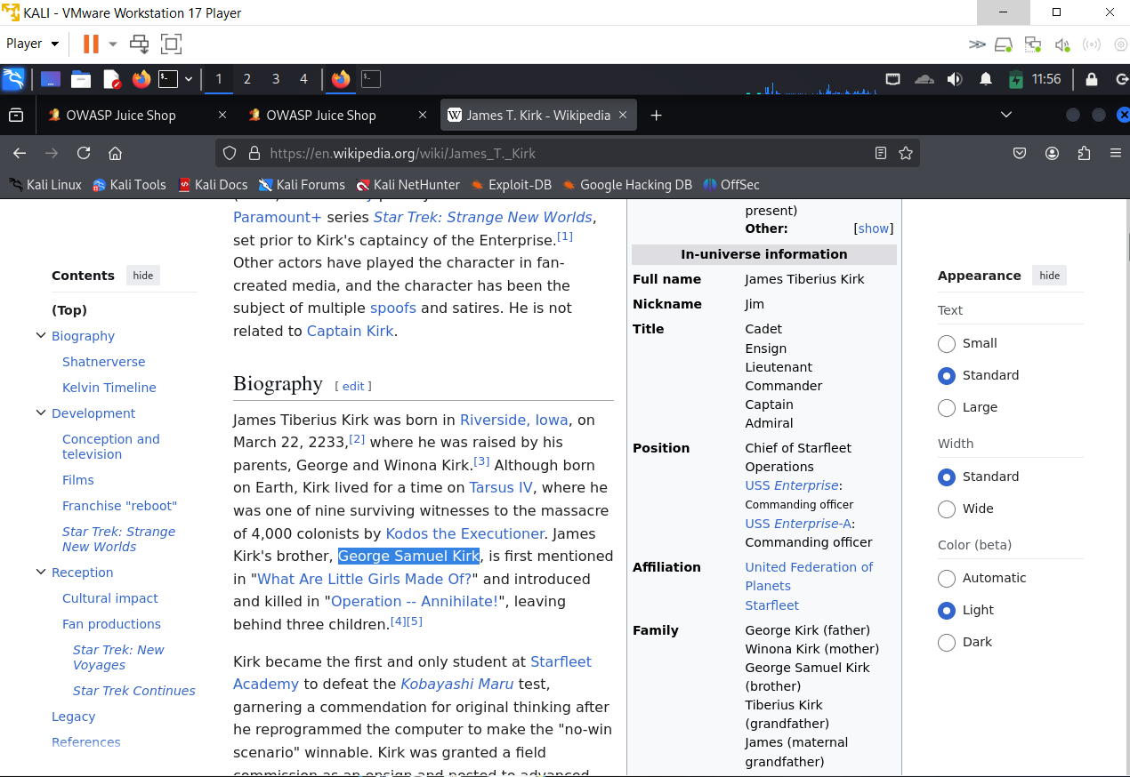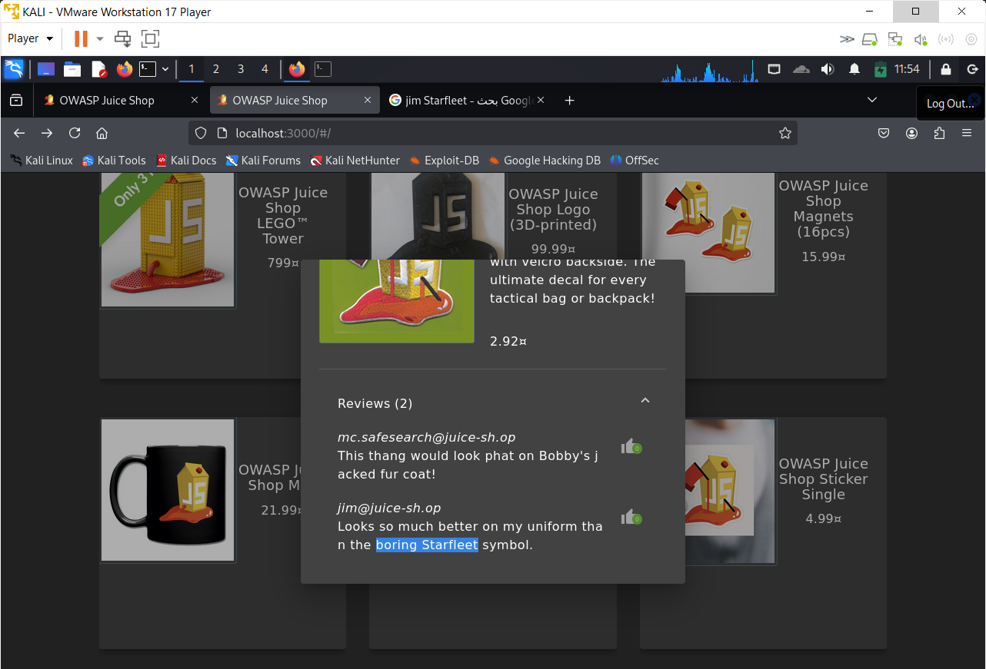

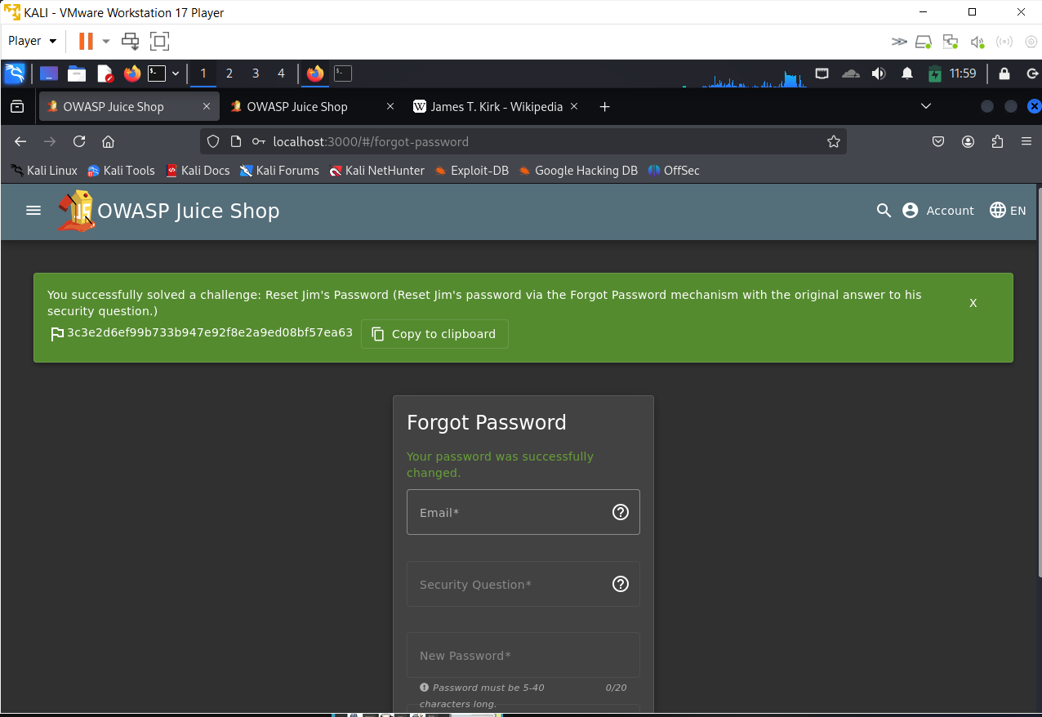

**Password Strength & Login Admin**

**Severity: High**

**Description:**

The login form of the application does not implement protection mechanisms against brute-force attacks. Combined with the fact that the **administrator account uses a weak default password**, this allows attackers to perform credential stuffing using common password lists to successfully gain administrative access.

**Affected Component:**

/login form – authentication endpoint

**Steps to Reproduce:**

1. Identified the admin email (admin@juice-sh.op) from a previous challenge (recon via comments/posts).
2. Opened Burp Suite and captured a valid login request with the known email.
3. Sent the request to **Intruder**, configured it to **fuzz the password field** using the payload list from:

Daniel Miessler’s SecLists:

passwords/common-credentials/best1050.txt

(https://github.com/danielmiessler/SecLists)

1. Started the attack.

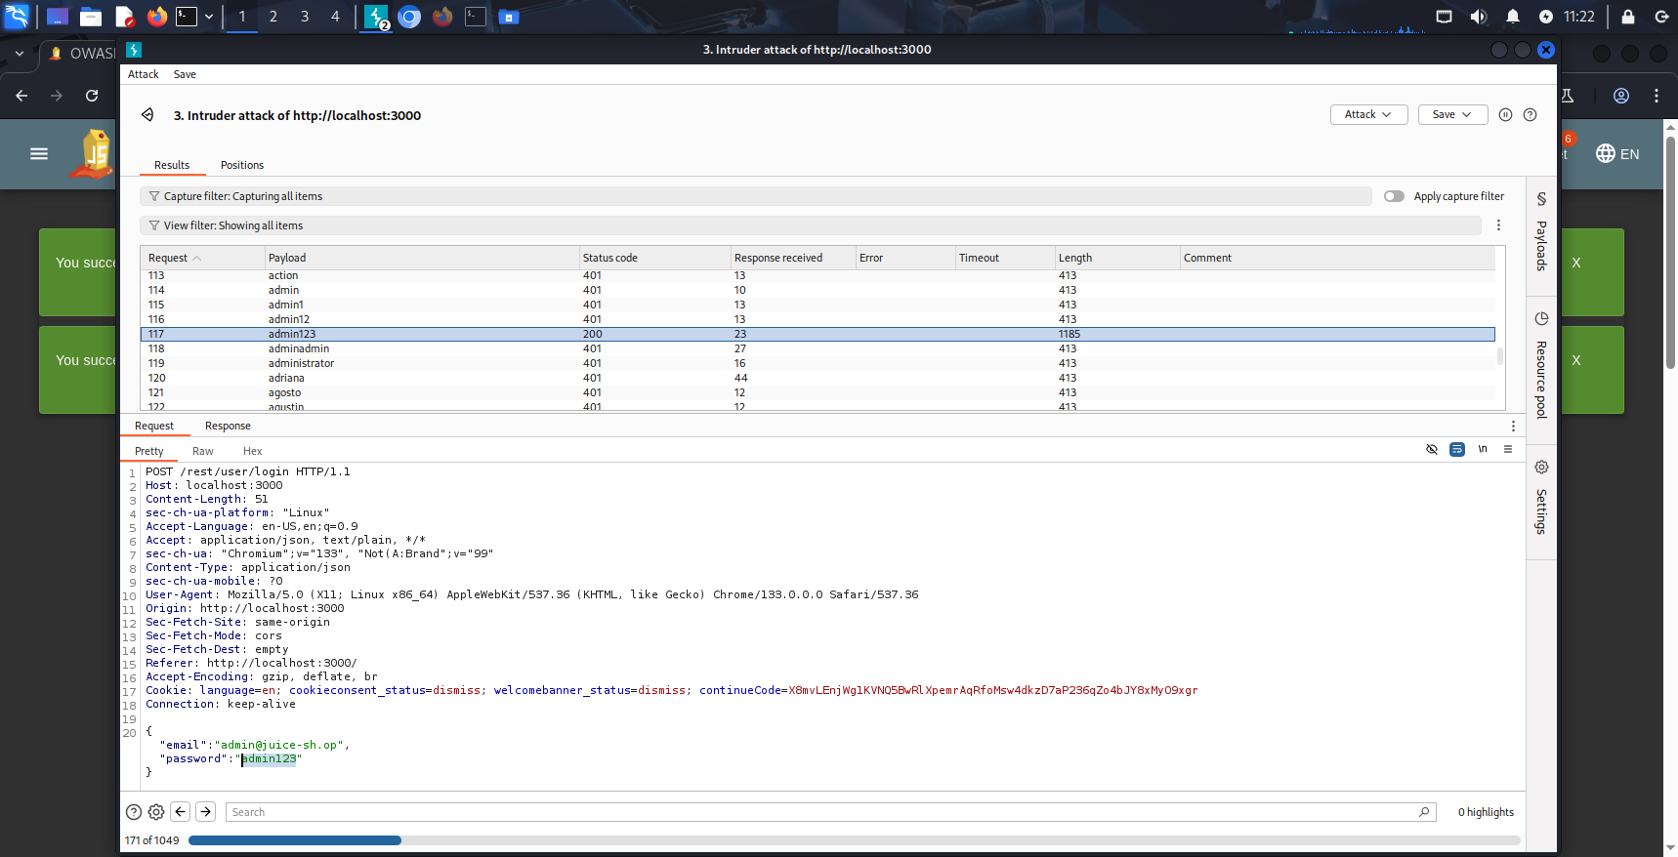

1. One of the requests received a **200 OK** response with an authentication token in the body, indicating a successful login.
2. Verified that the login led to the **admin dashboard**, confirming full compromise.

**Impact:**

* **Full administrative access** to the application without needing to exploit any injection or misconfiguration.
* Enables the attacker to:
  + View and delete user data.
  + Access internal functions (e.g., feedback management, user roles).
  + Perform lateral movement within the app or infrastructure.

**Remediation:**

* Enforce **strong passwords** for all privileged accounts.
* Implement **rate limiting, CAPTCHA**, and **account lockout mechanisms** after multiple failed login attempts.
* Monitor for brute-force behavior and alert on anomalies.

**Poc**

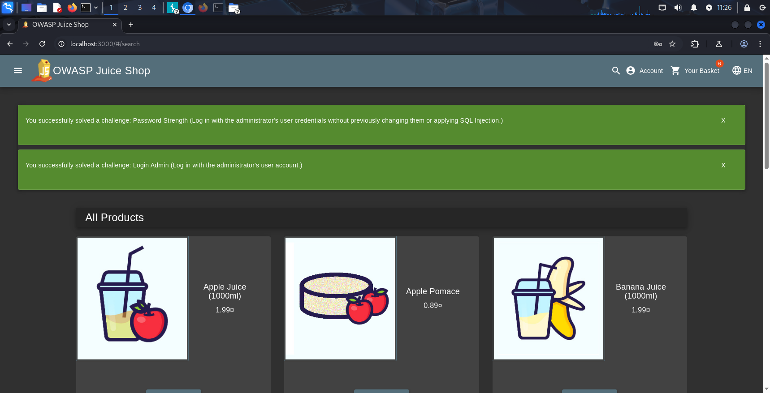

**GDPR – Data Erasure**

**Severity: High**

**Description:**

A previously registered user identified by email chris.pike@juice-sh.op is still **retrievable through SQL Injection**, even though the account is **marked as deleted** via the deletedAt field. This proves the system does **not fully erase or anonymize user data** in accordance with GDPR Article 17 (Right to erasure / right to be forgotten).

**Steps to Reproduce:**

1. Challenge solved: Database Schema.
2. Authenticated as a valid user.
3. Performed SQL Injection via:

GET /rest/products/search?q=banana')) UNION SELECT deletedAt, username, email, 4,5,6,7,8,9 FROM Users--

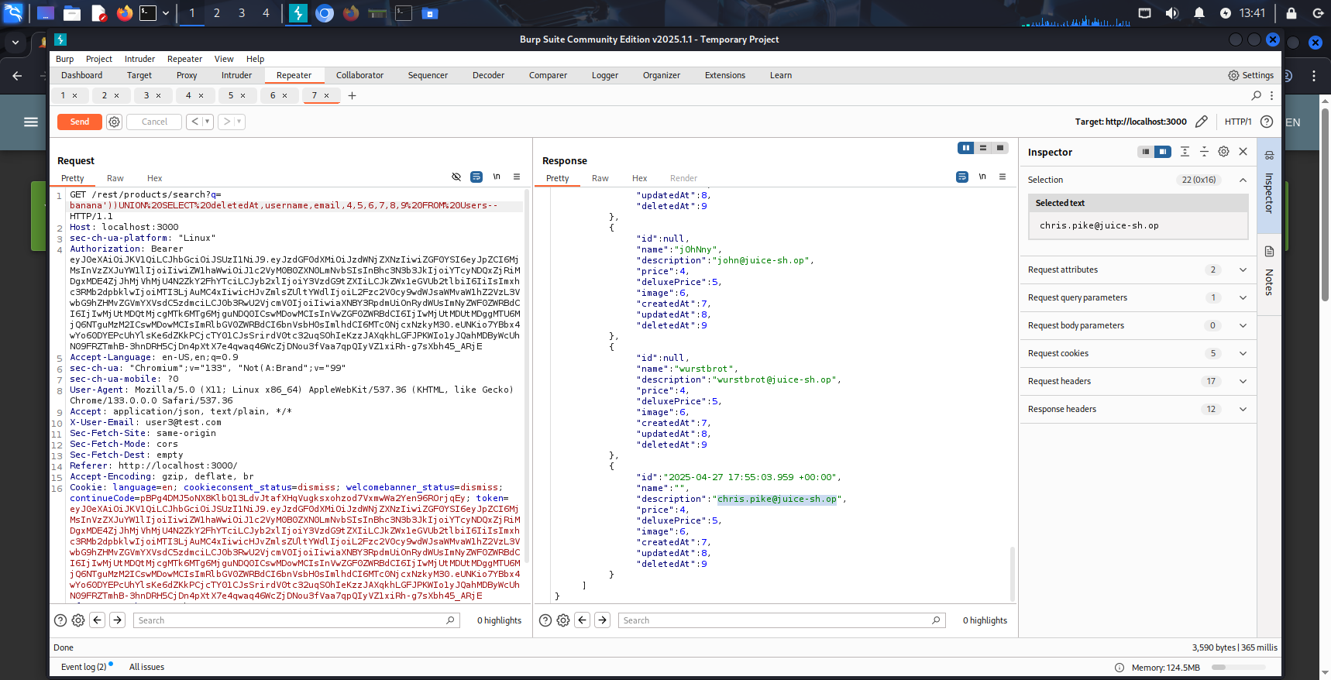

**Impact:**

* The user chris.pike is marked as deleted but their **personally identifiable information (PII)** remains accessible.
* Violates **GDPR Article 17**, putting the organization at legal risk.
* An attacker can enumerate and expose deleted users’ data.
* Users lose trust in the platform's privacy guarantees.

**Remediation:**

1. **Fully anonymize** or **delete** user data from all accessible sources when deletedAt is set.
2. Apply **logical deletion protection** in API layer to exclude such records by default.
3. Enforce **row-level access control** or **post-query filters** based on deletedAt IS NULL.
4. Regular audits to detect presence of deleted user data in logs, caches, and API responses.

**Poc**

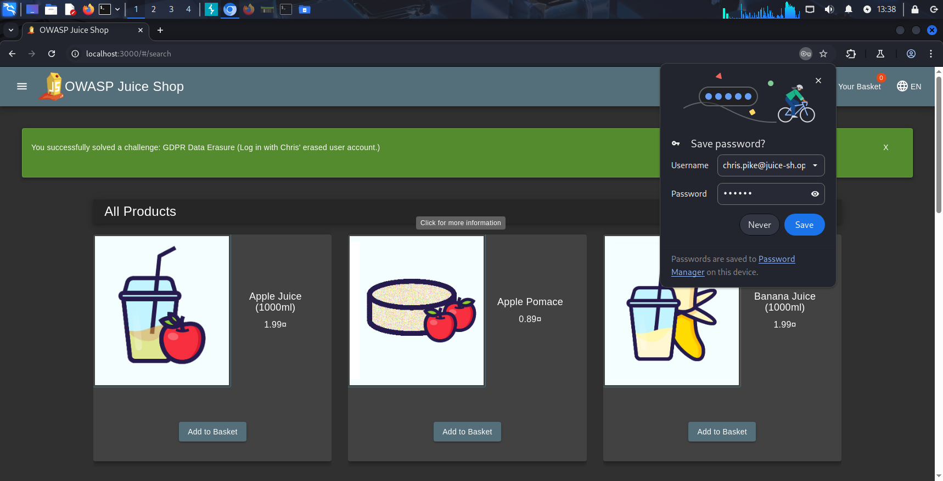

# 4- Security Misconfiguration:

**( Deprecated Interface):**

**Severity**: Medium (potential for unauthorized file uploads leading to further exploitation)

**Description**:  
A Security Misconfiguration vulnerability exists in OWASP Juice Shop's complaint section, where the file upload feature uses a deprecated interface. The UI restricts uploads to PDF and ZIP files, but the backend accepts XML files due to a misconfiguration in the validation logic. This discrepancy allows attackers to upload potentially malicious XML files, which could lead to XML External Entity (XXE) attacks or other exploits, completing the "Deprecated Interface" challenge.

**Affected Component**:

* **Complaint Section File Upload**: The file upload feature in the complaint section (/complaints) improperly validates file types, allowing XML files despite UI restrictions.

**Steps to Reproduce (in OWASP Juice Shop)**:

1. Navigate to the "Complaint" section at http://localhost:3000/#/complain.
2. Enter a customer email (e.g., vvc@gmail.com) and a message (e.g., "fgd").
3. Attempt to upload a file by clicking "Choose File" in the "Invoice" section.
4. Observe the file picker dialog, which indicates only PDF and ZIP files are allowed (e.g., dropdown shows "PDF (*.pdf)" and "ZIP (*.zip)").
5. Inspect the page source code by right-clicking and selecting "Inspect" or using a browser's developer tools (e.g., Chrome DevTools).
6. Locate the JavaScript file (e.g., main.js) and search for file upload validation logic.
7. Identify that the backend accepts XML files (e.g., application/xml is listed in the accepted MIME types alongside application/pdf and application/zip).
8. Create or select an XML file (e.g., test.xml) and attempt to upload it by selecting "All Files" in the file picker and choosing the XML file.
9. Submit the complaint by clicking "Submit".
10. Observe the success message: "You successfully solved a challenge: Deprecated Interface (Use a deprecated B2B interface that was not properly shut down.)", confirming the XML file was accepted.

**Impact**:

* Bypassing file type restrictions allows attackers to upload XML files, which could be exploited for XML External Entity (XXE) attacks, potentially leading to data exfiltration or server-side request forgery (SSRF).
* Use of a deprecated interface increases the attack surface, as outdated components may have unpatched vulnerabilities.
* Potential for further exploitation if uploaded XML files are processed unsafely by the backend.
* Violation of secure file upload best practices, undermining user trust and application integrity.

**Remediation**:

* Enforce strict file type validation on the backend to match the UI restrictions (e.g., only allow application/pdf and application/zip MIME types).
* Disable or remove deprecated interfaces (e.g., B2B interface accepting XML) that are no longer in use.
* Implement a whitelist for allowed file extensions and MIME types, rejecting all others.
* Sanitize and validate uploaded files to prevent processing of potentially malicious content (e.g., disable XML entity parsing to mitigate XXE risks).
* Regularly audit file upload mechanisms and deprecated components to ensure compliance with security best practices.

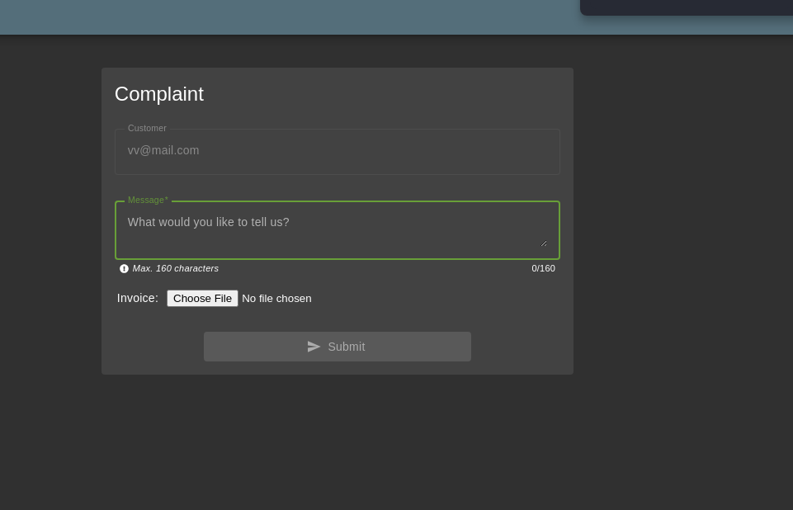

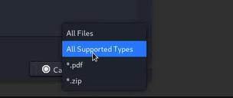

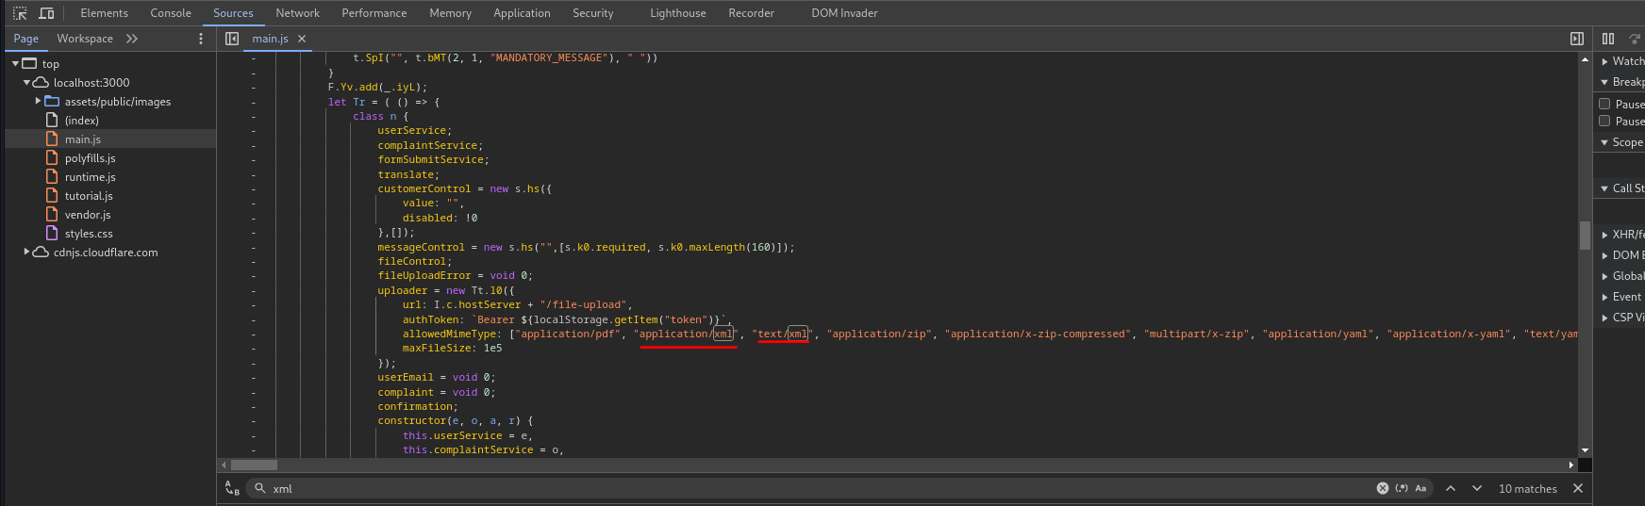

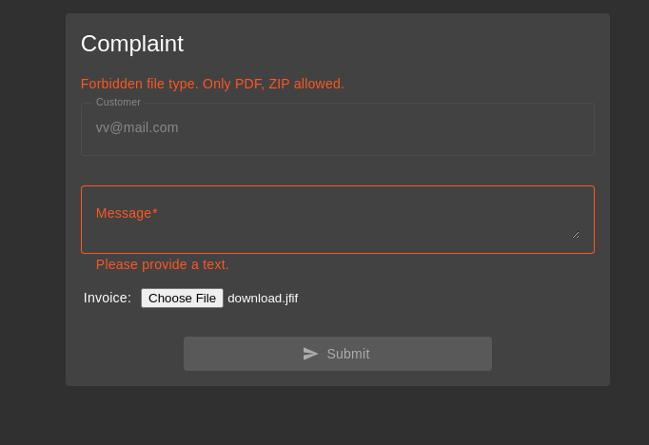

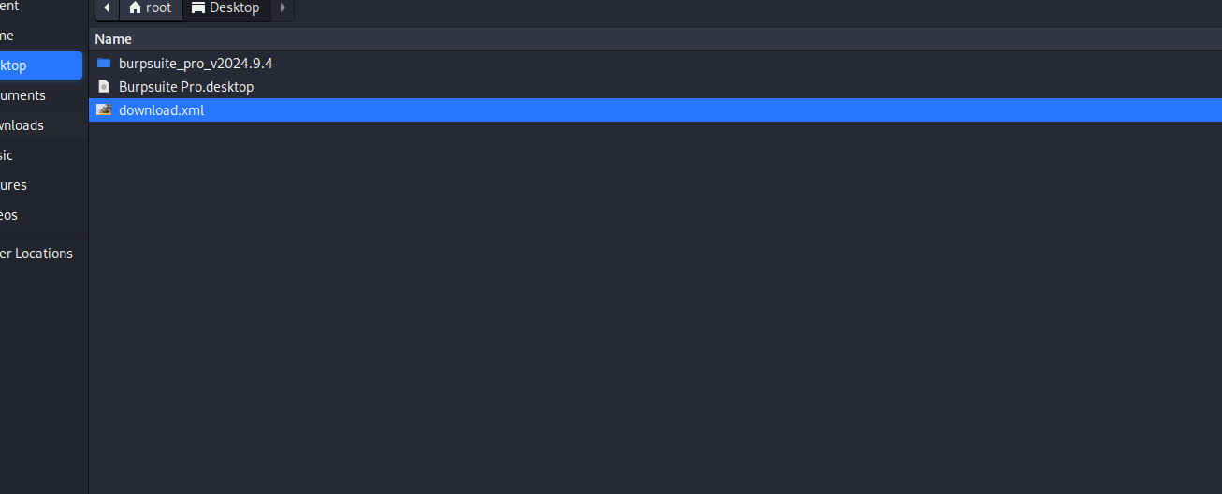

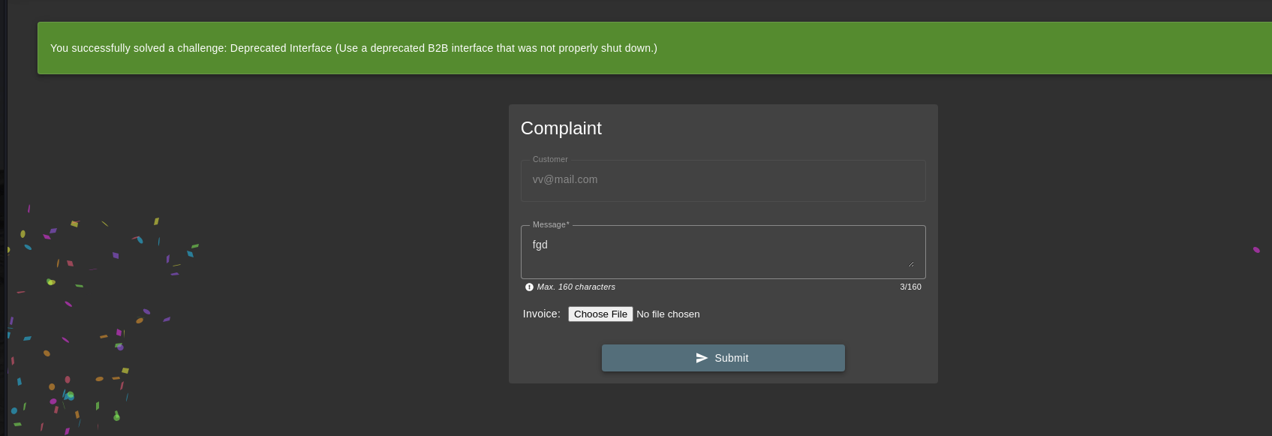

# Error Handling

**Severity: Medium**

**Description:**

The application reveals **detailed error messages** containing stack traces and internal implementation details when certain invalid requests are made. This information can be used by an attacker to **enumerate backend technologies**, understand business logic, and **identify potential entry points** for further exploitation.

**Affected Component:**

Multiple endpoints – error responses when sending malformed requests or triggering edge cases

**Steps to Reproduce:**

1. Send the following HTTP request:

GET /rest/anything HTTP/1.1

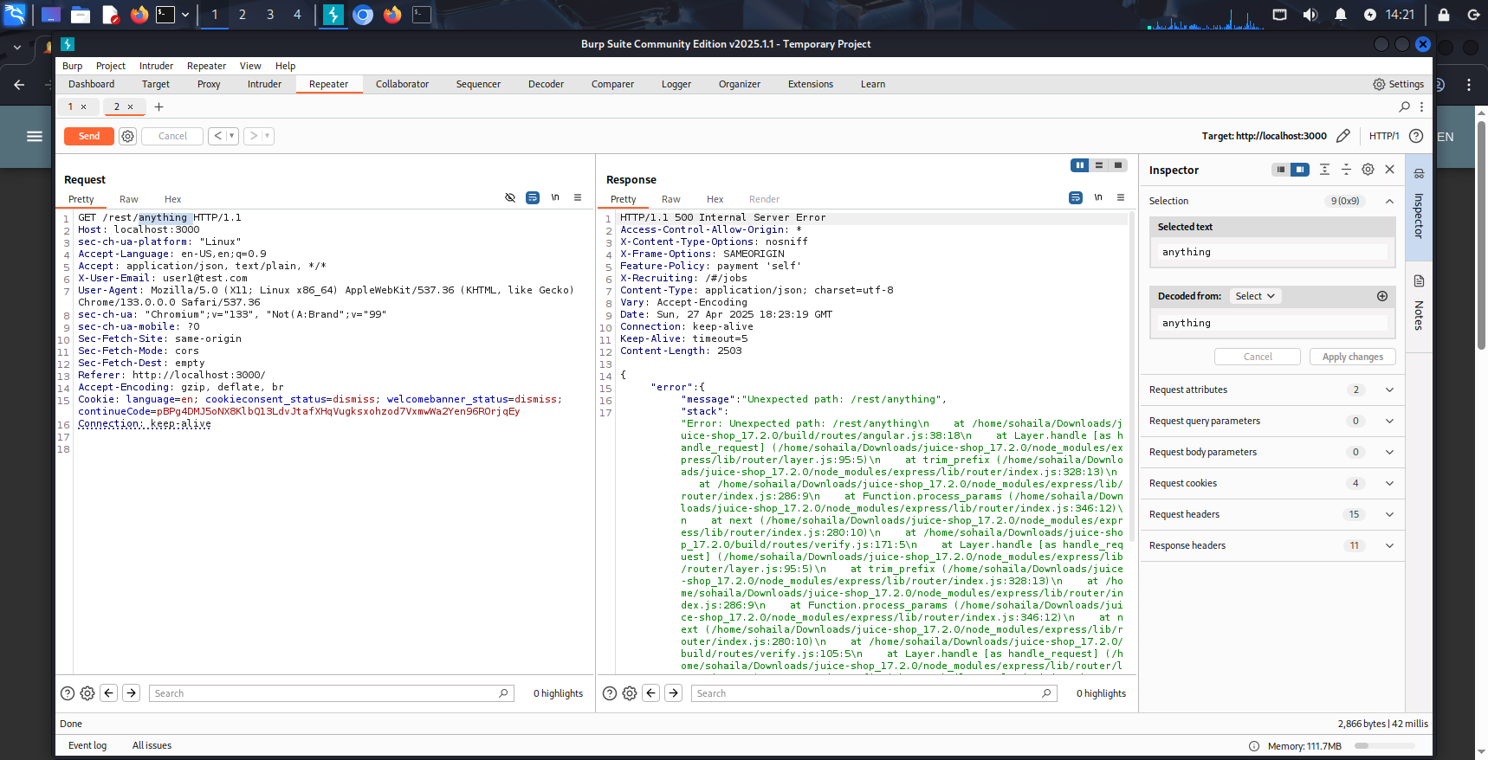

1. The application responded with a **500 Internal Server Error** and displayed a **stack trace** showing:
   * Internal class names
   * File paths
   * Node.js error messages
   * Possibly database errors (in some cases)
2. This confirmed the app does not properly sanitize or suppress internal errors.

**Impact:**

* Provides **insight into the backend stack**, including libraries, error types, and file structure.
* Can assist attackers in crafting targeted attacks (e.g., exploiting known vulnerabilities in specific packages).
* May expose sensitive logic or misconfigurations.

**Remediation:**

* Implement **generic error messages** for users (e.g., “An unexpected error occurred”).
* Log technical error details **server-side only**, not in client responses.
* Ensure error handling uses proper try/catch mechanisms and middleware to mask implementation details.

**Poc**



# 5 – CSRF

**Severity:** High  
**Description:**  
The /profile endpoint is vulnerable to Cross-Site Request Forgery (CSRF). The application fails to validate the origin of the request and lacks proper anti-CSRF mechanisms (e.g., CSRF tokens or SameSite cookie attributes). This allows an attacker to craft a malicious HTML page that forces a logged-in victim to unknowingly change their profile data—such as the username—without their consent, resulting in unauthorized actions being performed on their behalf.

**Affected Component:**  
POST /profile – Profile update endpoint

**Steps to Reproduce:**

1. Created a malicious HTML file named csrf.html with the following content:

**<!DOCTYPE html>**

**<html>**

**<body onload="document.forms[0].submit()">**

**<form action="http://localhost:3000/profile" method="POST">**

**<input type="hidden" name="username" value="hackedByCSRF">**

**</form>**

**</body>**

**</html>**

1. Hosted the file using Python’s built-in web server:

bash

CopyEdit

python3 -m http.server 8000

1. Sent the link (http://localhost:8000/csrf.html) to a victim logged into the target site.
2. When the victim accessed the link, the browser automatically sent a POST request to http://localhost:3000/profile using the victim’s session cookies.
3. The server accepted the request and updated the victim’s username without requiring any verification or CSRF token.

PoC :

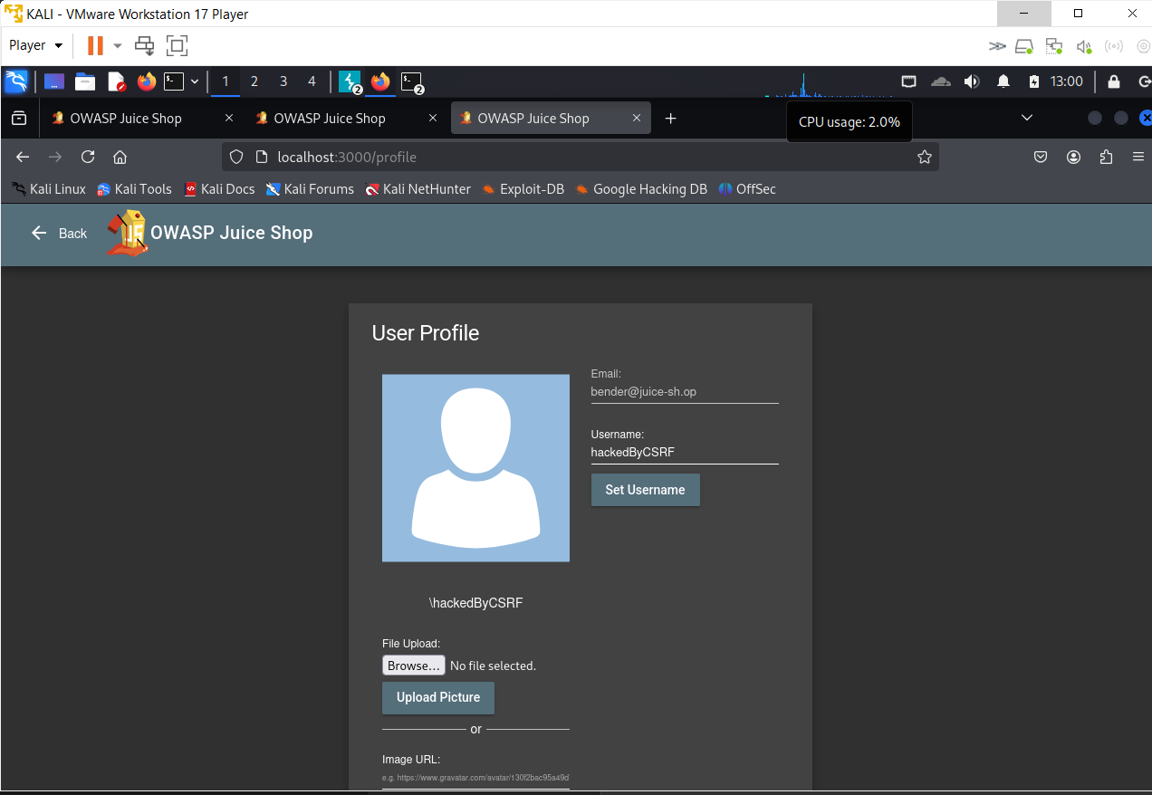

# 6 – Sensitive data exposure ALL vulnerabilities

**Confidential Document**

**Severity**: High (exposure of confidential business documents)

**Description**:  
A Sensitive Data Exposure vulnerability exists in OWASP Juice Shop due to improper FTP server configuration. The "About Us" page contains a hyperlink (ftp/legal.md) that, when hovered over, reveals an FTP directory path (/ftp). Accessing this path exposes the FTP directory structure, including a sensitive file (acquisitions.md), which contains confidential business acquisition plans. This misconfiguration allows unauthorized access to sensitive documents, potentially leading to competitive disadvantage or legal issues.

**Affected Component**:

* **FTP Directory Access**: The FTP server middleware exposes the /ftp directory and its contents, including sensitive files like acquisitions.md.

**Steps to Reproduce (in OWASP Juice Shop)**:

1. Navigate to the "About Us" section at http://localhost:3000/#/about.
2. Locate the hyperlink text in the "Corporate History & Policy" section that references ftp/legal.md.
3. Hover over the hyperlink to reveal the URL (http://localhost:3000/ftp/legal.md).
4. Modify the URL by removing /legal.md to access the FTP directory directly (http://localhost:3000/ftp/).
5. Observe the exposed directory structure, which includes files like acquisitions.md, legal.md, and others.
6. Access the acquisitions.md file by navigating to http://localhost:3000/ftp/acquisitions.md.
7. View the contents of acquisitions.md, which reveals sensitive acquisition plans (e.g., "Our company plans to acquire several competitors within the next year, this will have a significant stock market impact as we will elaborate in detail in the following paragraph").

**Impact**:

* Unauthorized access to sensitive business documents, such as acquisition plans, which could lead to competitive disadvantage if leaked to competitors.
* Potential financial loss due to stock market manipulation based on the exposed acquisition details.
* Legal and regulatory risks due to the exposure of confidential business strategies.
* Erosion of customer and stakeholder trust due to poor data protection practices.

**Remediation**:

* Remove the FTP middleware configuration that exposes the /ftp directory, specifically by deleting the line app.use('/ftp', serveIndexMiddleware, serveIndex('ftp', { 'icons': true })) from the server configuration.
* Restrict access to the /ftp directory by implementing proper access controls (e.g., authentication or IP whitelisting).
* Avoid linking directly to sensitive directories or files in public-facing pages like "About Us".
* Regularly audit server configurations to ensure sensitive directories are not exposed.
* Move sensitive files like acquisitions.md to a secure, non-public directory and encrypt them if necessary.

**PoC (Proof of Concept)**:  
**Request**:

GET /ftp/acquisitions.md HTTP/1.1

Host: localhost:3000

**Response (Excerpt from acquisitions.md)**:

Our company plans to acquire several competitors within the next year, this will have a significant stock market impact as we will elaborate in detail in the following paragraph...

**Exposed Directory Structure (via /ftp/)**:

* acquisitions.md
* legal.md
* quarantine/
* Other files and directories

The sensitive file acquisitions.md is accessible without authentication, confirming the vulnerability.

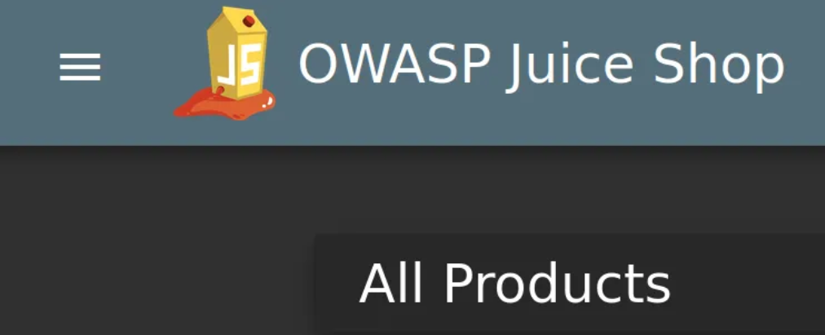

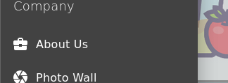

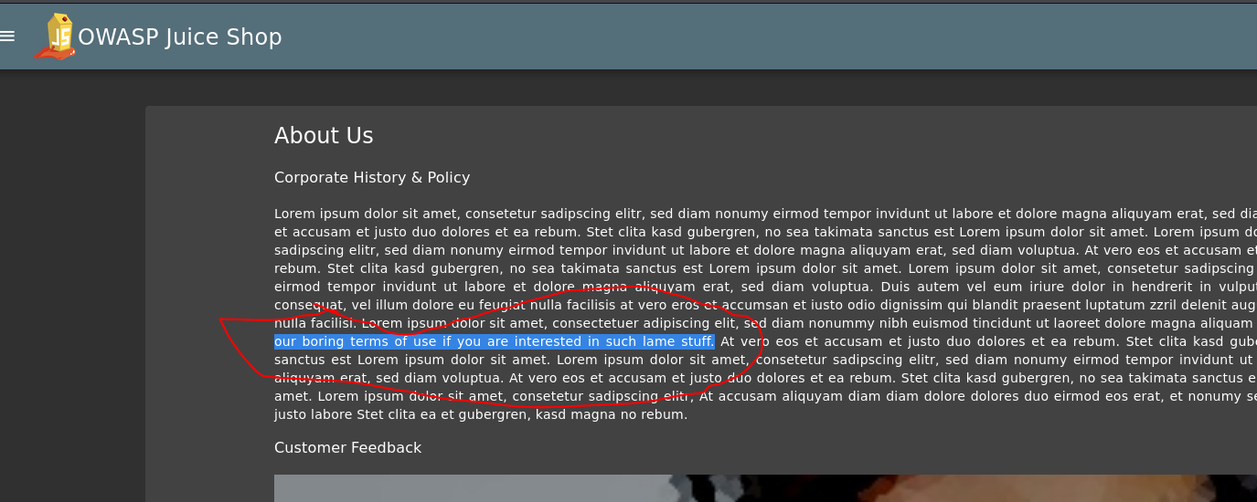

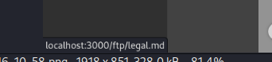

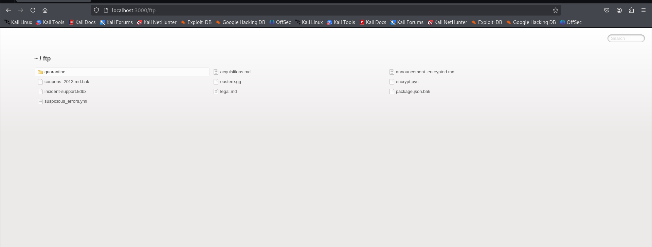

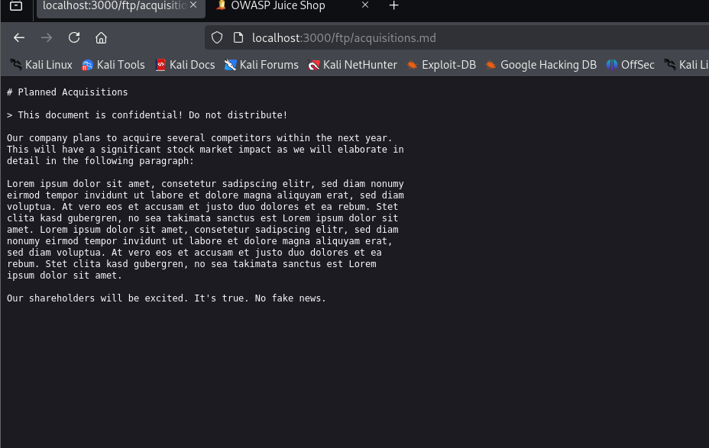

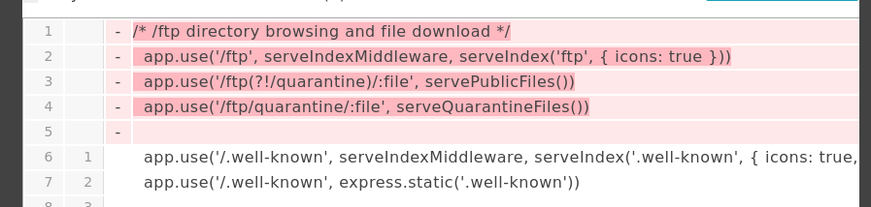

**Forgotten Developer Backup**

**Severity:**  
**Medium to High** (depends on the context and what files can be accessed)

**Description:**  
Null Byte Injection is a technique that exploits how some backend systems handle null characters (%00) to bypass input validation — often tricking the server into treating part of a file name or input as complete while ignoring the rest. This is commonly used to bypass file extension filters or access restricted files.

**Affected Component:**  
File download endpoint  
/ftp/:file

This route checks for allowed file extensions (e.g., .md, .pdf) but may mishandle encoded null bytes in some configurations.

**Steps to Reproduce (in OWASP Juice Shop):**

1. Go to:
2. ftp/package.json.bak%2500.md
3. The %2500 is double-encoded and gets decoded by the server into %00 (null byte).
4. If the server is vulnerable, it sees the full string as .md, but actually opens package.json.bak.

**Impact:**

* Bypasses file extension restrictions.
* Allows access to sensitive backup files (e.g., .bak, .old, .config).
* Can lead to exposure of credentials, app secrets, or source code.

**Remediation:**

* Sanitize user input and remove null bytes.
* Use strict file path and extension validation **after decoding**.
* Avoid using null-terminated strings when handling user input.
* Implement allowlists for file types using reliable libraries.

**PoC (Proof of Concept):**

GET /ftp/package.json.bak%2500.md HTTP/1.1

If vulnerable, this will return the contents of package.json.bak, bypassing the .md filter.

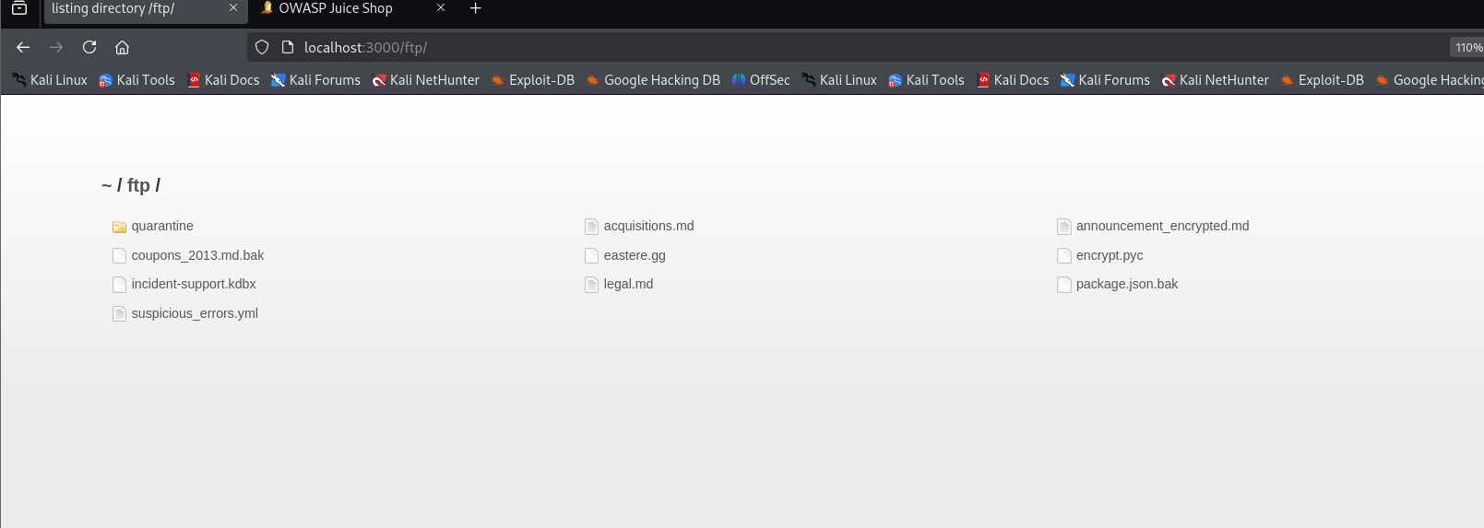

And we have a backup file that usually developers name it ending with .bak .

So if we tries to access it it will give an error saying that only .md and .pdf files are allowed :

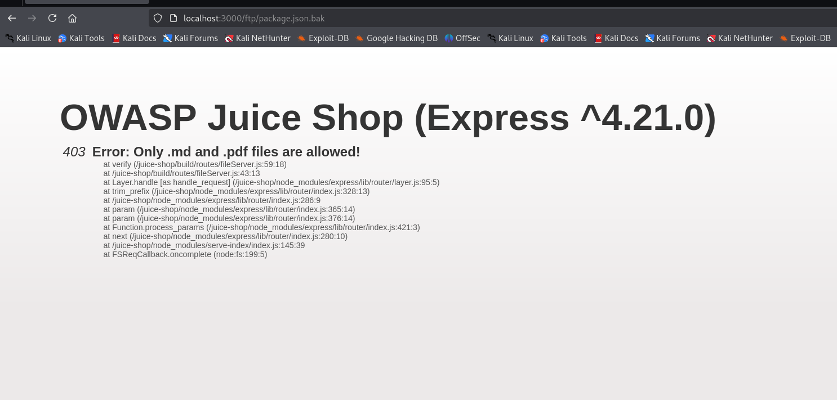

So we will use something called nullbyte injection:

**So we use something called null byte injection.**

**So what is null byte injection?**

Null byte injection is a technique where an attacker inserts a special null character (%00) to trick the server into cutting off a string early. It's used to bypass security checks, like file extension filters, by making the server think the file ends before the real extension.

Here’s what we do:

We try to trick the server by writing the file name like this:

/ftp/package.json.bak%00.md

Let’s explain it step by step:

* %00 is a **null byte**, and in some systems, it means “the end of the string”.
* So when the server checks the file name, it sees:
* package.json.bak%00.md → Ends with .md? Yes! ✅
* But when the system **opens the file**, it may stop reading at %00, so it actually reads:
* package.json.bak

So the server **thinks it’s a .md file**, but really it opens the **.bak file**!

But there was an error when we tried this:  
  
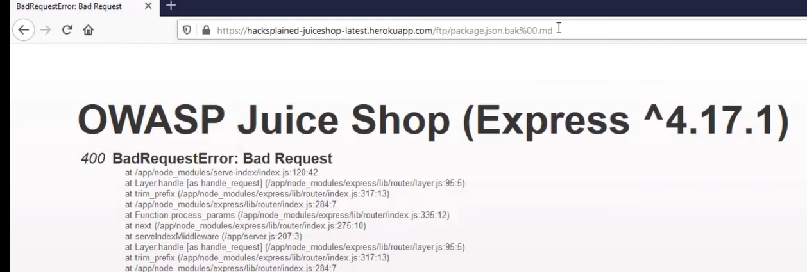

Showing bad request so lets try to give it encoded in the url:

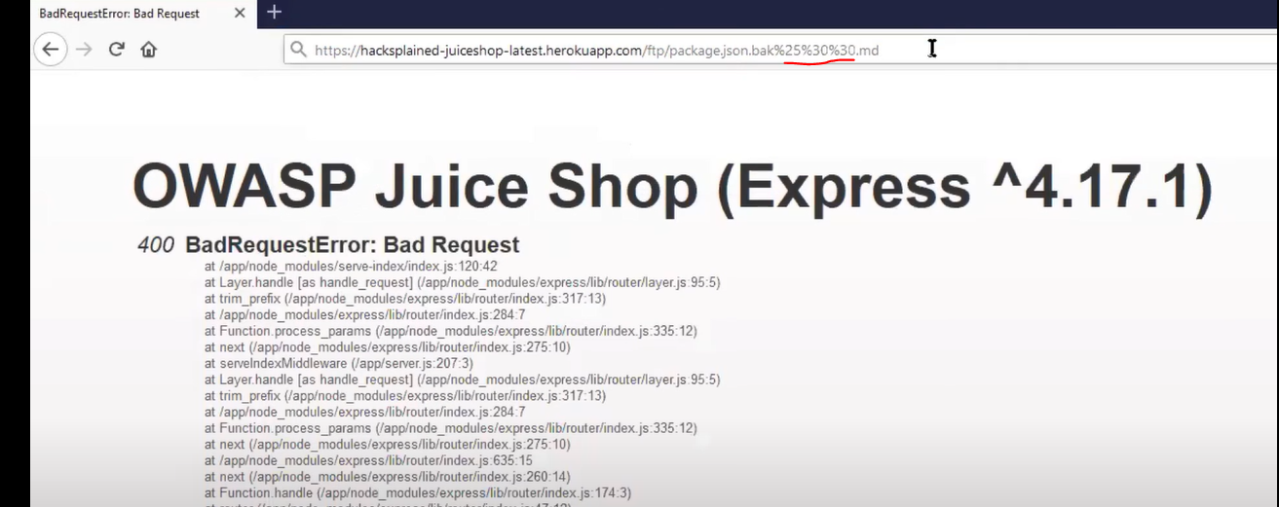

And now it works:

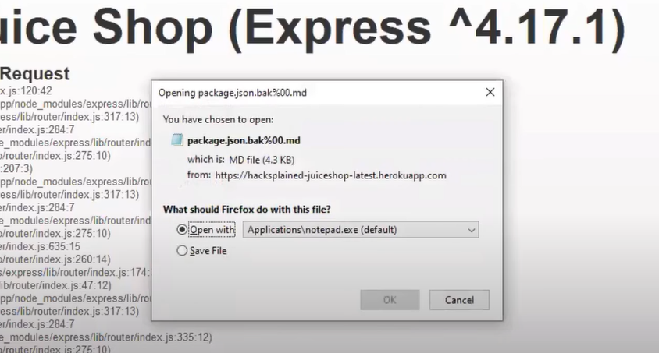

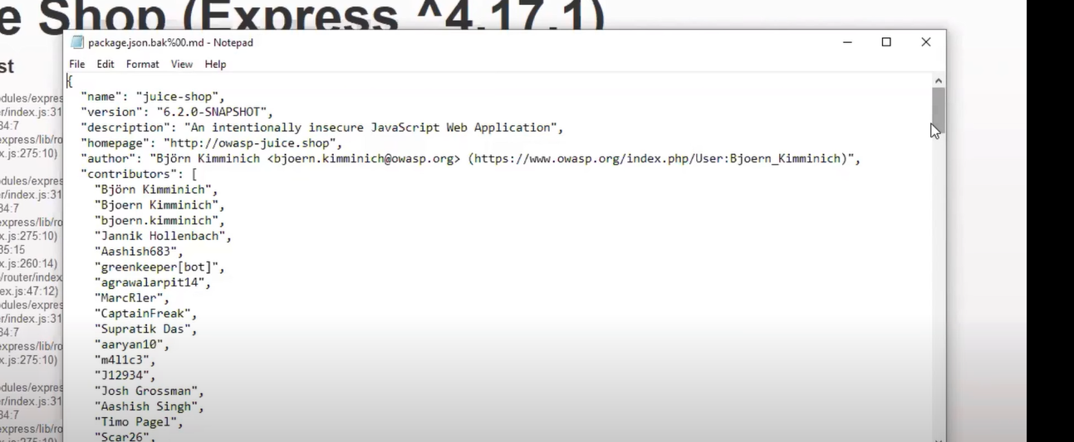

**Email Leak**

Severity:  
Critical (complete bypass of authentication and access controls)

Description:  
Broken Access Control occurs when an application fails to enforce proper authorization or authentication checks, allowing unauthorized users to access restricted resources or data. The /usr/whoami?callback={parameter} endpoint returns sensitive user data when the callback parameter is modified (e.g., to -admin`), without verifying the requestor's authentication or authorization status, allowing unauthorized access to any user's data.

Affected Component:  
User information endpoint  
/usr/whoami?callback={parameter}  
The endpoint fails to validate authentication credentials or user permissions when the callback parameter is provided, exposing sensitive user data to unauthenticated requests.

Steps to Reproduce (in a vulnerable test environment):

1. Access the application and log in with any valid user account.
2. Intercept the HTTP request to the /usr/whoami endpoint using a proxy tool (e.g., Burp Suite).
3. Modify the request by changing the endpoint to /usr/whoami?callback=admin.
4. Remove any Authorization Bearer token or session cookies from the request.
5. Send the modified request using a repeater tool.
6. If vulnerable, the response will return sensitive data associated with the user logged in, without any authentication checks.

Impact:  
• Unauthorized access to any user’s sensitive data, including personal details or credentials.  
• Potential for account takeover by accessing data of privileged users (e.g., admins).  
• Exposure of confidential information, enabling further attacks like phishing or fraud.  
• Complete bypass of access controls, compromising the application's security.

Remediation:  
• Implement strict authentication and authorization checks for all sensitive endpoints.  
• Validate the callback parameter to ensure it corresponds to the authenticated user.  
• Reject requests lacking valid session tokens or authentication headers.  
• Use secure session management and access control mechanisms (e.g., OAuth 2.0, RBAC).  
• Regularly audit and monitor API endpoints for unauthorized access attempts.

PoC (Proof of Concept):

GET /usr/whoami?callback=admin HTTP/1.1

Host: example.com

If vulnerable, the response will return sensitive data for the admin user, regardless of the requestor's authentication status.

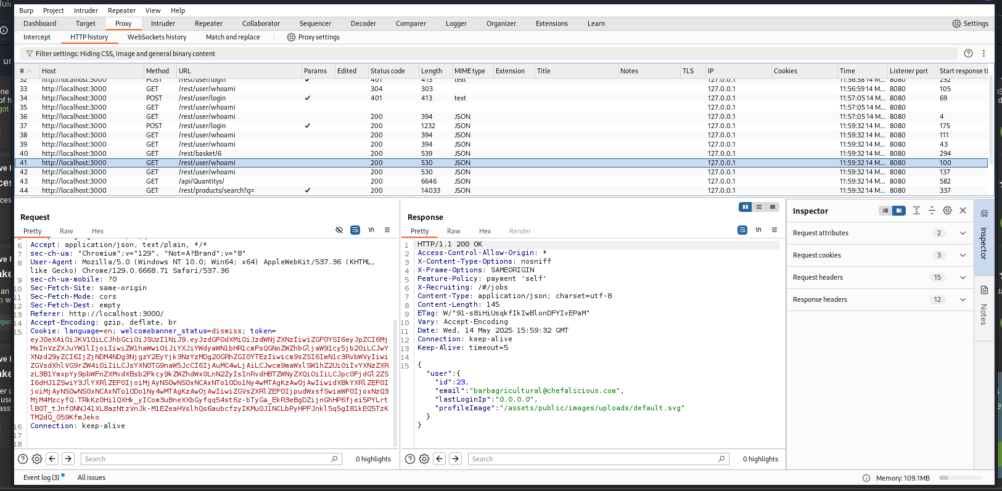

Just added ?callback=admin and removed the authorization bearer

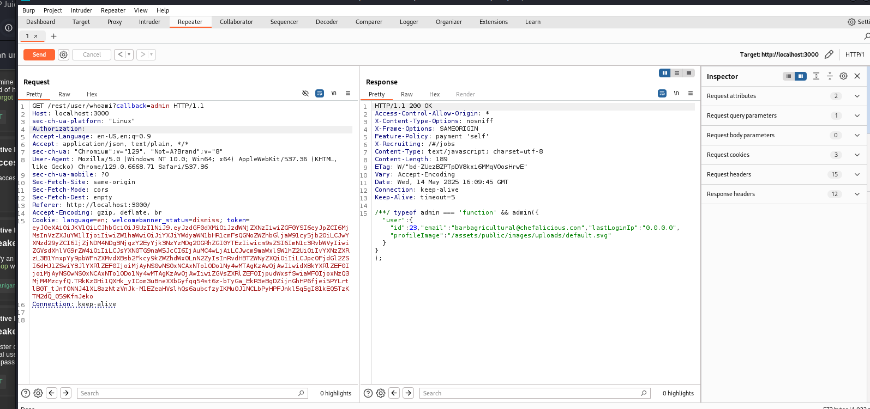

**GDPR Data Theft**

Severity:  
High (exposure of sensitive user data and potential unauthorized access)

- Description:  
Sensitive Data Exposure occurs when an application fails to adequately protect sensitive information, such as user email addresses. In OWASP Juice Shop, the /rest/track-order endpoint exposes user email addresses in a JSON response by replacing vowels with asterisks (*), which can be easily reversed to reveal the original email. Additionally, when exporting data via the "Privacy and Security" settings, sensitive user details are exposed. This flawed obfuscation also allows an attacker to register a similar email (e.g., odmin@juice-sh.op for admin@juice-sh.op) and potentially access admin data, completing the "Privacy Policy Inspection" challenge.

- Affected Component:  
Track order endpoint  
/rest/track-order  
The endpoint exposes obfuscated email addresses in JSON responses, and the "Privacy and Security" data export feature reveals sensitive user details without proper protection.

Steps to Reproduce (in OWASP Juice Shop):

1. Register a new user at http://localhost:3000/#/register with an email (e.g., testuser@juice-sh.op) and password (e.g., Pass123!).
2. Log in with the newly created account at http://localhost:3000/#/login.
3. Add any product (e.g., "Apple Juice (1000ml)") to the basket.
4. Proceed to checkout and add a delivery address (e.g., "123 Main St, City, Country").
5. Select "One Day Delivery" as the delivery option.
6. Add a new payment card (e.g., card number: 1234 5678 9012 3456, expiry: 12/26, CVV: 123) and select it for payment.
7. Place the order by clicking "Place Order".
8. Navigate to "Track Order" to view the order details.
9. Intercept the /rest/track-order request using a proxy tool (e.g., Burp Suite) and examine the JSON response, which shows the email with vowels replaced by asterisks (e.g., t*st*s*r@j**c*-sh.*p for testuser@juice-sh.op).
10. Export user data via the "Privacy and Security" settings, revealing sensitive details like the full email, address, and order history.
11. Register a new user with a similar email to the admin's (e.g., odmin@juice-sh.op for admin@juice-sh.op) by mimicking the obfuscation pattern (*dm*n@j**c*-sh.*p).
12. Log in with this account and export data again, gaining access to the admin's sensitive information, such as email and order details, completing the "Privacy Policy Inspection" challenge.

Impact:  
• Exposure of sensitive user data, including email addresses, addresses, and order details, through the data export feature.  
• Potential reconstruction of obfuscated emails due to predictable vowel replacement, leading to privacy breaches.  
• Unauthorized access to admin data by registering a similar email, exploiting the obfuscation flaw.  
• Increased risk of account impersonation or targeted attacks using exposed user information.

Remediation:  
• Remove or securely encrypt sensitive data (e.g., email addresses) in API responses instead of using reversible obfuscation.  
• Restrict data export features to only include necessary information and implement strong access controls.  
• Validate email uniqueness during registration to prevent similar email patterns (e.g., odmin@juice-sh.op vs. admin@juice-sh.op).  
• Implement rate limiting and monitoring on sensitive endpoints like /rest/track-order to detect unusual access patterns.  
• Regularly audit data exposure points to ensure compliance with privacy policies and regulations.

PoC (Proof of Concept):

GET /rest/track-order/12345 HTTP/1.1

Host: localhost:3000

Authorization: Bearer <user_token>

The response reveals the obfuscated email in JSON:

{

"orderId": "12345",

"email": "t*st*s*r@j**c*-sh.*p",

"status": "Processing"

}

Additionally, registering with odmin@juice-sh.op allows access to admin data via the "Privacy and Security" export, exposing sensitive details like the admin's email (admin@juice-sh.op) and order history.

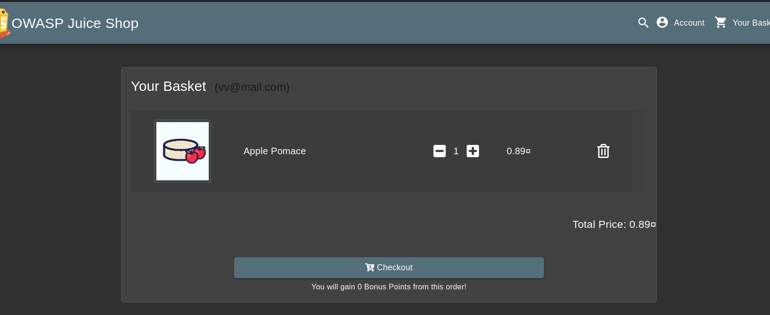

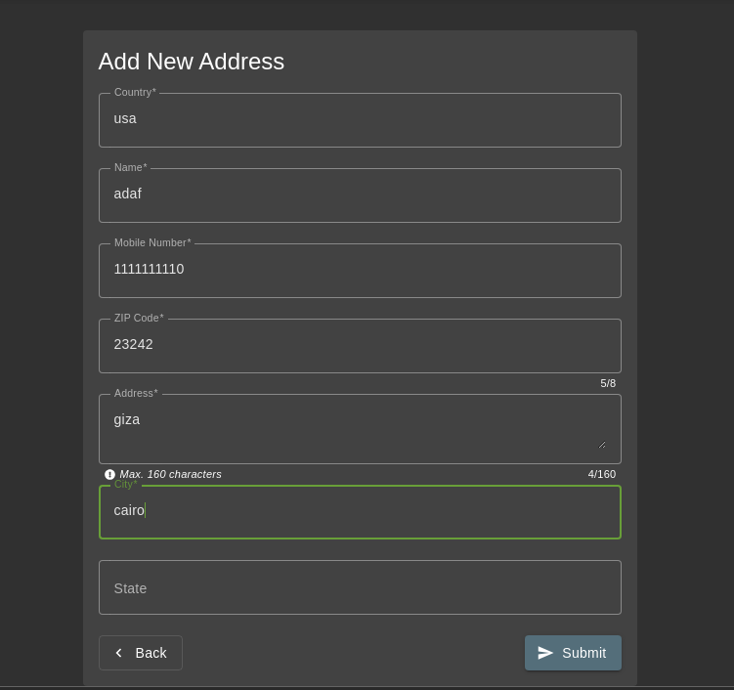

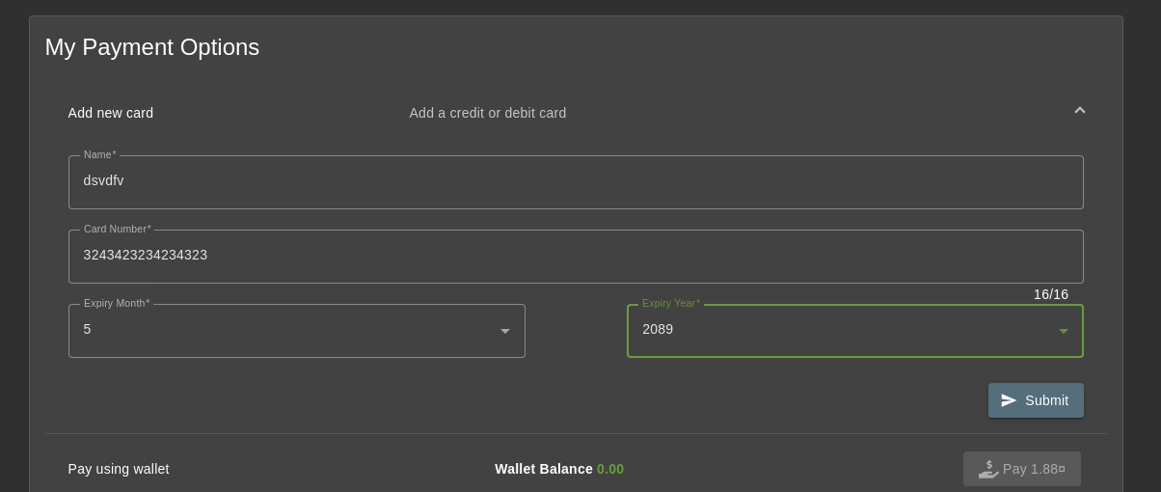

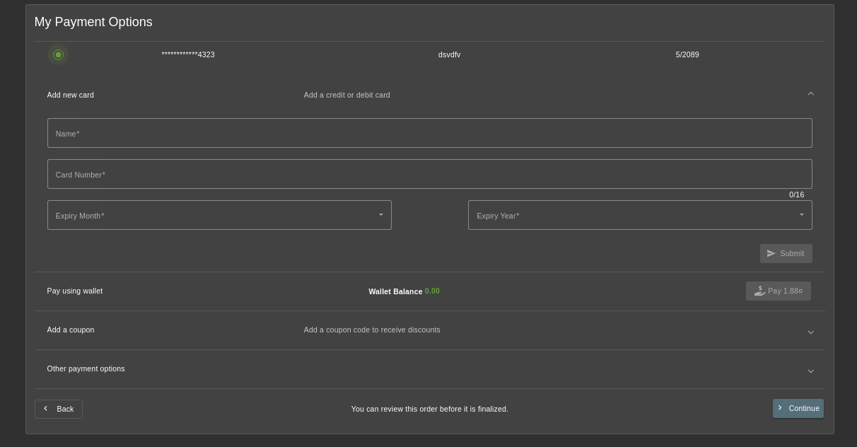

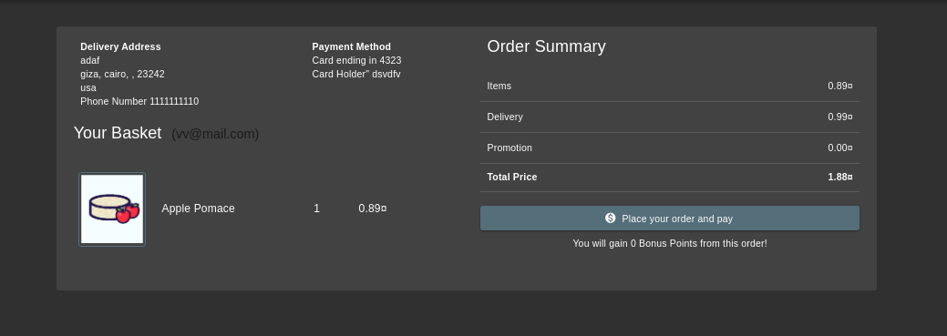

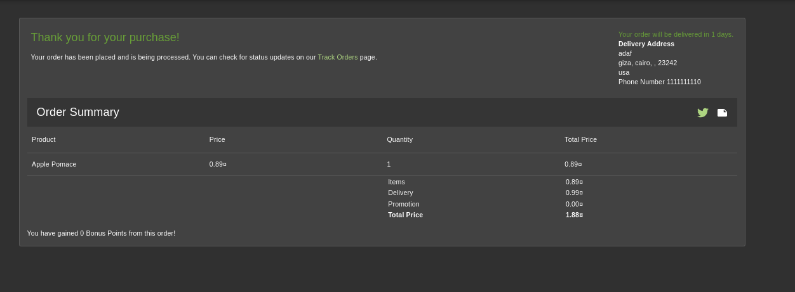

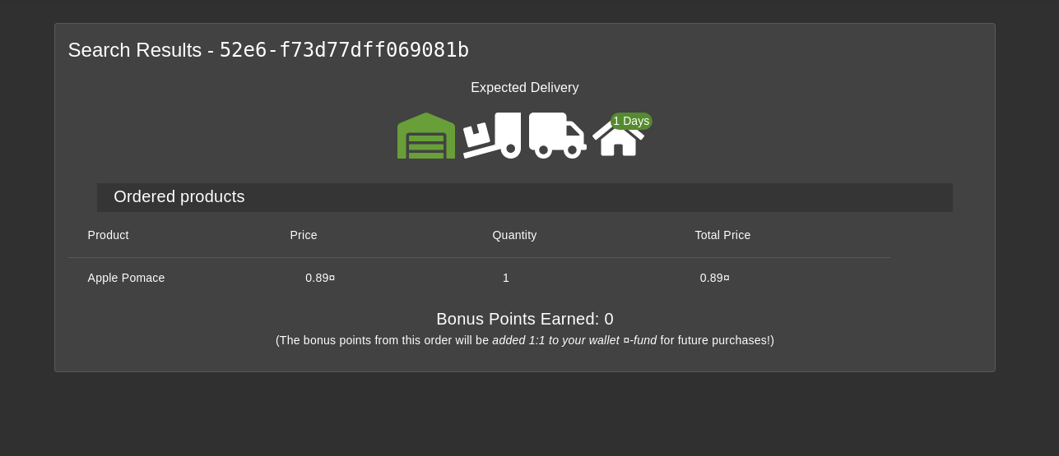

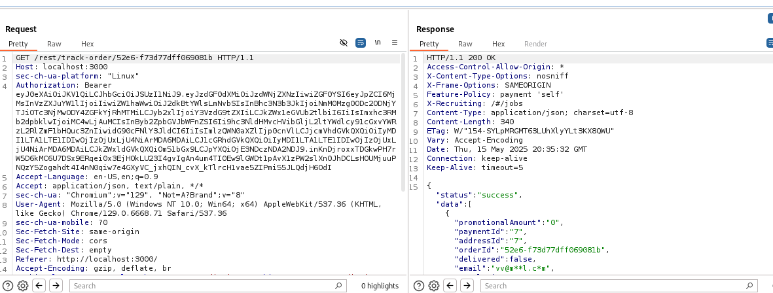

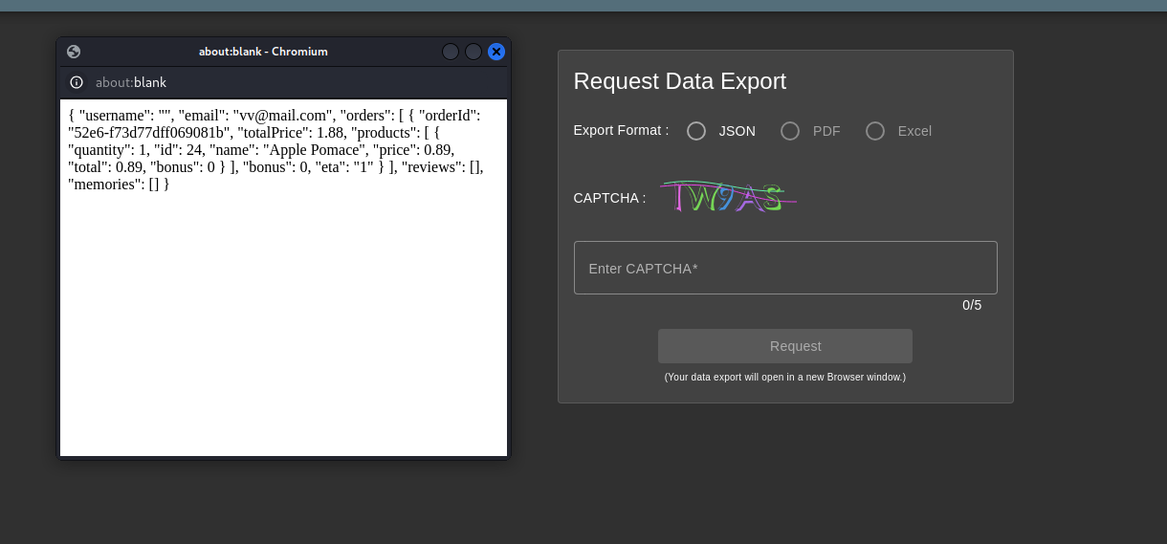

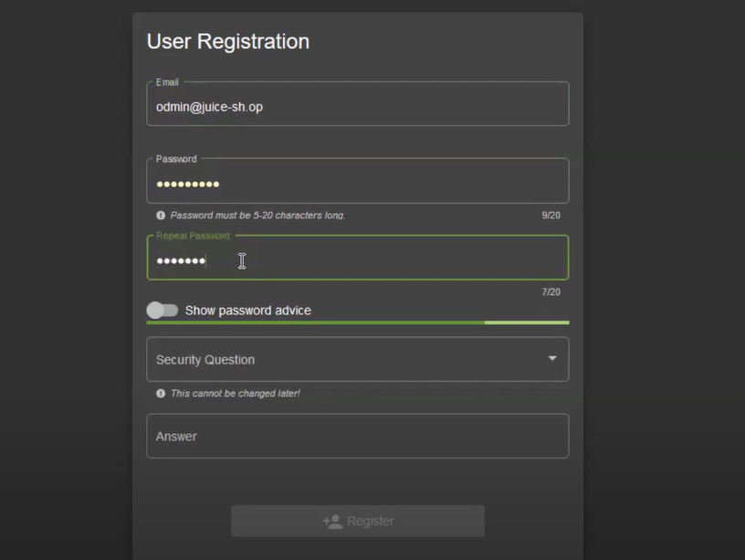

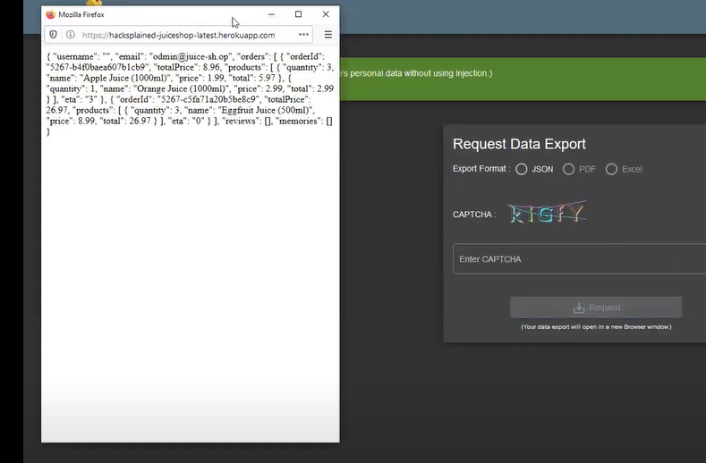

**Meta Geo Stalking**

**Severity**: High (unauthorized account takeover through metadata exploitation)

**Description**:  
A Meta Geo Stalking vulnerability exists in OWASP Juice Shop's Photo Wall and Forgot Password features. The Photo Wall exposes images with embedded GPS metadata, revealing the user's location. By extracting this metadata, an attacker can determine the answer to a user's security question (e.g., "What's your favorite place to go hiking?"). Using the default domain name (@juice-sh.op), the attacker can access the Forgot Password functionality, input the victim's email (e.g., john@juice-sh.op), retrieve the security question, and reset the password, leading to a full account takeover. This completes the "Meta Geo Stalking" challenge.

**Affected Components**:

* **Photo Wall**: Exposes images with unstripped GPS metadata, revealing user locations.
* **Forgot Password Functionality**: Allows retrieval of security questions with predictable email domains, enabling account takeover.

**Steps to Reproduce (in OWASP Juice Shop)**:

1. Navigate to the "Photo Wall" section at http://localhost:3000/#/photo-wall.
2. Identify a photo uploaded by the target user (e.g., a photo with the caption "I love going hiking here ... (@johnny)") and save the image (e.g., favorite-hiking-place.png).
3. Note that the default email domain for users in OWASP Juice Shop is @juice-sh.op, so the target's email is likely john@juice-sh.op.
4. Navigate to the "Forgot Password" section at http://localhost:3000/#/forgot-password.
5. Enter the target's email (john@juice-sh.op) to retrieve the security question: "What's your favorite place to go hiking?".
6. Use an EXIF metadata extraction tool (e.g., ExifTool) to analyze the downloaded image.
7. Extract the GPS coordinates from the image metadata (e.g., 36°57'31.4" N 84°20'53.6" W).
8. Input the GPS coordinates into Google Maps to identify the location (e.g., Daniel Boone National Forest, London, Kentucky 40744, USA).
9. Return to the Forgot Password page, enter the security question answer (Daniel Boone National Forest), and set a new password (e.g., NewPass123!).
10. Submit the password reset by clicking "Change".
11. Observe the success message: "You successfully solved a challenge: Meta Geo Stalking (Determine the answer to John's security question by looking at uploaded metadata in the Photo Wall and use it to reset his password via the Forgot Password mechanism.)".

**Impact**:

* Exposure of sensitive user location data through unstripped GPS metadata in uploaded images.
* Full account takeover by exploiting predictable email domains and security question answers derived from metadata.
* Potential for further unauthorized actions, such as accessing sensitive user data or impersonating the victim.
* Violation of privacy best practices, increasing the risk of targeted attacks (e.g., physical stalking or social engineering).

**Remediation**:

* Strip GPS and other sensitive metadata from images during upload processing on the server side.
* Implement stronger security question mechanisms, such as requiring additional authentication factors or using less predictable questions.
* Randomize or obscure email domains for users to prevent easy guessing of email addresses.
* Add rate limiting and monitoring to the Forgot Password endpoint to detect and block suspicious activity.
* Educate users about the risks of uploading images with embedded metadata and provide options to remove it before upload.

**PoC (Proof of Concept)**:  
**Extracted Metadata (via ExifTool)**:

File Name: favorite-hiking-place.png

GPS Position: 36 deg 57' 31.4" N, 84 deg 20' 53.6" W

**Forgot Password Request**:

* Email: john@juice-sh.op
* Security Question: "What's your favorite place to go hiking?"
* Answer: Daniel Boone National Forest
* New Password: NewPass123!

**Result**:

* Success message: "You successfully solved a challenge: Meta Geo Stalking (Determine the answer to John's security question by looking at uploaded metadata in the Photo Wall and use it to reset his password via the Forgot Password mechanism.)".
* The password reset is successful, allowing full access to the victim's account.

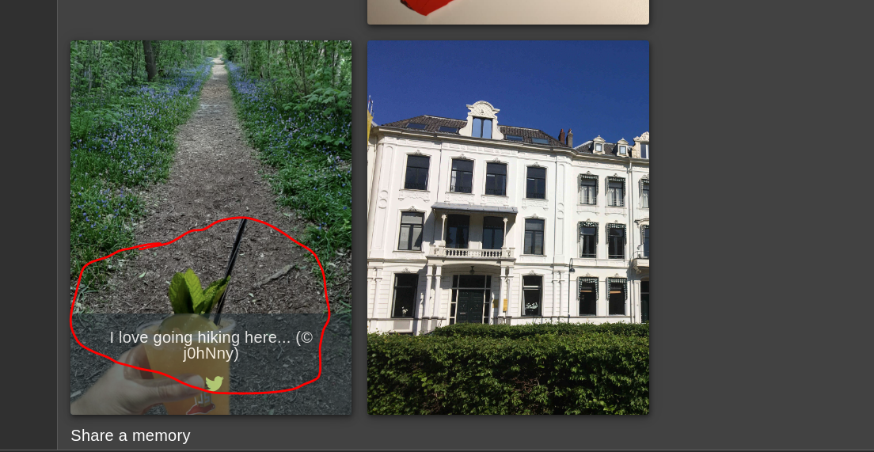

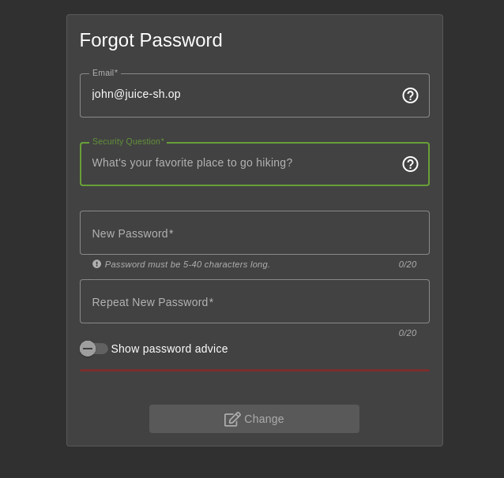

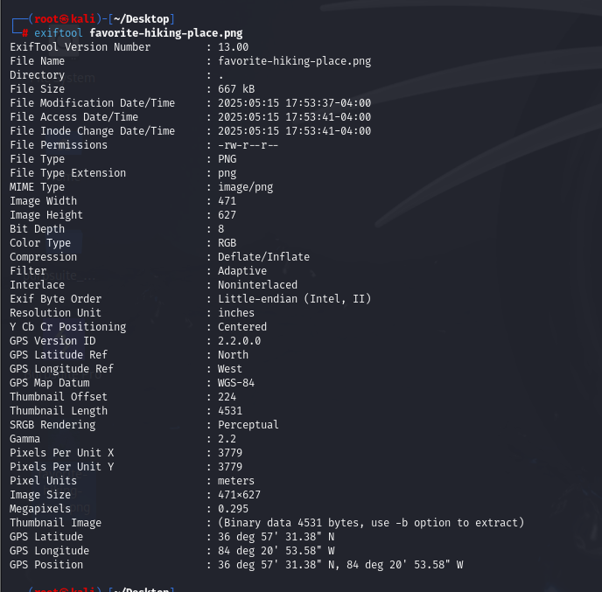

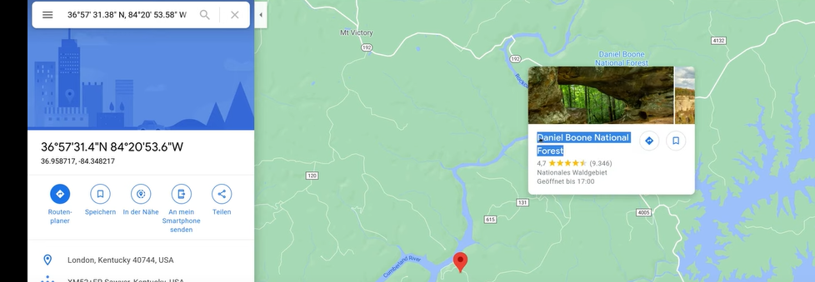

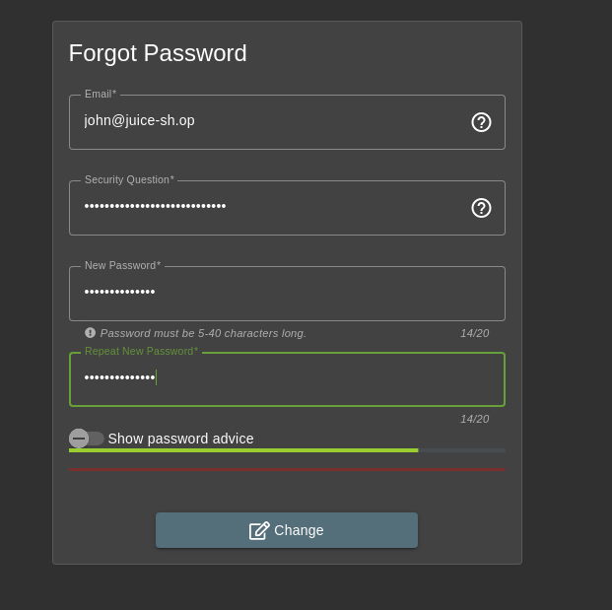

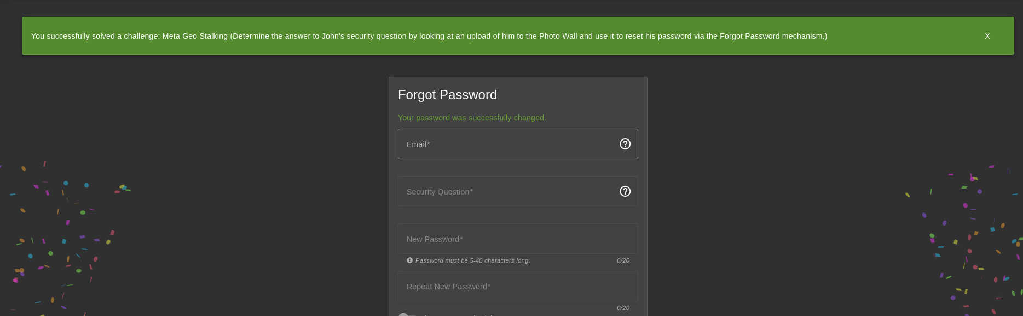

**Login MC SafeSearch**

* **Severity:** Medium – 2 Stars  
  **Description:**  
  The application allows logging in as the user **MC SafeSearch** using default credentials without requiring SQL Injection or bypass techniques. The credentials were discovered through:  
  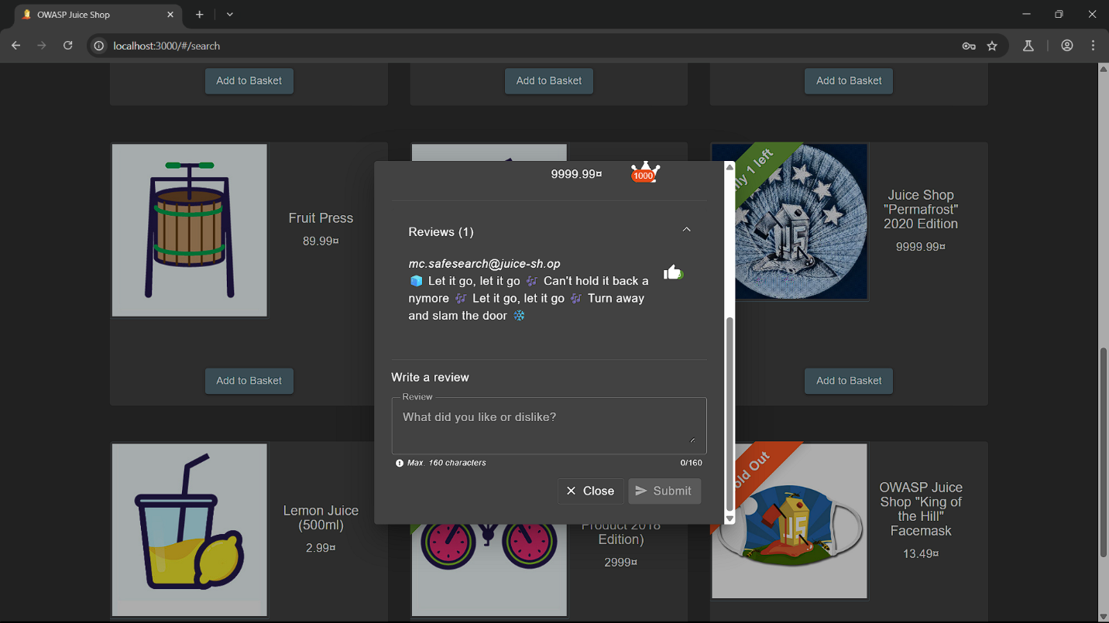
* **Product Review Analysis**: A review by mc.safesearch@juice-sh.op contained lyrics from *Frozen*’s "Let It Go" (🧊 Let it go, let it go 🎶 ... ❄️), hinting at a weak password themed around the song (e.g., LetItGo - LetItGo123 – Frozen – Elsa - MrN00dles).
* Enter the credentials:  
   **Email:** [mc.safesearch@juice-sh.op](mailto:mc.safesearch@juice-sh.op)  
   **Password:** trying different ones!  
  1-  
   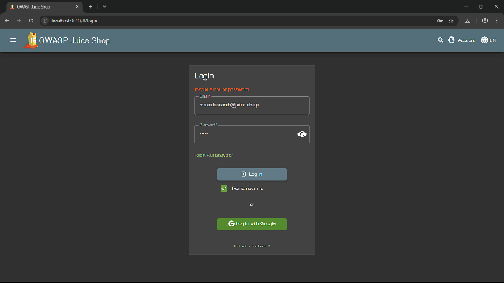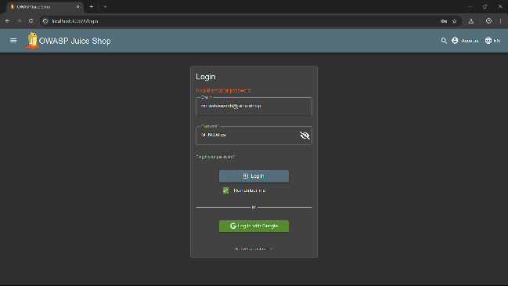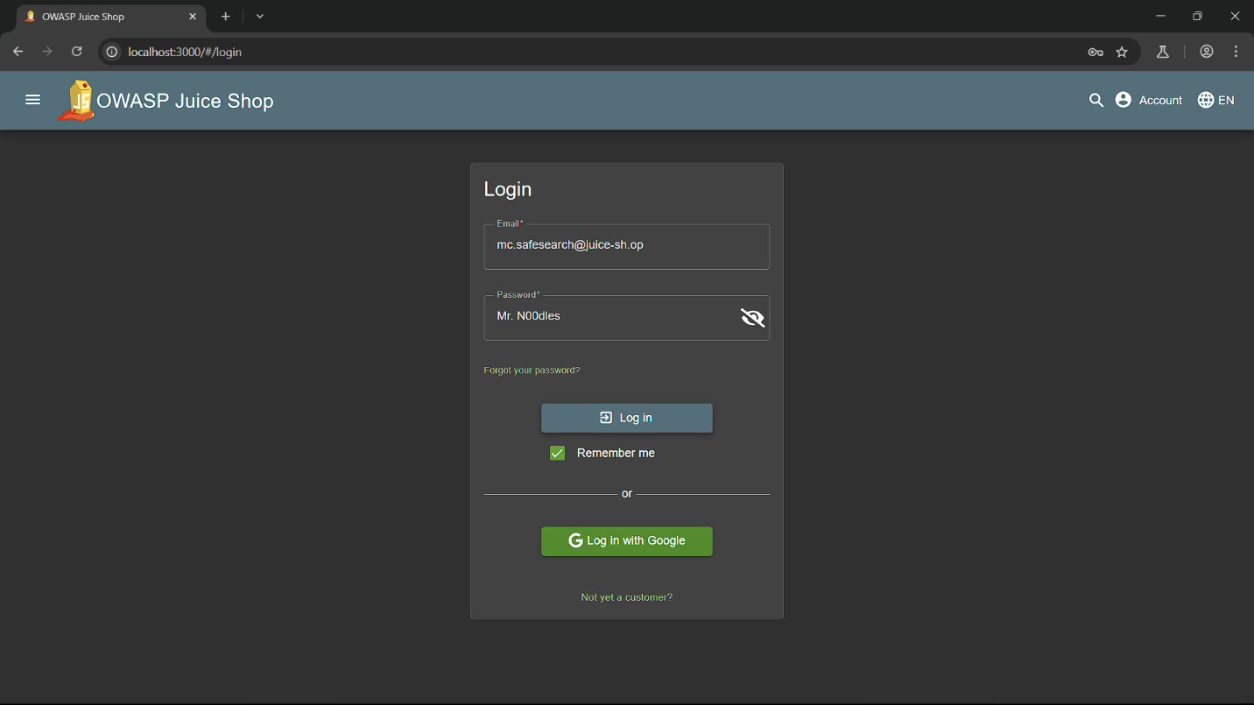
* And finally   
  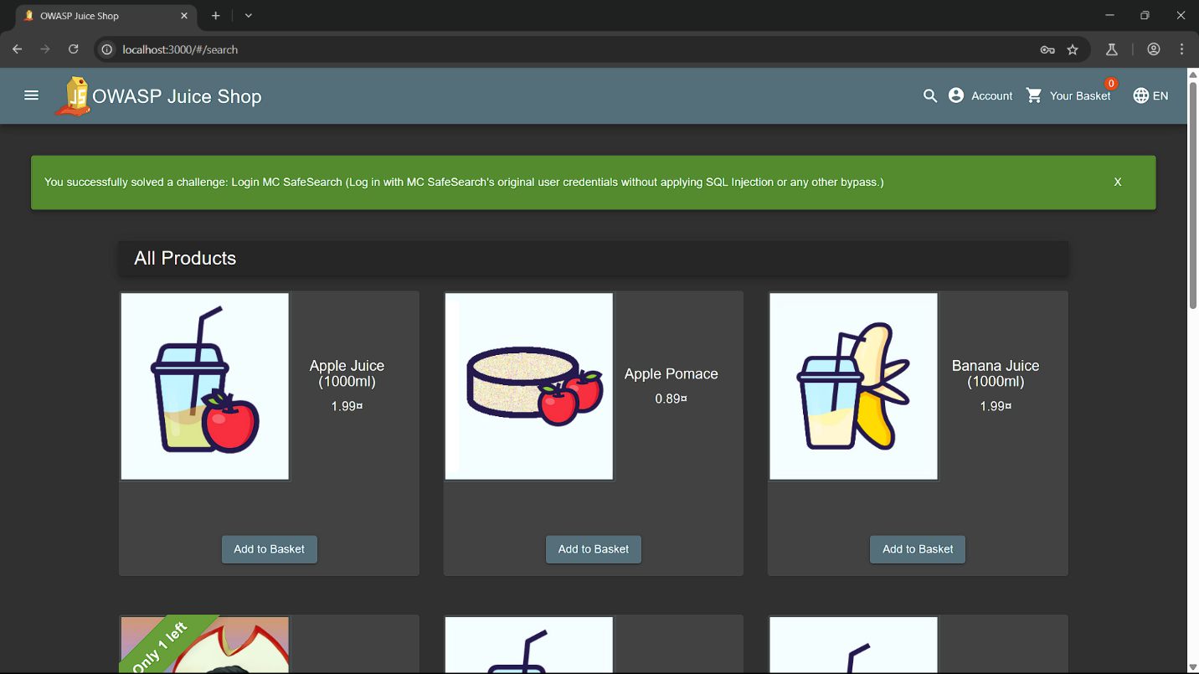

**Access Log**

* **Severity:** Critical 4-stars
* **Description:**  
  The application improperly exposes system access logs through an unprotected /support/logs endpoint. By modifying the URL path from  
   /score-board to /support/logs, attackers can view raw server logs containing sensitive operational data without authentication.
* **Affected Component:**  
  Unprotected endpoint: <http://localhost:3000/support/logs>  
    
  **Steps to Reproduce:**

1. While authenticated, navigate to:  
   <http://localhost:3000/#/score-board>  
   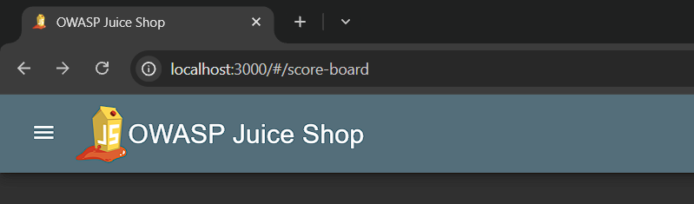
2. Manually modify the URL to:  
   <http://localhost:3000/support/logs>  
   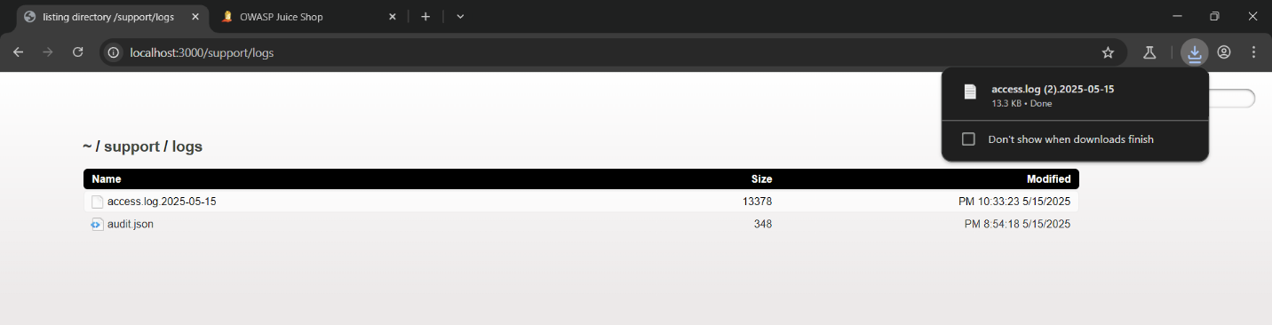
3. Observe the server responds with:
   * Full access logs in plaintext  
     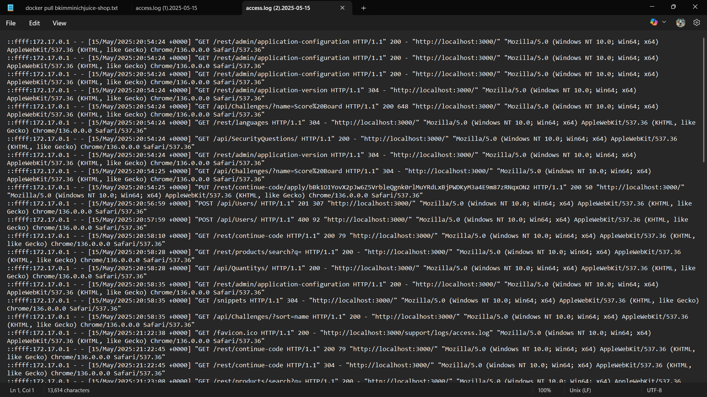
   * Timestamps of all requests
   * User IP addresses
   * HTTP methods and endpoints accessed
   * Session tokens (if logged)
4. 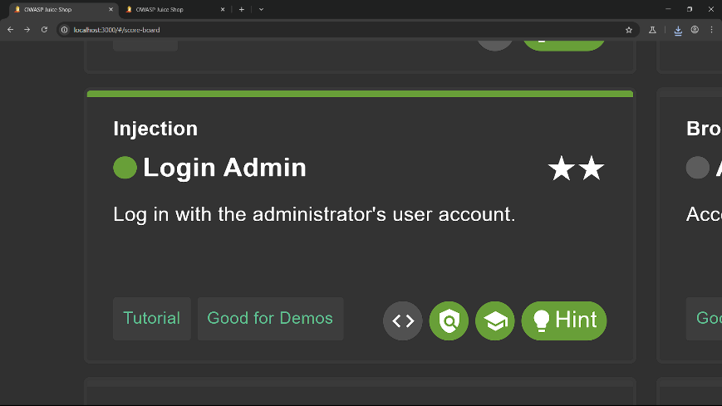

# 7 – Improper input validation ALL vulnerabilities

**Deluxe Fraud**

Severity:  
High (potential for unauthorized access to premium features without payment)

Description:  
Improper Input Validation occurs when an application relies on client-side controls and fails to enforce server-side validation, allowing attackers to bypass payment restrictions. In this case, the /payment/deluxe endpoint in OWASP Juice Shop permits a Deluxe Membership to be obtained by manipulating the disabled "Pay" button and removing the wallet parameter from the intercepted request, enabling fraudulent upgrades without payment.

Affected Component:  
Payment processing endpoint  
/payment/deluxe  
The endpoint does not validate payment legitimacy on the server-side and processes requests even when the wallet parameter is removed, bypassing payment requirements.

Steps to Reproduce (in OWASP Juice Shop):

1. Navigate to the payment page:  
   http://localhost:3000/#/payment/deluxe
2. Enter new card information (e.g., card number: 1234567890123456, expiry: 12/25, CVV: 123).
3. Right-click the "Pay" button and select "Inspect Element" to view its HTML.
4. Locate the button's class (e.g., mat-button-disabled) and disabled attribute.
5. Modify the HTML to remove mat-button-disabled and set disabled="false".
6. Click the now-enabled "Pay" button and intercept the request using a proxy tool (e.g., Burp Suite).
7. In the intercepted request, remove the wallet parameter (e.g., change wallet=... to an empty value or remove it entirely).
8. Forward the modified request.
9. If vulnerable, the response confirms a successful Deluxe Membership upgrade without payment, as shown in the success message.

Impact:  
• Unauthorized access to premium features (e.g., Deluxe Membership) without payment.  
• Financial loss for the application provider due to fraudulent upgrades.  
• Potential exploitation by attackers to scale the attack across multiple accounts.  
• Undermines the payment system's integrity, affecting user trust.

- Remediation:  
• Enforce server-side validation to ensure all payment requests include a valid wallet parameter.  
• Disable client-side manipulation of payment buttons by validating state on the server.  
• Use secure tokens or session-based checks to authenticate payment actions.  
• Implement strict payment verification (e.g., card processing) before granting upgrades.  
• Monitor and log payment attempts to detect and block suspicious behavior.

- PoC (Proof of Concept):

POST /payment/deluxe HTTP/1.1

Host: localhost:3000

Content-Type: application/x-www-form-urlencoded

card=1234567890123456&expiry=12/25&cvv=123

After enabling the button via client-side manipulation and removing the wallet parameter, forwarding the request results in a successful Deluxe Membership upgrade, as confirmed by the message: "You successfully solved a challenge: Deluxe Fraud (Obtain a Deluxe Membership without paying for it!)."

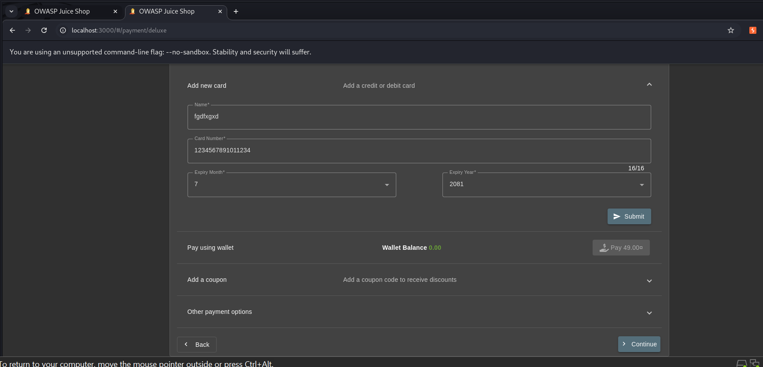

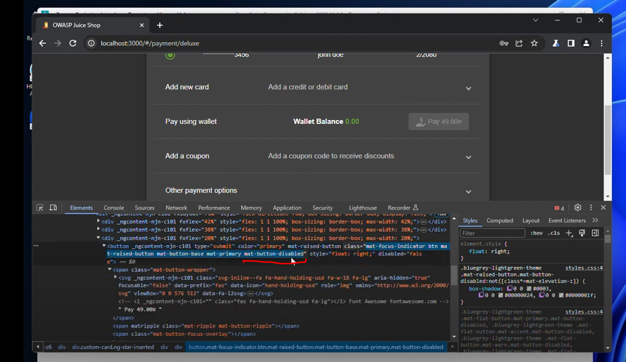

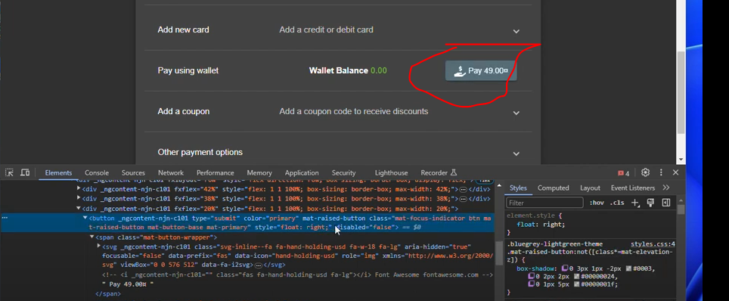

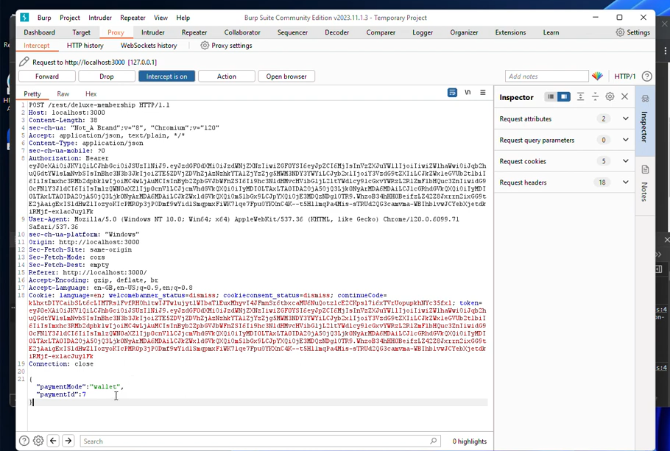

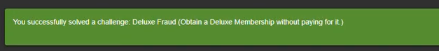

**Repetitive Registration**

First we will register with email and then enter password and then enter password again but not correct so we will go again and change the password above again and the error will go

- Severity:  
Medium (potential for inconsistent password handling and bypassing validation due to DRY violation)

- Description:  
The DRY (Don't Repeat Yourself) principle, which mandates that every piece of knowledge should have a single, authoritative representation within a system, is violated in the OWASP Juice Shop registration process. This violation manifests as an Improper Input Validation vulnerability where the /register endpoint relies on client-side validation to ensure "Password" and "Repeat Password" fields match, without enforcing this check on the server-side. The lack of a centralized validation mechanism allows users to bypass the intended DRY-compliant workflow by manipulating the form after an initial mismatch, enabling registration with inconsistent passwords and solving the "Repetitive Registration" challenge.

- Affected Component:  
Registration endpoint  
/register  
The endpoint fails to adhere to the DRY principle by duplicating validation logic between client and server, with the server lacking an authoritative validation step to ensure password consistency.

Steps to Reproduce (in OWASP Juice Shop):

1. Navigate to the registration page:  
   http://localhost:3000/#/register
2. Enter an email (e.g., hacked@email.com).
3. Enter a password (e.g., Pass123!) that meets the 5-40 character requirement.
4. Enter a mismatched repeat password (e.g., Pass456!).
5. Observe the client-side DRY violation warning: "Passwords do not match."
6. Modify the first password field to match the repeat password (e.g., change Pass123! to Pass456!).
7. Select a security question (e.g., "Mother's maiden name?") and provide an answer (e.g., Smith).
8. Submit the form.
9. If vulnerable, the server accepts the registration without re-validating the inputs, completing the "Repetitive Registration" challenge with the message: "You successfully solved a challenge: Repetitive Registration (Follow the DRY principle while registering a user)."

Impact:  
• Bypassing of password validation due to the DRY principle violation, leading to potential inconsistencies in user accounts.  
• Increased risk of user errors or unintended password usage, undermining the single-source-of-truth concept central to DRY.  
• Potential exploitation by attackers to manipulate registration workflows where DRY is not enforced.  
• Erodes trust in the registration process due to inconsistent application of the DRY principle.

Remediation:  
• Implement a centralized, server-side validation function that adheres to the DRY principle, ensuring "Password" and "Repeat Password" fields match as a single source of truth.  
• Eliminate redundant client-side validation by relying on a unified server-side check, aligning with DRY's goal of avoiding repetition.  
• Define password policies (e.g., 5-40 characters) in a single configuration, ensuring all validation logic follows DRY.  
• Treat client-side feedback as an enhancement, not a security control, to maintain DRY compliance.  
• Monitor registration attempts to detect DRY-related bypass attempts and enforce consistent validation.

By modifying the form to bypass the client-side DRY violation warning, the server accepts the registration, highlighting the lack of a centralized DRY-compliant validation mechanism.

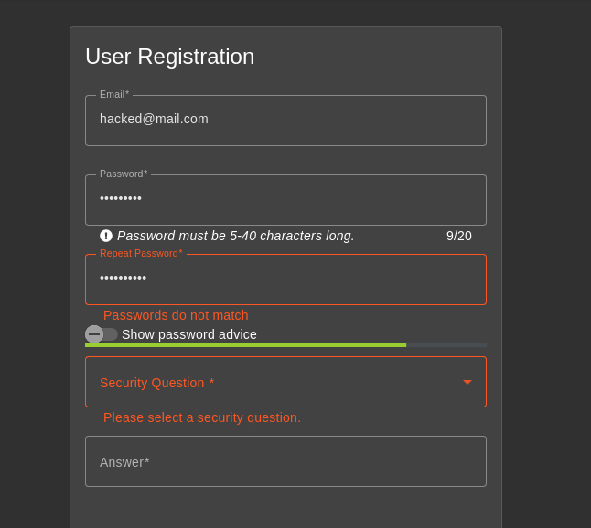

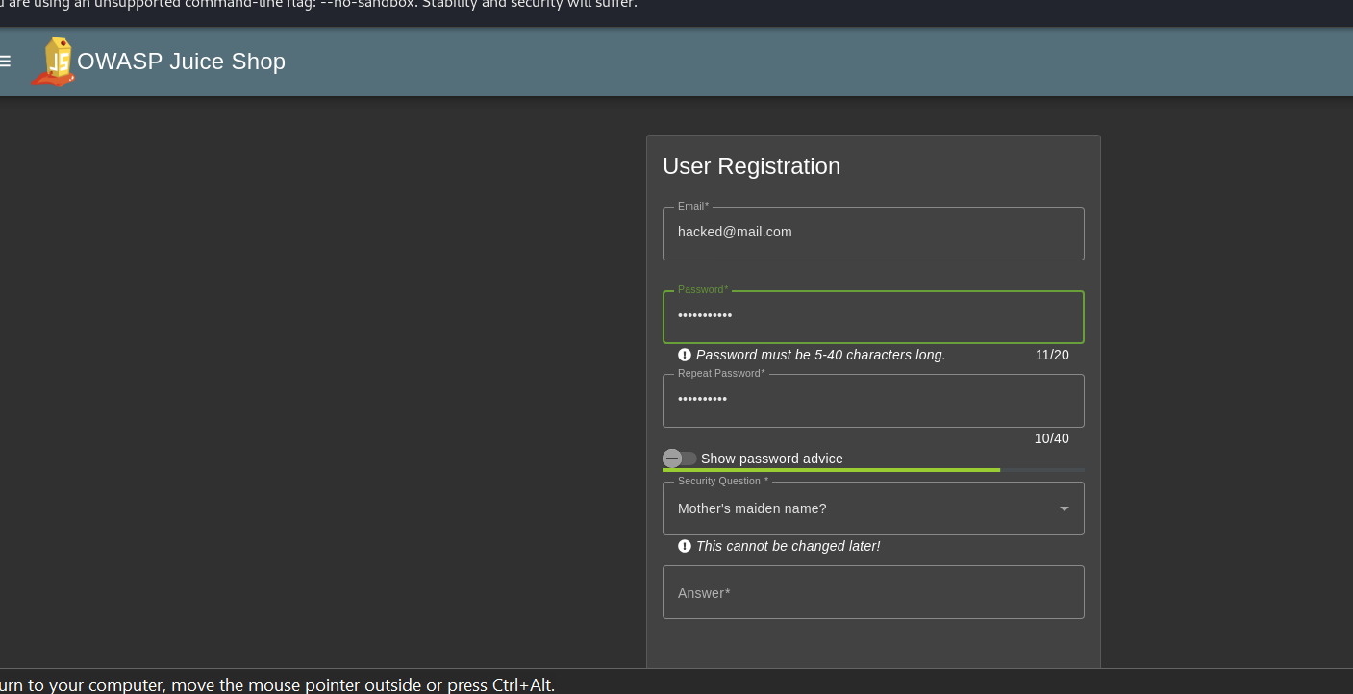

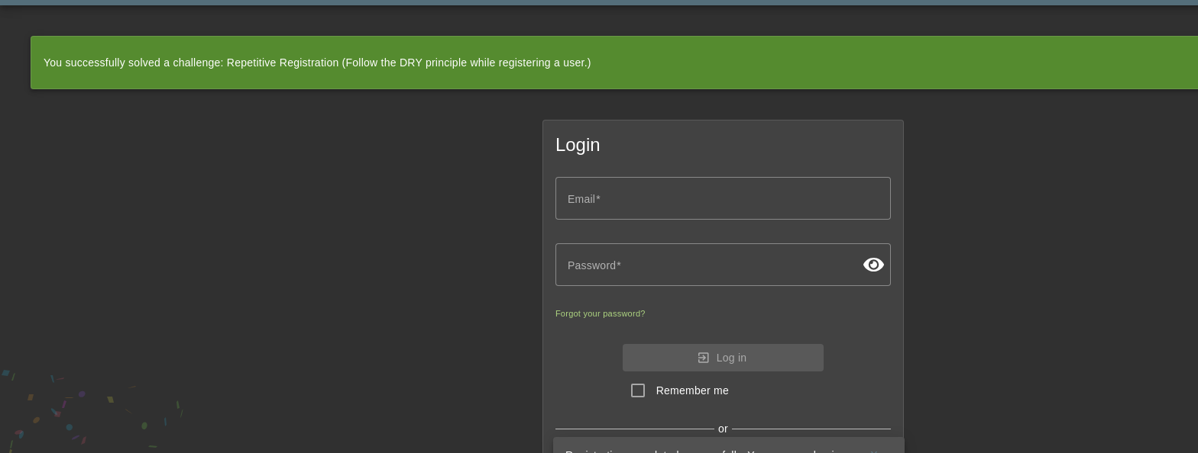

**Empty User Registration**

Here's your requested writeup formatted with the specified structure:

## Severity: Medium

(Potential for creating invalid user accounts and bypassing registration validation)

## Description

**Improper Input Validation** occurs when applications fail to enforce input checks. In OWASP Juice Shop, the /api/Users endpoint allows user registration without validating critical fields like email and password. Attackers can intercept requests, remove these fields, and create empty user accounts, bypassing essential validation and completing the "Empty User Registration" challenge.

## Affected Component

**User registration endpoint** /api/Users  
The endpoint lacks server-side validation for required fields, enabling incomplete account creation.

## Steps to Reproduce (OWASP Juice Shop)

1. **Navigate to registration page**:  
   http://localhost:3000/#/register
2. **Register a valid user**:
   * Email: emptyreg@email.com
   * Password: Pass123!
   * Security Question: "Mother's maiden name?"
   * Answer: Smith
3. **Intercept the request** (e.g., Burp Suite):

text

POST /api/Users HTTP/1.1

{

"email": "emptyreg@email.com",

"password": "Pass123!",

"role": "customer"

}

1. **Resend the request** via Repeater → 400 Bad Request (email exists).
2. **Modify the request** by removing email and password:

text

POST /api/Users HTTP/1.1

{

"role": "customer"

}

1. **Confirm vulnerability**: Server responds 201 Created, creating an empty account and solving the challenge.

## Impact

* ❗ Invalid accounts disrupt user management.
* ❗ Bypasses registration validation integrity.
* ❗ Enables anonymous/untraceable account creation.
* ❗ Risks system errors from incomplete data.

## Remediation

* **Enforce server-side validation** for email and password.
* **Reject requests** with missing/empty critical fields.
* **Define a strict schema** for registration data.
* **Monitor and log** suspicious registration attempts.
* **Regularly audit** validation mechanisms.

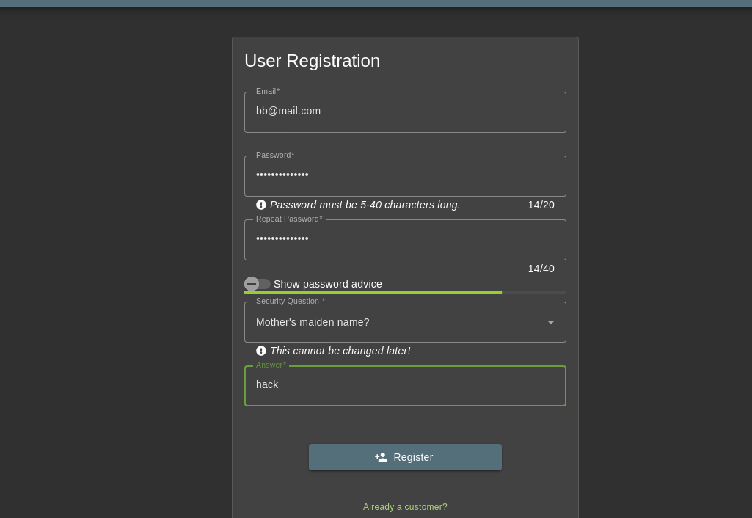

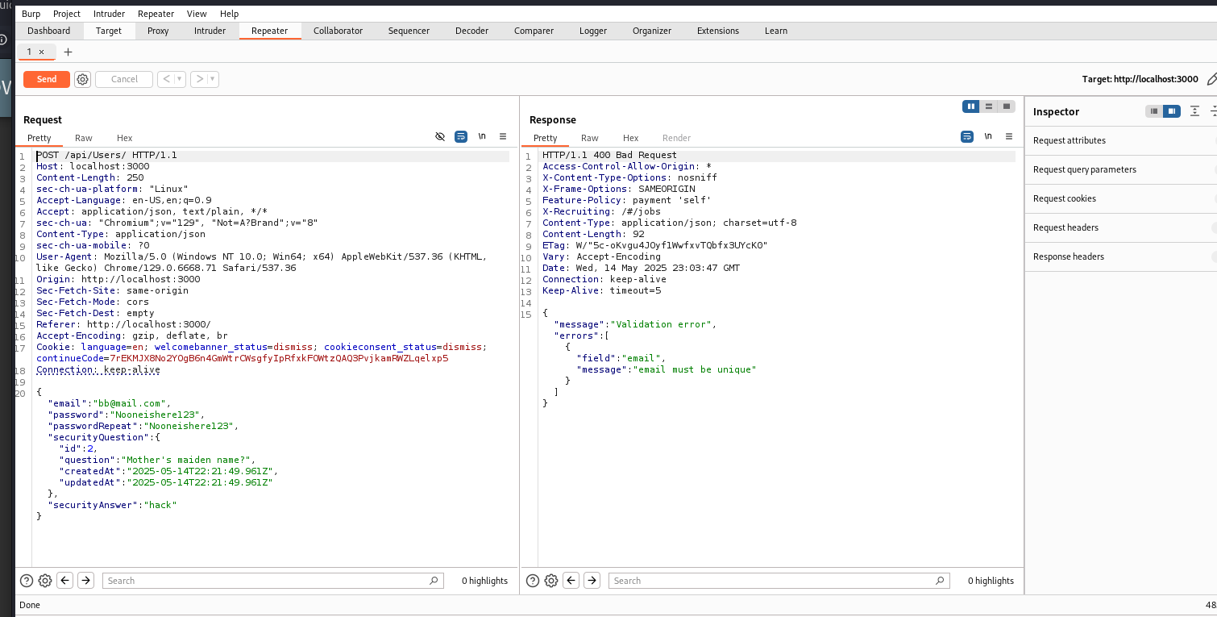

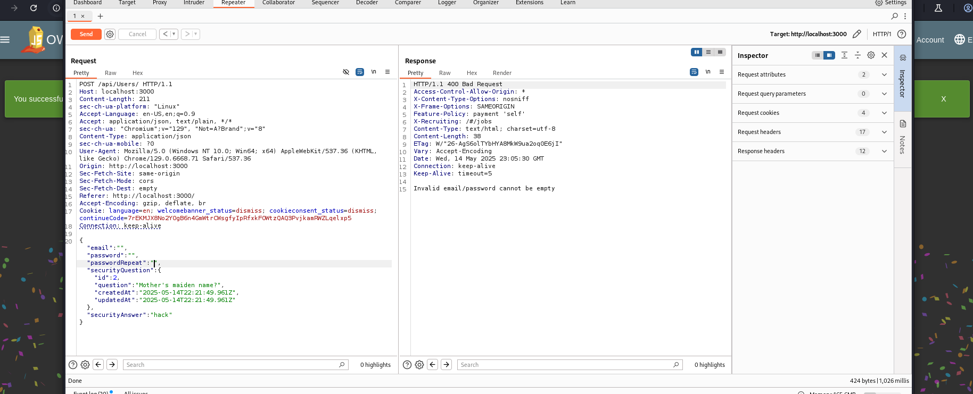



**Upload Size**

* **Severity:** high 3-stars
* **Description :**The application's file upload functionality relies on client-side validation, allowing attackers to bypass size and type restrictions by modifying requests through Burp Suite. During testing, we successfully uploaded a prohibited 150KB .txt file despite apparent client-side restrictions (100KB limit).
* Step-by-Step Exploitation:

1. Payload Preparation (PowerShell/Python):  
   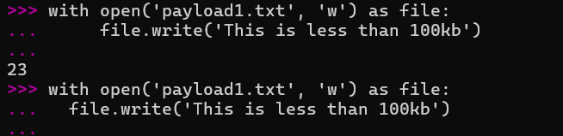  
     
   
2. Interception & Tampering:

* Intercepted legitimate upload of payload1.pdf (1KB)   
  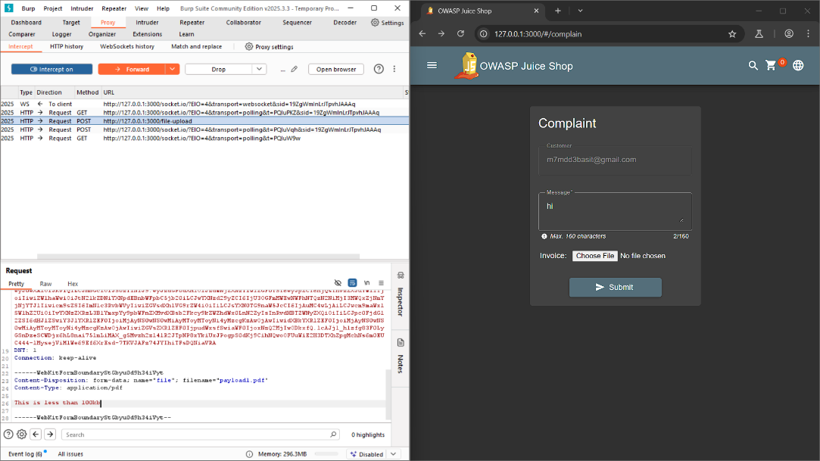
* Modified filename and content to payload1.txt (150KB) in Burp:  
  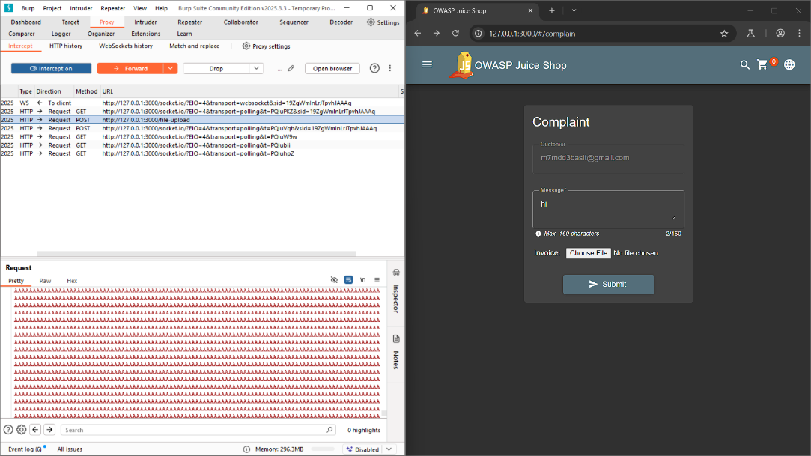

3-Bypass Result: Server accepted the oversized file despite client-side restrictions   
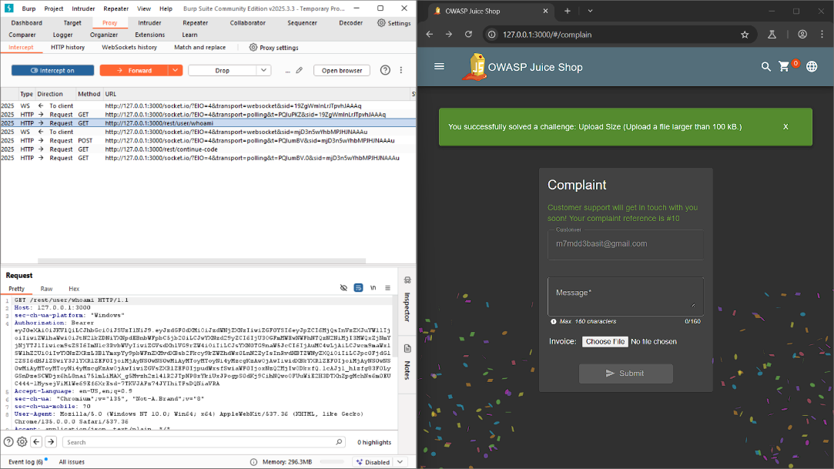

**Upload Type**

* **Severity:** high 3-stars
* **Description :**The application's reliance on client-side file type validation allows attackers to upload prohibited file types (e.g., .txt) by intercepting and modifying requests in Burp Suite. During testing, we bypassed PDF-only restrictions to upload a .txt file despite frontend controls.
* **Exploitation Steps :**

1-upload the file   
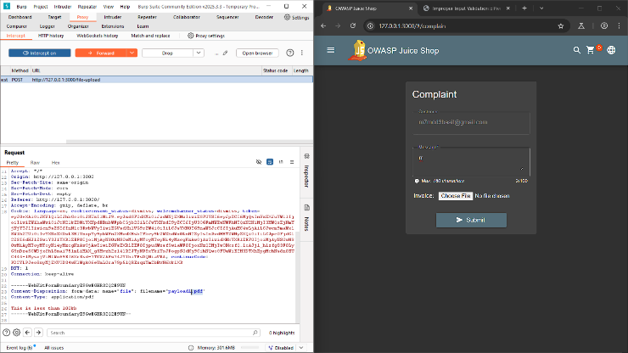

2- Modified the Content-Disposition and Content-Type headers:  
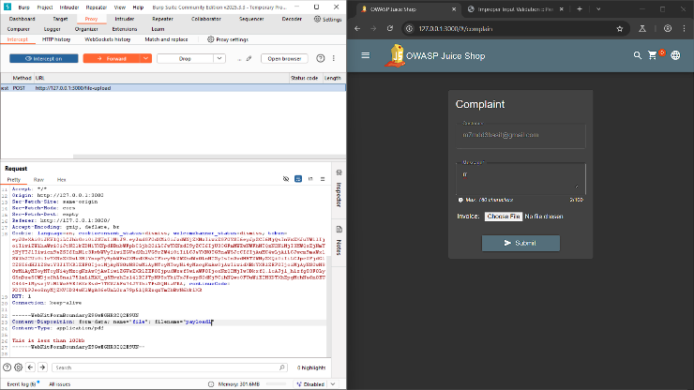

* **Confirmed successful   
  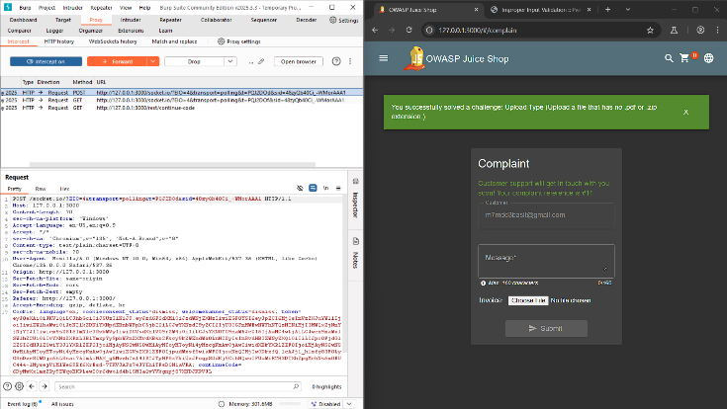**

**Payback Time**

* **Severity:** High 3-stars
* **Description :**

The application fails to validate product quantity values during checkout, allowing attackers to submit negative quantities (e.g., -10000) through request tampering. This flaw credits the attacker's account instead of debiting it, enabling financial fraud.

* **Exploitation :**Steps 1 - Legitimate Order Placement:

Add a product (e.g., Banana Juice) to cart with quantity 1 Initiate checkout 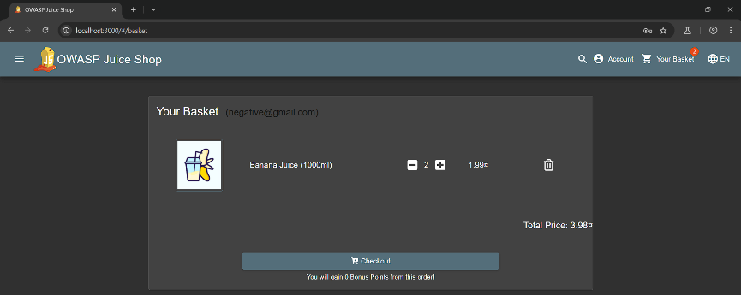  
  
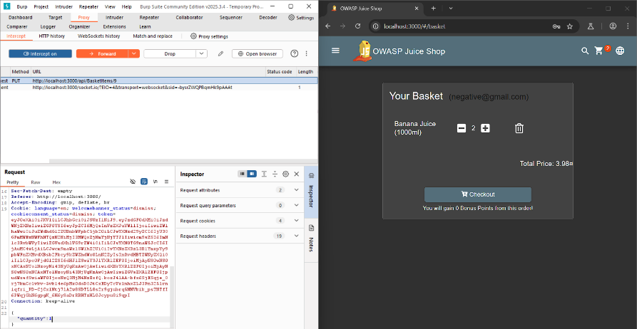

Step 2 - 2. Request Tampering:  intercept the request in Burp Suite and send it .  
 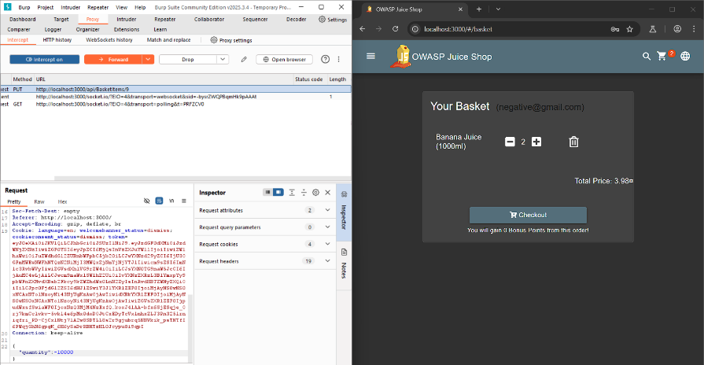  
  
**Exploit Result:**

* System processes negative quantity as a refund
* Attacker's balance increases by 10000 * product_price
* Challenge "Payback Time" solved   
  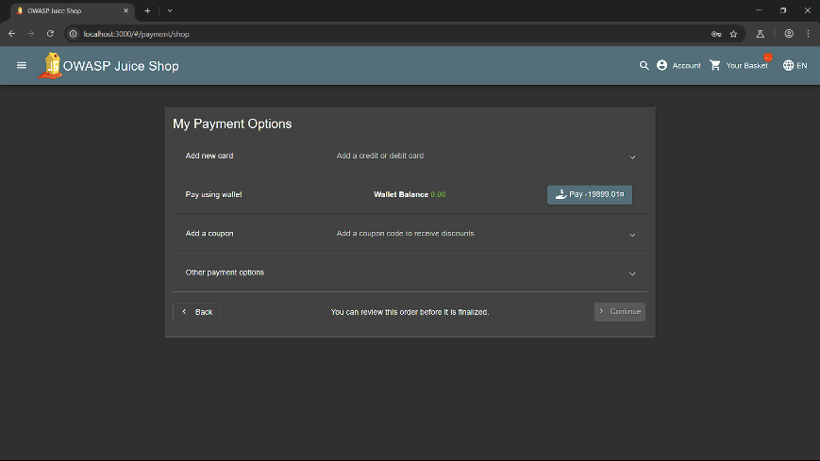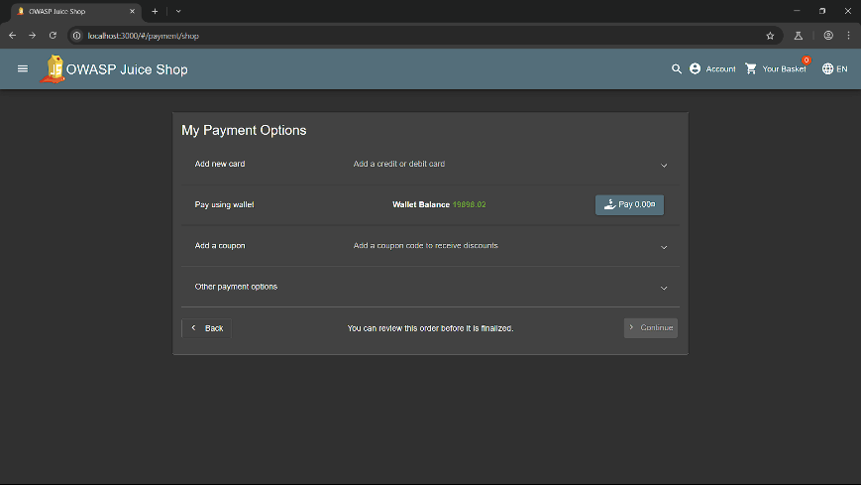

**Admin Registration**

* **Severity:**high , 3 stars
* **Description:**The application's user registration functionality improperly validates input, allowing attackers to self-assign administrator privileges by manipulating the registration request. This flaw bypasses the intended role-based access control (RBAC) system, enabling vertical privilege escalation.
* Intercept the registration request using Burp Suite or browser developer tools :   
  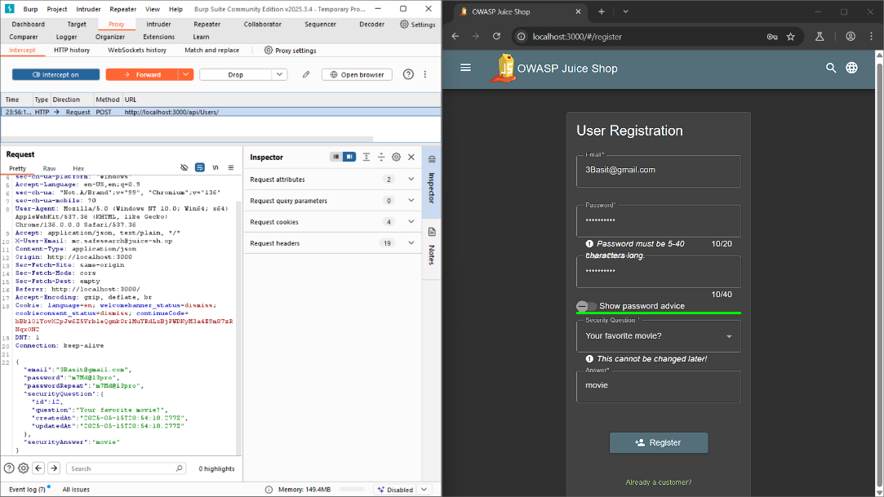
* Send it to repeater , you will see that the role is “customer”  
  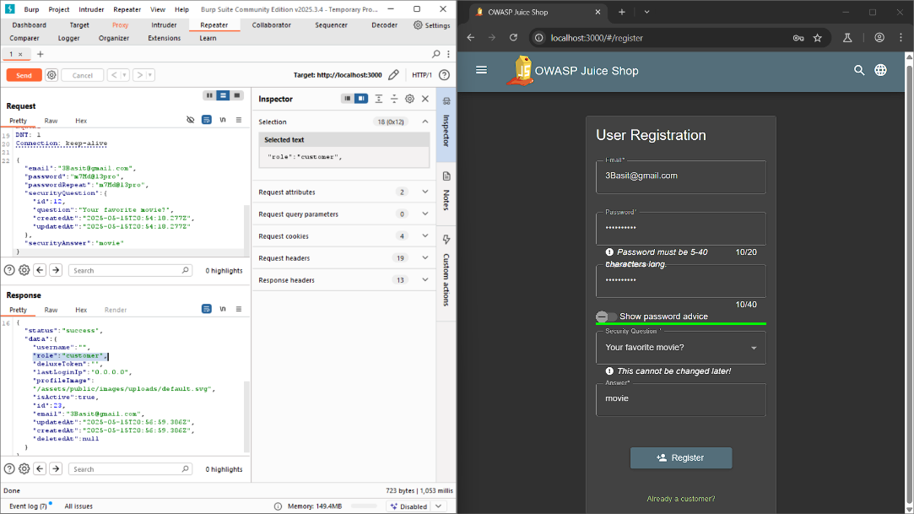
* So before sending it I will change it’s role to “admin”  
    
  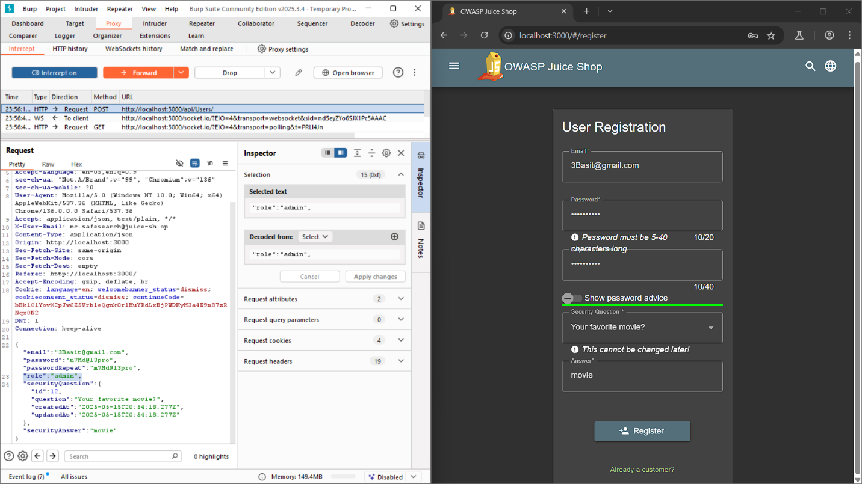
* 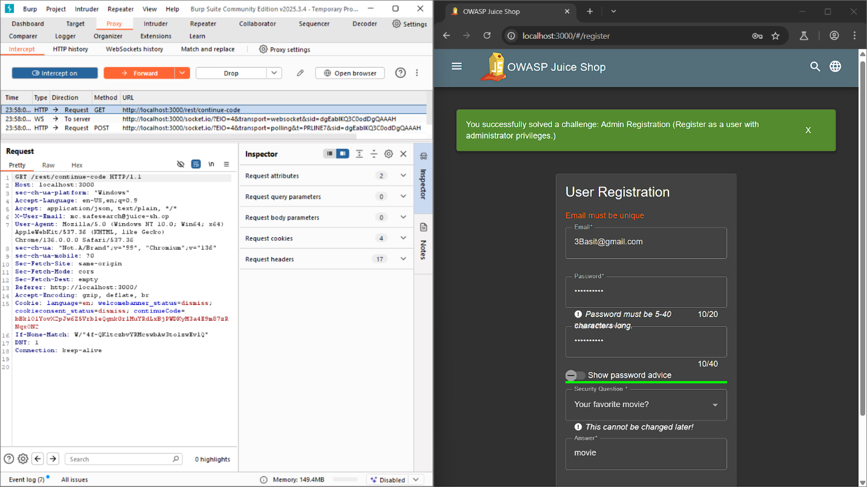

**Poison Null Byte** Bypass a security control with a Poison Null Byte to access a file not meant for your eyes.

* **Severity:** High 4-stars
* **Description :** The application fails to sanitize null bytes (%00) in file paths, allowing attackers to bypass extension-based security controls. By appending %00.md to a restricted filename (e.g., eastere.gg), the system incorrectly validates the file extension, enabling unauthorized access to blocked files.
* **Exploitation :**

1. Initial Access:

Navigated to About Us → Clicked "Legal Notice" (http://localhost:3000/ftp/legal.md) Modified URL to list FTP directory: http://localhost:3000/ftp/   
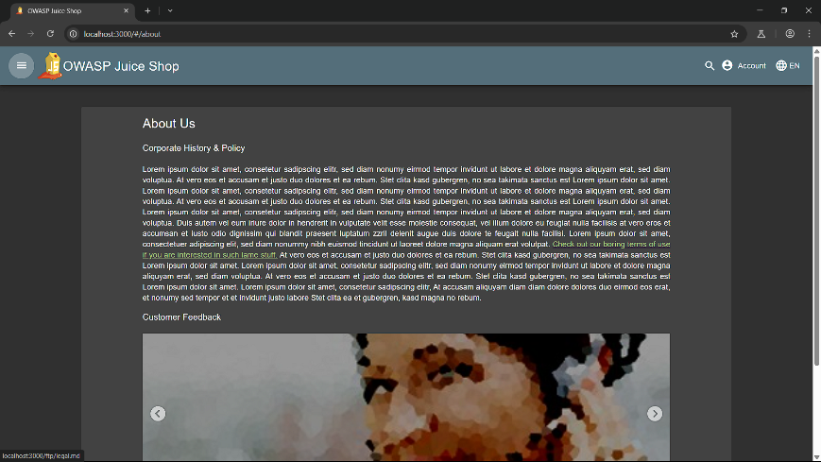

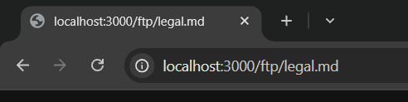

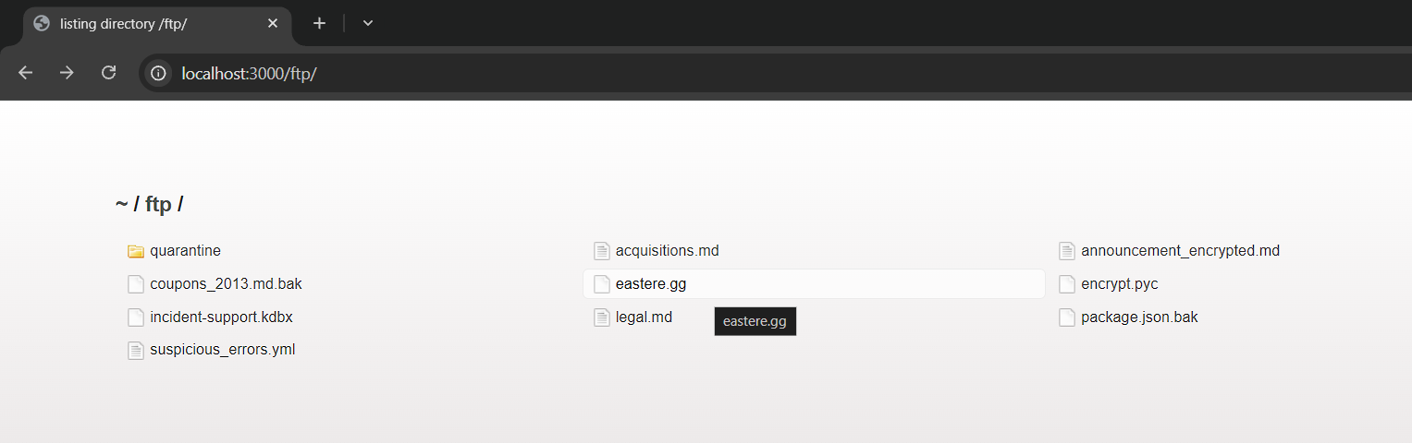

1. Identify Target File: Discovered restricted file eastere.gg (hidden "Easter Egg" challenge file)

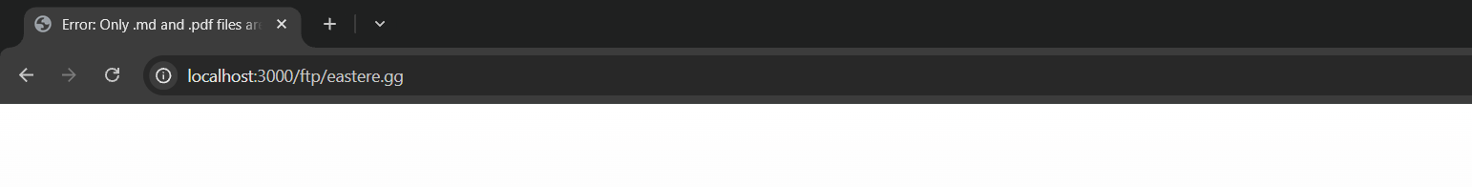

1. Bypass Extension Filter:

Direct access blocked: http://localhost:3000/ftp/eastere.gg → Error: "Only .md and .pdf files allowed" Injected null byte:



**Result:** Successfully retrieved eastere.gg contents   
  
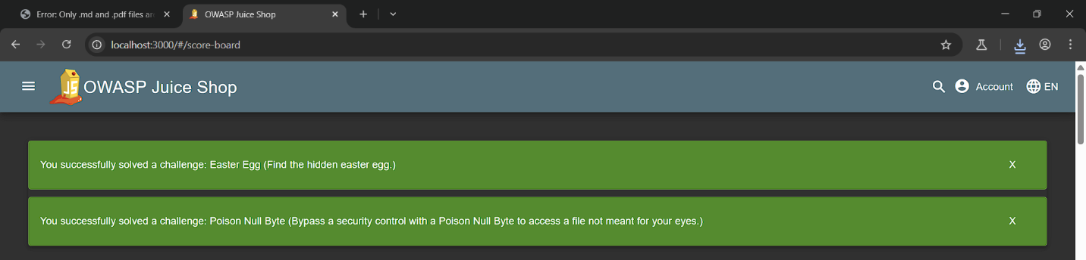

**8-SSRF vulnerabilities:**

Severity:

High (potential for unauthorized access to internal or external resources)

Description:  
The application is vulnerable to a Server-Side Request Forgery (SSRF) attack due to improper validation of user-supplied URLs in the image upload functionality. This allows an attacker to manipulate the server into making unauthorized requests to internal or external resources, potentially exposing sensitive data or enabling further exploitation.

Affected Component:  
Image upload feature (specifically the "Image URL" input field) that fetches images from user-provided URLs.

Steps to Reproduce (in the vulnerable application):

1. Access the application and navigate to the image upload page.
2. Upload an image file (e.g., resulting in a src like assets/public/images/uploads/23.jpg at localhost:3000).
3. Locate the "Image URL" input field, which allows entering a URL to fetch an image.
4. Obtain a unique PostBin URL (e.g., https://postb.in/123456) from the PostBin service.
5. Enter the PostBin URL (https://postb.in/123456) into the "Image URL" field.
6. Click the "Link Image" button.
7. Check the PostBin dashboard to confirm the server sent a request to the provided URL, as evidenced by logged headers (e.g., user-agent, cf-ray).

Impact:  
• Unauthorized access to internal services (e.g., http://localhost:8080/admin or http://127.0.0.1).  
• Potential extraction of sensitive data from internal resources or cloud metadata endpoints (e.g., http://169.254.169.254/latest/meta-data/ on AWS).  
• Ability to bypass network restrictions or firewalls, enabling reconnaissance or further attacks.  
• Possible exploitation of misconfigured internal systems, leading to full server compromise.

Remediation:  
• Implement strict URL validation using a whitelist to allow only trusted domains (e.g., gravatar.com).  
• Block requests to internal IP addresses and localhost (127.0.0.1, localhost, 192.168.x.x).  
• Restrict server permissions to minimize the impact of unauthorized requests.  
• Use a network firewall to limit outbound traffic from the server to untrusted or internal endpoints.

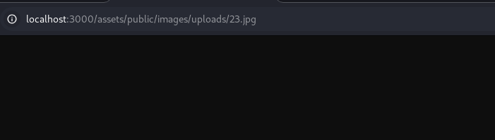

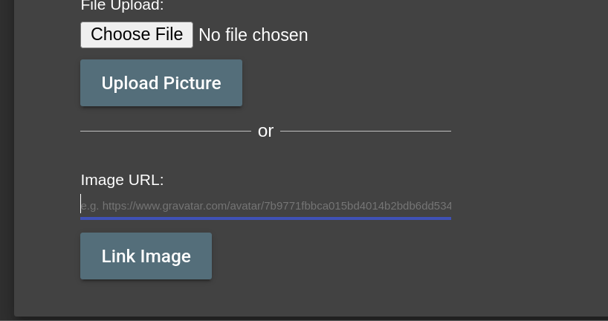

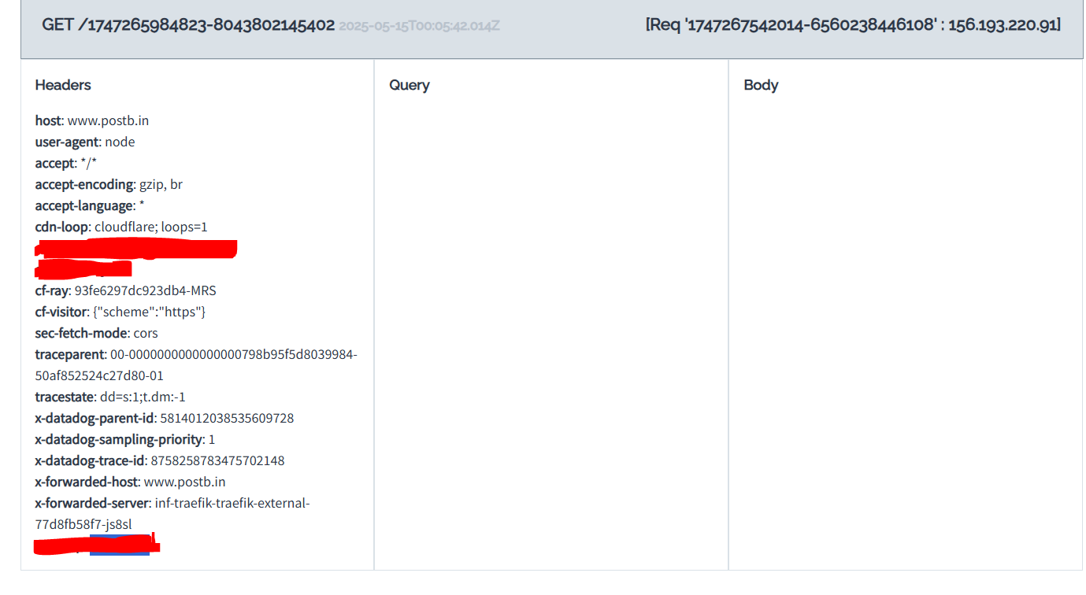

**9-Miscellaneous vulnerabilities:**

**Security Policy**

**Accessing the security.txt file by the endpoint**

**(/.well-known/security.txt)**

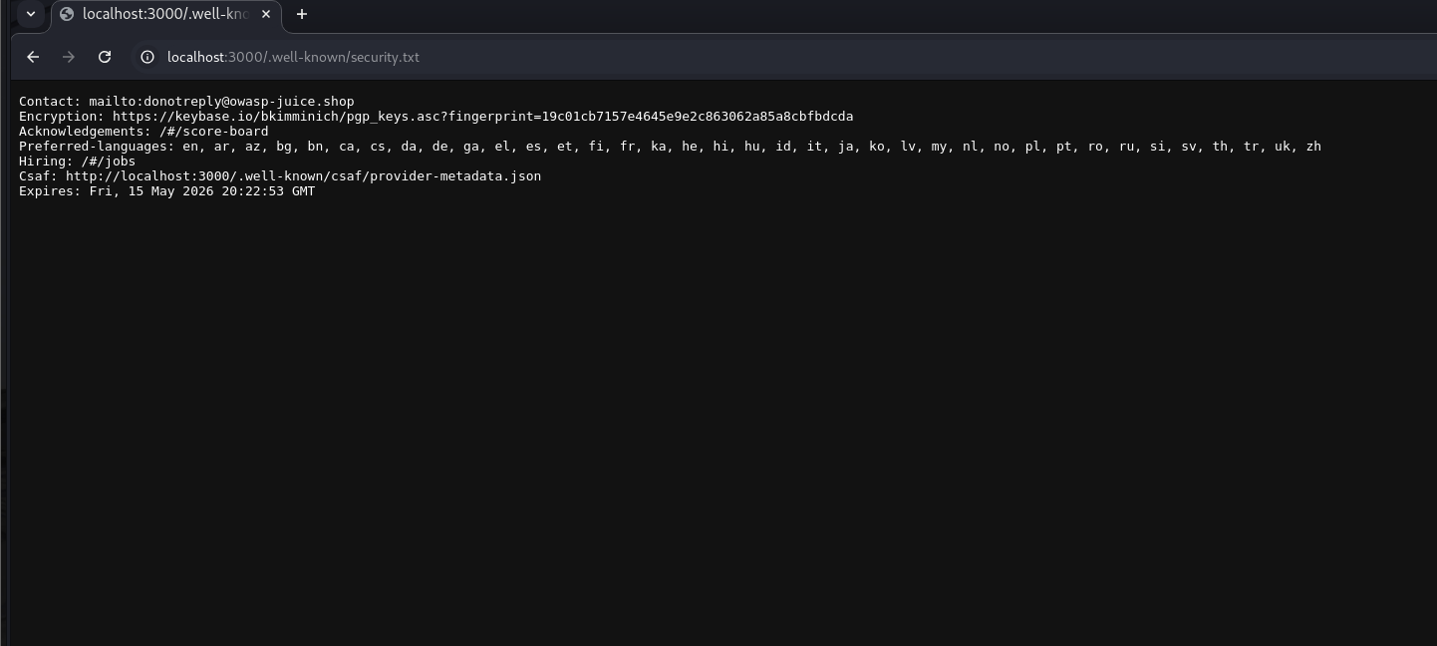

* 1. **Forgotten Developer Backup (Sensitive Data Exposure)**
* Severity: High (4 stars)
* Description:

A backup file, package.json.bak, was discovered in the /ftp directory (http://localhost:3000/ftp). This file contains the application's dependency list, including development dependencies, which should not be publicly accessible. This exposure can lead to further attacks, such as identifying vulnerable components.

* Steps to Reproduce:

Navigate to http://localhost:3000/ftp.

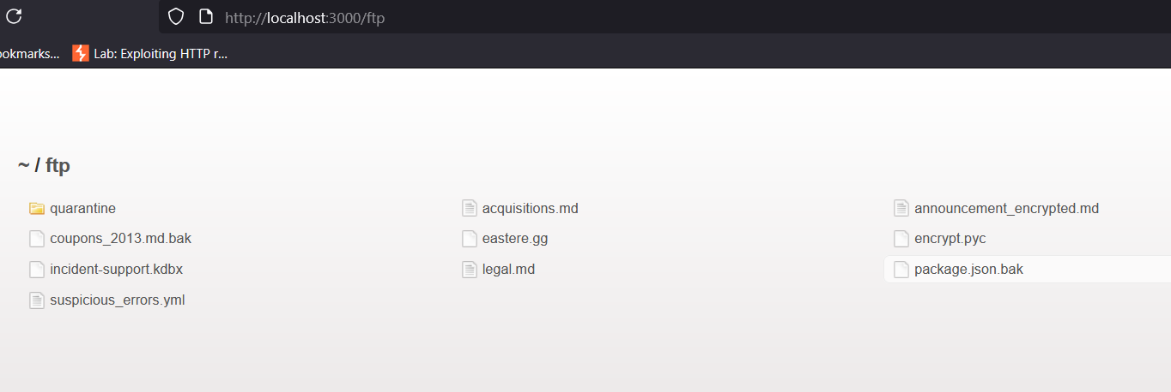

Observe the directory listing, which includes package.json.bak among other files.Attempt to access http://localhost:3000/ftp/package.json.bak, revealing the file's contents.

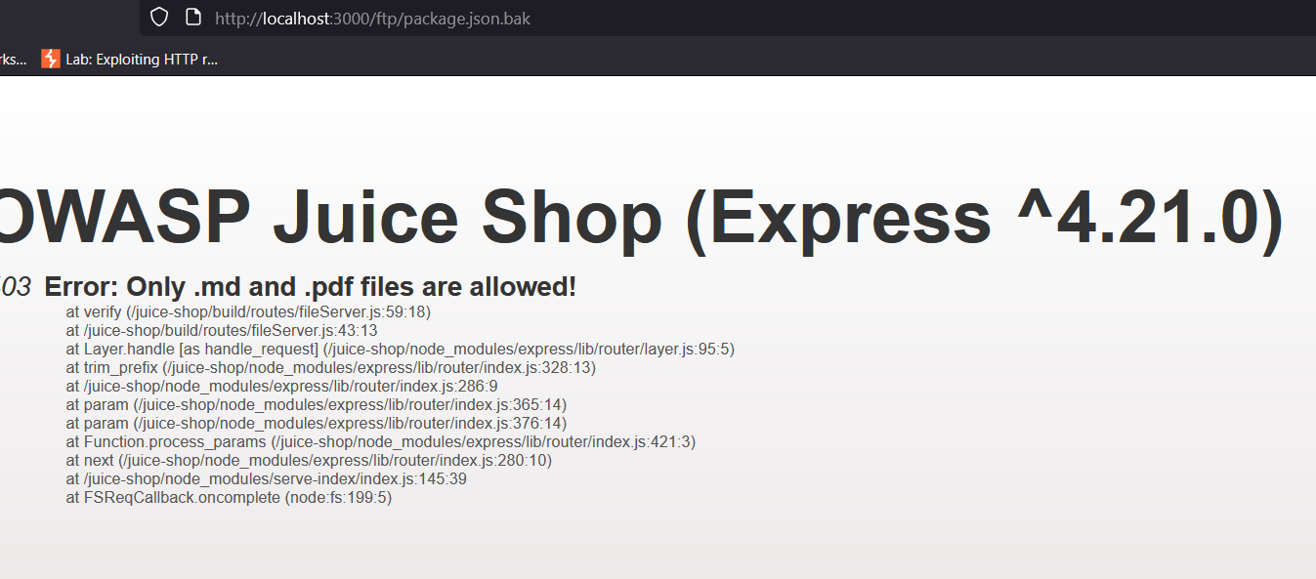  
bypass whitelist containing pdf and md with null byte  
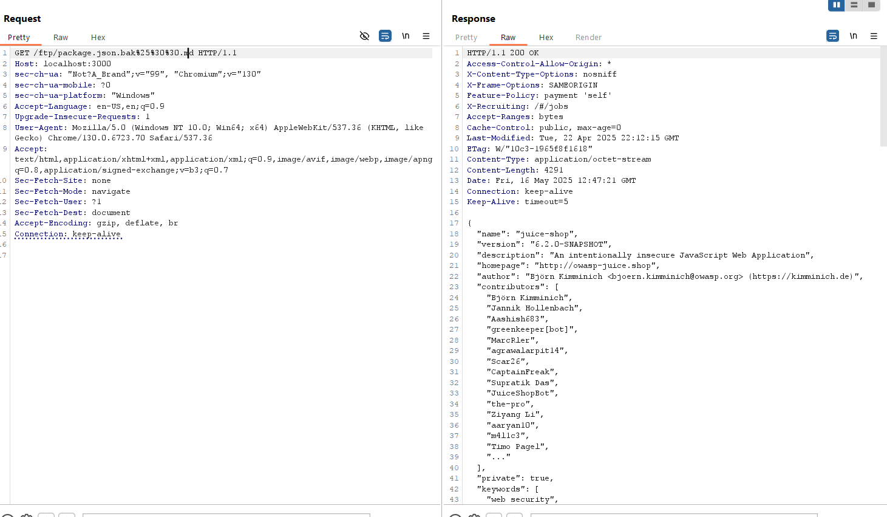

Exposure of sensitive configuration data, including dependency versions.

Enables attackers to identify outdated or vulnerable dependencies for further exploitation (e.g., supply chain attacks).

Potential leakage of internal development practices or credentials if embedded in the file.

Mitigation Recommendations:

Remove or restrict access to backup files in production environments.

Disable directory listing on web servers (e.g., configure Nginx or Express to disable directoryIndex).

Implement proper access controls to prevent unauthorized file access.

# 3. Supply Chain Attack (Vulnerable Components)

* Severity: Critical (5 stars)
* Description:

The package.json.bak file revealed a development dependency, eslint-scope@3.7.2, which was compromised in a real-world supply chain attack in 2018. The malicious version included code to steal npm tokens and enable remote code execution, posing a significant risk to developer credentials.

* **Steps to Reproduce:**

Access package.json.bak using the Poison Null Byte bypass (http://localhost:3000/ftp/package.json.bak%00.md).  


Identify eslint-scope@3.7.2 in the devDependencies section.  
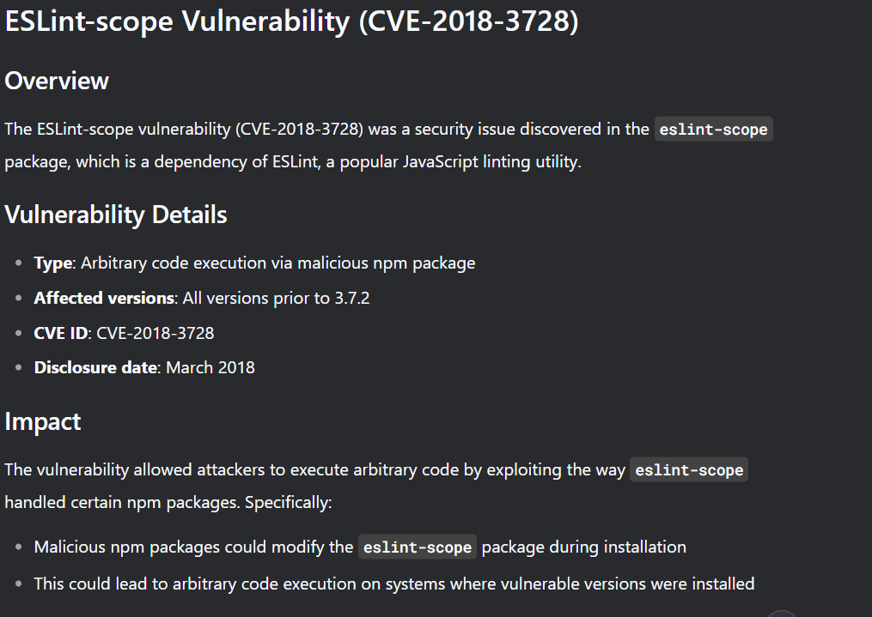

Research the package and confirm its compromise (e.g., via https://github.com/eslint/eslint-scope/issues/39).

Report the vulnerability to the development team via the contact form at http://localhost:3000/#/contact, including the package name, version, risk, and a reference URL.  
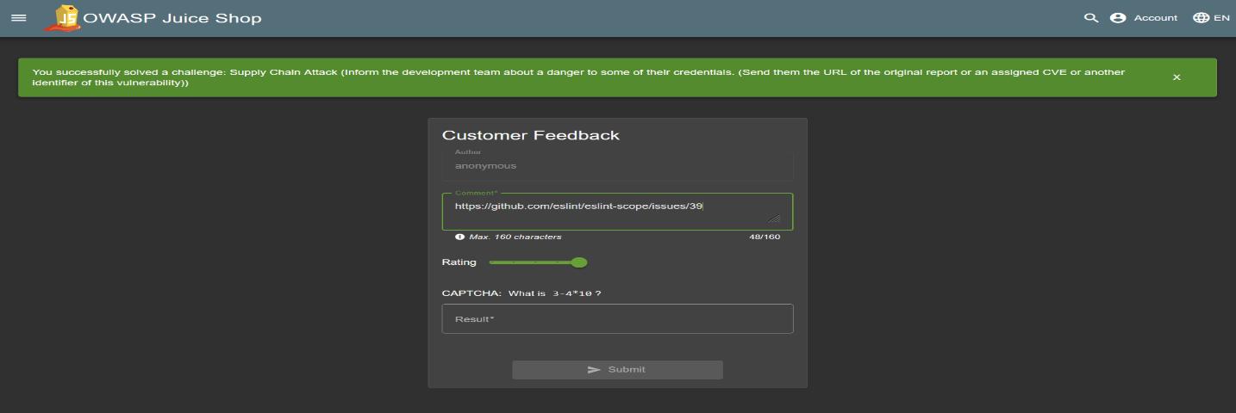

* impact:

Erosion of trust in the software supply chain, as malicious dependencies can propagate to production.

Mitigation Recommendations:

Use dependency scanning tools (e.g., npm audit, Snyk) to identify and update vulnerable components.

Pin dependencies to trusted versions and verify their integrity using checksums.

Educate developers on supply chain risks and enforce secure development practices

## 10- Broken Anti Automation

( **CAPTCHA Bypass )** Submit 10 or more customer feedbacks within 20 seconds.

* **Severity:**  high 3-stars
* **Description :** The application's CAPTCHA mechanism fails to prevent automated submissions, allowing attackers to bypass rate limiting by replaying the same feedback request multiple times through Burp Repeater. This enables spam attacks and potential data corruption.
* **Exploitation Steps :**

1. **Legitimate Feedback Submission**:

Submit a feedback form with valid CAPTCHA   
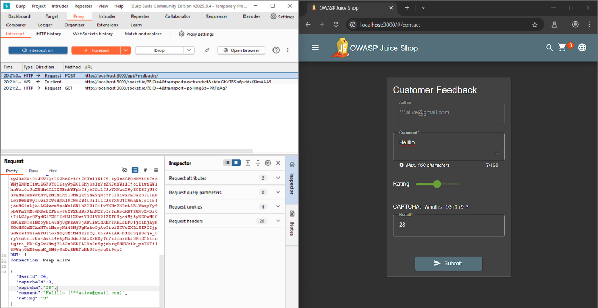

1. **Intercept the request in Burp Suite** : Request Replay Attack

Sent 10+ identical requests within 20 seconds via Burp Repeater   
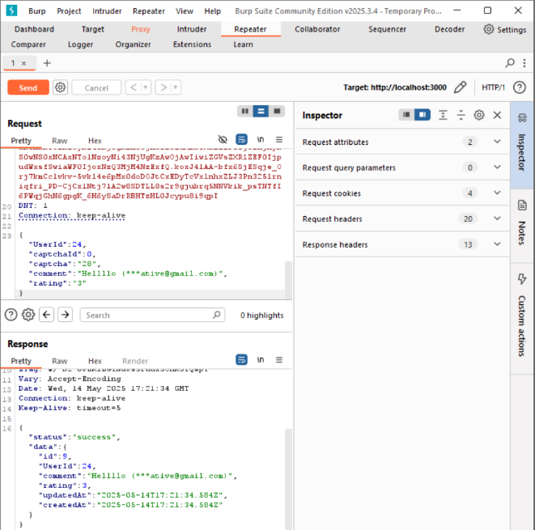

1. **Verification:**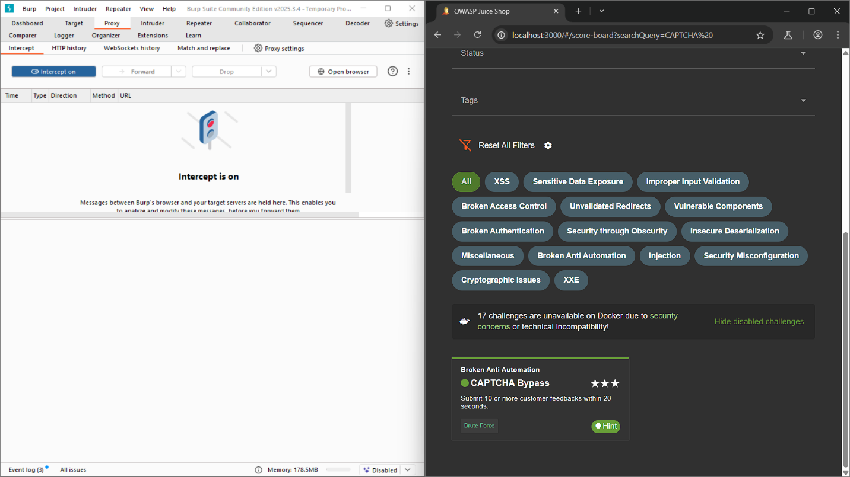

**3. Conclusion**

The OWASP Juice Shop assessment reveals a broad spectrum of vulnerabilities ranging from low to critical severity. While some issues present minor risks, several critical and high-severity challenges pose significant threats to the security, privacy, and integrity of your application and data.

Addressing these vulnerabilities is essential to safeguard against potential data breaches, unauthorized access, and compliance violations. Prioritizing remediation efforts on critical and high-severity issues will dramatically improve your security posture and reduce the risk of exploitation.

By implementing the recommended fixes and adopting strong security practices, your organization can enhance trust with users, ensure regulatory compliance, and build a resilient, secure application environment. We are ready to support you throughout this process to help achieve these goals efficiently and effectively

## 4 - Findings Summary

